Community Safety and Antisocial Behaviour Strategy 2023 - 2028

Introduction

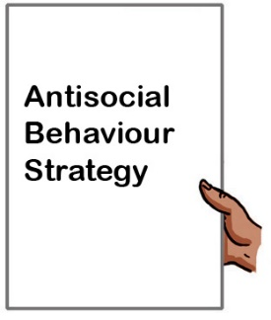

The law says that every Council must have a strategy for dealing with antisocial behaviour. A strategy is a plan.

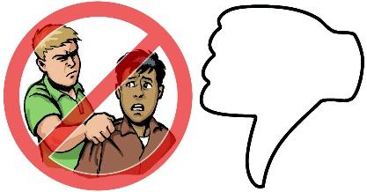
Antisocial behaviour is behaviour by a person which annoys, scares or upsets people in the community.

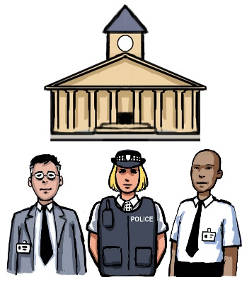
The Antisocial Behaviour Strategy is made by The Edinburgh Community Safety and Justice Partnership. This has staff from the Council, Police, Fire and Rescue Service and NHS Lothian.

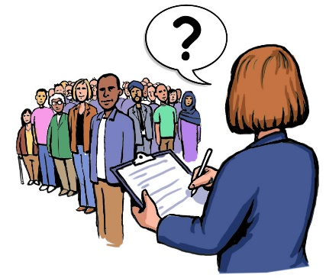
The Partnership wants to find out how people feel about antisocial behaviour in their communities. This is called a Consultation. The feedback will help make the strategy.

Why your views matter

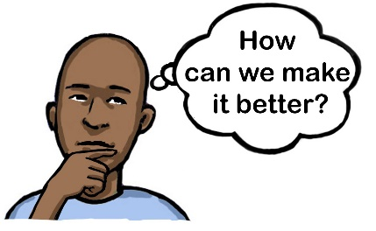
Your views will help us understand how you feel about crime and antisocial behaviour in your neighbourhood. This will help us solve them.

1. Your Details
We will use this information to make sure each person is making 1 response.

We will not publish people’s names, email addresses or postcodes. We will publish the names of organisations.

We will use your email address to contact you to let you know the results of this consultation.

Are you responding as an individual or an organisation? Please tick one of the answers below:

An individual
For an individual
An organisation

Your name or the name of the organisation (required):

Email address, if you have one:

Postcode (required):

Can we contact you about this consultation? Please tick one of the answers below:

Yes
No

Safety in Edinburgh
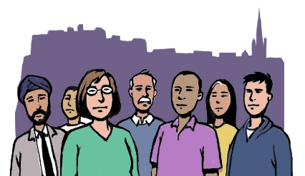

2. How happy are you with Edinburgh as a place to live, work and visit?

Please tick one of the answers below:
Very Happy
Happy
Neither happy or unhappy
Unhappy
Very unhappy

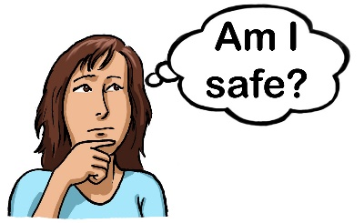

3. How safe do you feel in Edinburgh?

Please tick one of the answers below:
Very safe
Quite safe
A little unsafe
Very unsafe
Do not know or do not want to say

4. What makes you feel less safe in Edinburgh?

Please write your answer in the box below:

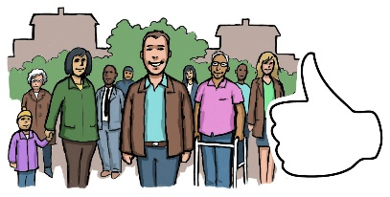

5. What would make you and the people you live with feel safer in Edinburgh?

Please write your answer in the box below:

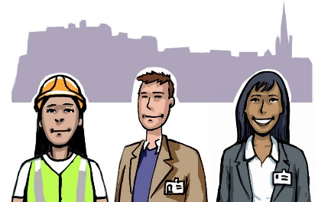

6. Do you work in Edinburgh?

Please tick one of the answers below:
Yes
No

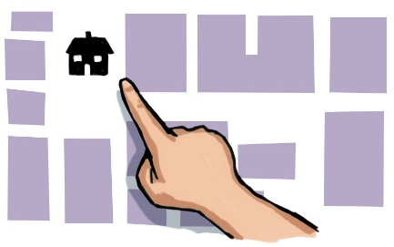

7. Do you live in Edinburgh?

Please tick one of the answers below:
Yes
No

People who live in Edinburgh
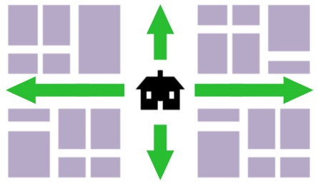

The following questions are about your neighbourhood. This is the area within a 20 minute walk from your home.

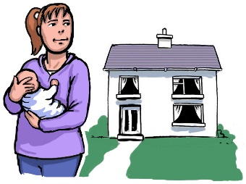

8. How happy are you with your neighbourhood as a place to live?

Please tick one of the answers below:
Very Happy
Happy
Neither happy or unhappy
Unhappy
Very unhappy

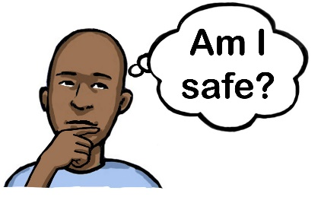
9. How safe do you feel in your neighbourhood?

Please tick one of the answers below:
Very safe
Quite safe
A little unsafe
Very unsafe
Do not know or do not want to say

10. What makes you feel less safe in your neighbourhood?

Please write your answer in the box below:

11. What would make you feel safer in your neighbourhood?

Please write your answer in the box below:

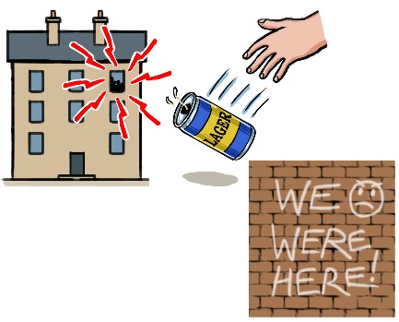
12. In the last year have you experienced or seen antisocial behaviour like noise, littering or vandalism in your neighbourhood?

Please tick one of the answers below:
Yes
No

If you said yes, please tell us about your experience in the box below:

Antisocial behaviour and crime in Edinburgh

13. In the last year do you think antisocial behaviour and crime in Edinburgh has:
Please tick an answer below:
Gone up
Stayed the same
Gone down
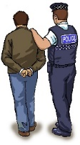
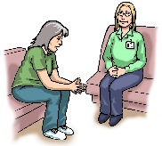
14. What do you think would help to lower antisocial behaviour and crime in Edinburgh? This could be better jobs and mental health services or more Police.

Please tell us about your ideas in the box below:

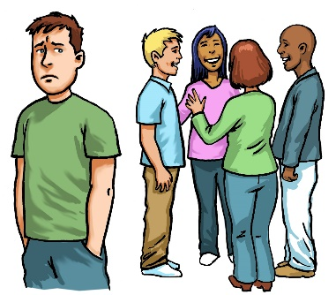
Antisocial behaviour and crimes may be committed by people who come from different backgrounds. This includes people who might have been treated unfairly by the criminal justice system.

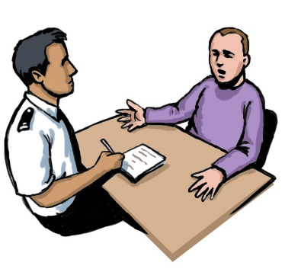

15. Should the criminal justice system deal with vulnerable people differently?

Please tick one of the answers below:
Strongly agree
Agree
Neither agree or disagree
Strongly disagree
Do not know

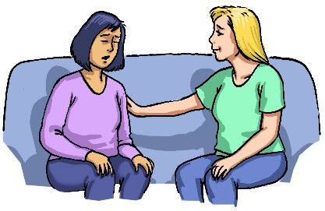
Victims of crime can feel left out and treated badly by the criminal justice system. Restorative Justice is a system that lets them talk about what happened to them and how it made them feel. This can happen in a face-to-face meeting, by video, or through letters.

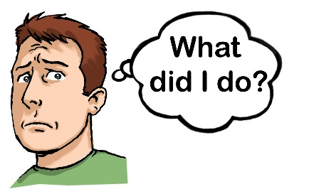
It helps the person responsible for the harm to understand the impact of their actions. This can help them to change their behaviour.

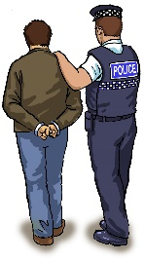

16. Will Restorative Justice help to lower antisocial behaviour and crime in Edinburgh?

Please tick one of the answers below:
Strongly agree
Agree
Neither agree or disagree
Strongly disagree
Do not know

17. Do you have any other comments about Community Safety and Antisocial Behaviour in Edinburgh?

Please write your answer in the box below:

Our future strategy
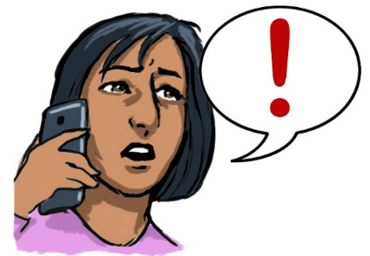
In the last year the Council received 1,140 complaints about antisocial behaviour. The main reason was due to noise. The next most common complaints were about annoying behaviour.

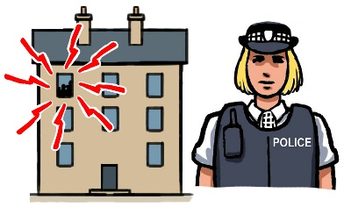
Our new Community Safety Strategy will tackle these issues over the next 5 years. We will work on how to respond to noise complaints by using new technology.

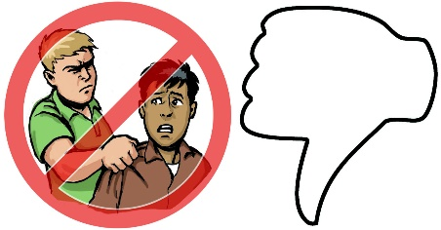
We will work with local communities, community planning organisations and local businesses to tackle antisocial behaviour and crime in Edinburgh.

Edinburgh will be a safe place to live, work and visit.

18. Do you agree with our ideas about Community Safety and Antisocial Behaviour in Edinburgh?

Please tick one of the answers below:
Strongly agree
Agree
Neither agree or disagree
Strongly disagree
Do not know

19. Let us know why?

Please write your answer in the box below:

About you

We would like to know more about you. These questions are optional, but answering them will help us make sure we are hearing from a wide range of people from different backgrounds.

20.What is your age:

21. What is your gender?

22. What is your sexual orientation?

23. What is your ethnic group?

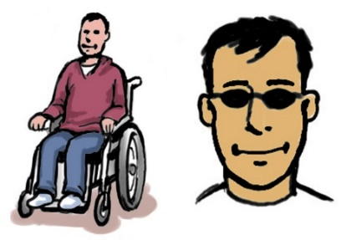
24. Do you have any physical or mental health conditions lasting more than 1 year?

Please tick an answer below:
Yes
No
Prefer not to say
Please tell us more about this if you want to:

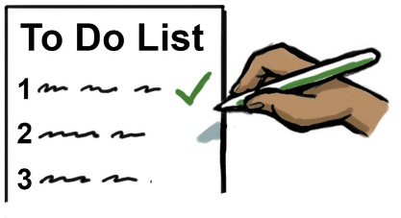
25. Does your condition affect your ability to do day-to-day activities?

Please tick an answer below:
Yes
No
Prefer not to say

26. What religion do you belong to?

