Strategic Environmental Assessment Environmental Report
Appendix A. SEA Baseline
Revision no: 0.2
City of Edinburgh Council

Climate Strategy 2030
August 2022

- SEA Baseline
Baseline data were collated to summarise the key environmental characteristics of the City of Edinburgh Council area, focusing on SEA issues. Schedule 3 of the Environmental Assessment (Scotland) Act 2005 requires the Climate Strategy to be assessed against the following environmental issues:
- Air Quality
- Climatic factors
- Land and soil
- Water
- Landscape and townscape
- Biodiversity, flora and fauna
- Material assets
- Population and human health
- Cultural heritage
Appropriate baseline information is important to allow a ’Base Case’ or Business as Usual option to be developed. The Base Case will be used in the SEA assessments, as a reference to help highlight particular environmental problems risks and opportunities.

Air Quality
Edinburgh has six Air Quality Management Areas (AQMAs; Figure 3). Five of these AQMAs are in locations where annual mean limits for NO₂ are regularly exceeded, these include:
- City Centre
- Glasgow Road
- Great Junction Street
- Inverleith
- St John’s Road
There is only one AQMA, at Salamander Street, where annual mean limits for PM₁₀ are regularly exceeded.
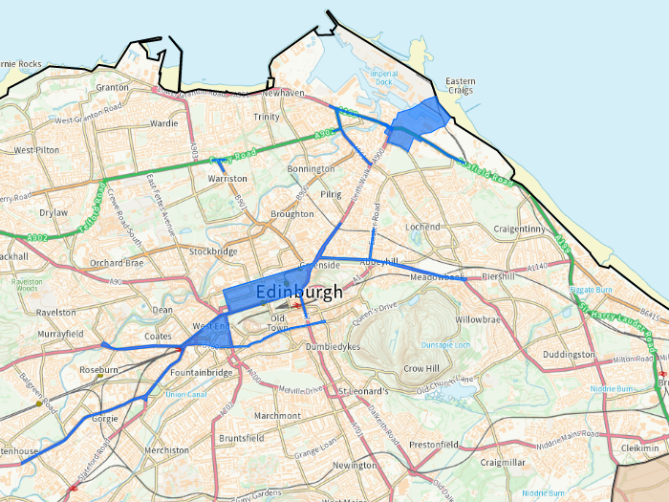

Figure 3: AQMAs currently declared in Edinburgh (Air Quality in Scotland, 2021)
Key issues relevant to appraisal of Climate Strategy:
- Edinburgh has six AQMAs, five AQMAs are in locations where annual mean limits for NO₂ are regularly exceeded.
- There is one AQMA, at Salamander Street, where annual mean limits for PM₁₀ are regularly exceeded.

Climatic Factors
Edinburgh is aiming to meet the current national reductions target (42% reduction by 2020 and 80% by 2050) for carbon emissions by reducing CO₂ emissions in the transport sector by 290kt CO₂.
Edinburgh has a maritime climate with cold and humid winters and mild summers, however Scotland’s climate is changing and the impacts on Edinburgh are already being felt. Climate projections show that Edinburgh will experience warmer and wetter winters, summers are expected to become hotter and drier, and occurrences of extreme rainfall events are expected to increase. In response, the City of Edinburgh Council continue to develop a variety of strategies, frameworks and goals to address the change in climate.
Data from the Met Office shows a distinct warming trend for Edinburgh in line with climate change predictions, outlining a daytime temperature rise of 0.75°c comparing 1961-1990 averages with those of 1981-2010. As well as warming, climate change trends predict drier summers for southeast Scotland, with periods of intense rainfall projected to become more extreme.
While Edinburgh has suffered from a number of river floods, coastal flooding has not been a significant issue up to now. However, there are concerns that climate change could lead to more widespread coastal flooding, resulting from a combination of rising sea levels (see Figure 4), increased frequency of storm surges, and rougher sea conditions. The Dynamic Coast – The National Overview 2021 report draws upon the latest climate projections on sea level rise, providing strategic evidence on the projected extent of coastal erosion in Scotland. Importantly, national-level modelling of Scotland’s wave-dominated soft coast reveals that coastal erosion currently affects 46% of soft shorelines (an increase from 38% over that report in 2017). The extent and rate of coastal erosion, and the risk to coastal assets, is expected to increase under all emissions scenarios.
In addition to the above, the frequency of severe rainfall events and flooding in the city is expected to increase in the coming decades. Instances of intense and prolonged summer rainfall have caused localised disruption and damage, with flooding resulting from a combination of surface water and surcharged drainage. UKCP18 projections indicate that Scottish winters will become wetter, with more heavy rainfall and a greater number of wet days, although this increase is less extreme in east Scotland than in the west. In summer months, total rainfall amounts are expected to decrease, while convectional rainfall will trigger storms between 10% and 45% more extreme than at present.
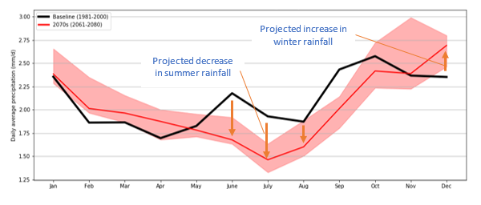

Figure 4: UKCP18 Daily average precipitation for the baseline and future 2070s period under the high emissions (provided by the City of Edinburgh Council)
Sea levels in the UK rose at a rate of around 1.4 mm/year in the 20th century. This is associated with the increase in global temperatures and its impact on oceanic thermal expansion and ice melt. This trend is projected to continue to the end of the 21st century and beyond. Edinburgh’s coast is projected to experience the impacts of sea level rise. Rates of increase are largely independent of all emissions scenarios over the next 20 years, with increases of 16-20 cm possible relative to the 1981-2000 baseline (see Figure 5). Rates vary notably in the latter half of the century, with possible increases as high as 90 cm under the high emissions scenario. A medium emissions scenario results in sea level rise of 30-40 cm but with the possibility of rising by up to 60 cm.
As Figure 5 shows, sea level change in Edinburgh will continue to increase over the next 80 years.
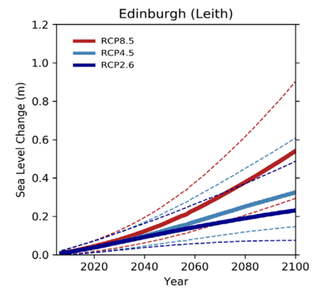
Figure 5: Sea level rise to 2100 using the UKCP18 probabilistic projections (provided by Atkins Ltd Edinburgh Climate Change and Adaptation Assessment 2021/22)
As summarised in Table A.1, the following changes to local conditions can be expected.
Table A.1: Expected changes in Edinburgh’s climate and weather conditions
Changes in Conditions | ‘Overall Confidence’ in scientific evidence for each change
Minimum, average and maximum daily temperatures will increase in all seasons, with the greatest increase in summer | High/Medium
What is considered a heatwave (projected to become around 4 times more frequent in the latter half of the 21st century) or extremely hot summer today will occur more frequently in future (Up to a 5°C temperature increase during summer months by the 2070s) | Medium
Rainfall is projected to become more seasonal, with an increase in average winter and autumn rainfall. Average summer rainfall is projected to decrease in Edinburgh in coming decades | Medium/Low
Heavy rainfall events may occur more frequently in winter, spring, and autumn. Summer heavy rainfall events are projected to become more extreme | Medium/Low
Edinburgh signed its climate emergency declaration in May of 2019, thereby committing itself to work towards net-zero emissions by 2030. Produced by the ESRC Place-Based Climate Action Network (PCAN), this net-zero roadmap is designed to inform how Edinburgh can work towards that ambitious target in the coming years.
Analysis of the Net Zero Carbon Roadmap for Edinburgh shows that emissions have fallen by 42% since 2000, due to a combination of increasingly decarbonised electricity supply, structural change in the economy, and the gradual adoption of more efficient buildings, vehicles and businesses. With full decarbonisation of UK electricity by 2045, and taking into account economic growth, population growth and on-going improvements in energy and fuel efficiency, it is projected that Edinburgh’s baseline emissions will only fall by a further 9% by 2030, 13% by 2037, and 15% by 2045. This is a total of just over 50% between 2000 and 2045 (see Figure 6). Emissions included here are derived from fuel, landfill sites and industry within the area and emissions from electricity used within the area (even if it’s generated elsewhere).

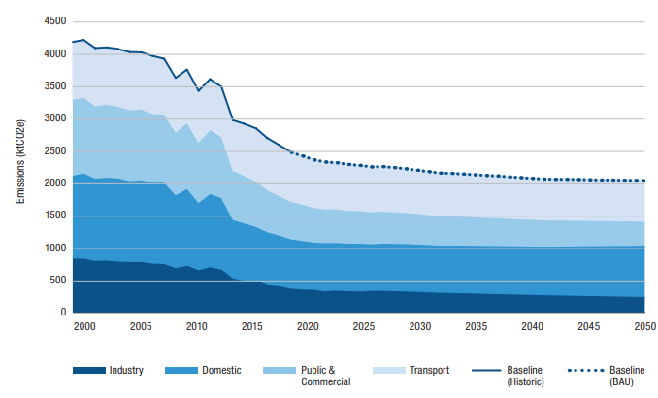
Figure 6: Edinburgh’s Carbon Emissions (2000-2050)
Currently, 31% of Edinburgh’s emissions come from the transport sector, with housing responsible for 29% of emissions and public and commercial buildings accounting for 23% and industry 17%. At current rates of emissions output, Edinburgh is set to use its total carbon budget of 22.1 megatonnes over the period between the present and 2050 in just over a decade at some point during the winter of 2031. However, Edinburgh could stay within its carbon budget by reducing its emissions by c.8% year on year.
There is opportunity across all sectors to introduce low carbon measures, including an increase in walking and cycling, enhanced public transport, electric and more fuel-efficient vehicles (transport) and better lighting, improved process efficiencies and a wide range of other energy efficiency measures (industry).

Land and Soil
The majority of farmland in the area is classified as prime agricultural land (Soil Survey of Scotland – Land Capability for Agriculture, Macaulay Institute for Soil Research) with the majority also within the Edinburgh Green Belt (see Figure 7). In addition, there is a limited amount of carbon-rich and peatland soil which can be found in the Pentland Hills which is a designated Special Landscape Area.
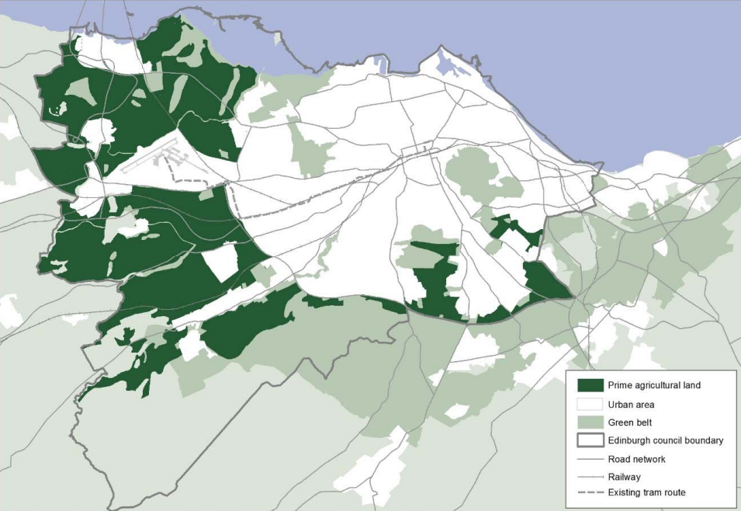

Figure 7: Prime Agricultural Land in Edinburgh in 2017 (City of Edinburgh Council, 2020)
Edinburgh has a relatively low incidence of vacant and derelict land compared with other central belt authorities. High land values and pressures for development means that land tends to be re-used quickly. However, there are significant areas of vacant and derelict sites in clusters, including Newbridge and parts of the waterfront (see Figure 8), although the total amount in Edinburgh has dropped by 20% from 223ha in 2011 to 178ha in 2017.

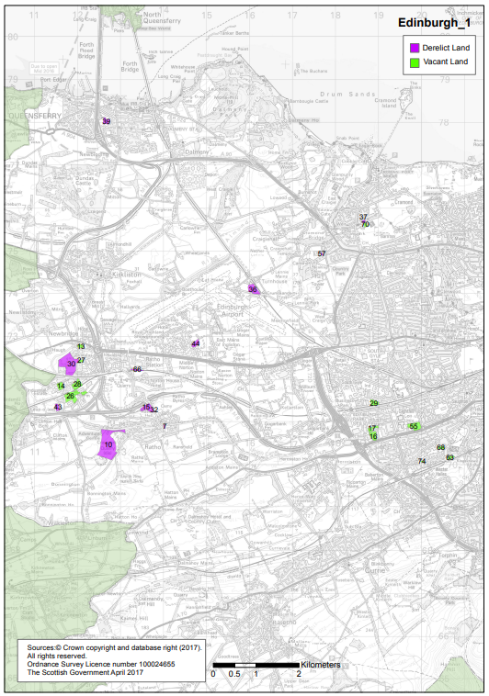
Figure 8: Vacant and Derelict, Scottish Vacant and Derelict Land Survey for the City of Edinburgh 2017(City of Edinburgh Council, 2017)

Water
Areas of importance for flood management: These have been identified within the study area associated with specific water bodies. The potentially vulnerable areas in the Forth Estuary Local Plan District within the City of Edinburgh council are: Granton, Water of Leith catchment, Braid Burn catchment, Cramond Bridge, South Gyle, Broxburn and Bathgate, South Queensferry, Lasswade, Penicuik, Dalkieth and Musselburgh, Niddrie Burn/Burdiehouse Burn catchment and Musselburgh.
Rivers: Edinburgh is drained by a number of relatively short rivers which generally flow from southwest to northeast, rising in and around the Pentland Hills and discharging into the Firth of Forth. Principal among these is the Water of Leith, which flows through the heart of the city.
River, coastal and surface water flooding: The Water of Leith has been subject to intermittent flooding since people first settled in the area. However, this has become more of an issue with the increasing number of people living in close proximity. The Murrayfield, Roseburn and Gogarburn (around the airport) areas have a history of flooding and flood prevention schemes have been implemented to minimise the risk. In addition, due to the extent of hard surfacing within the urban area, there is a significant risk of surface water flooding events. SEPA has published a Flood Risk Management Strategy (FRMS) for the Forth Estuary. The City of Edinburgh Council has also produced a Local Flood Risk Management Plan (LFRMP), which was adopted in June 2016. This identifies areas vulnerable to flooding and potential mitigation actions. The LFRMP provides further information on the funding and timetable for delivering the actions identified in the strategy between 2016 and 2022. The FRMS and LFRMP are planned to be updated every six years. In addition, the Council will prepare surface water management plans following the completion of an Integrated Catchment Study in 2021. Due to project timescales, this information is not expected to be available prior to the plan being adopted. However, if the information does become available it will be incorporated into this SEA. Notably, updates to the SEPA pluvial maps and coastal flood hazard maps are underway, with outputs anticipated to be available in the next 18 months. These maps, along with other updates being made to flood mapping in the Southeast of Scotland, will be taken into consideration as the climate change strategy evolves and develops.
Water supply: Edinburgh’s water requirements are now supplied via a network of reservoirs in the Tweedsmuir, Moorfoot and Pentland Hills, some of which act as the main supply reservoirs and others act as holding or compensation reservoirs. This infrastructure was the subject of a recent major investment programme. Although the availability of water reserves could become a greater issue in the future, as a result of climatic changes, it is the capacity of the treatment and distribution infrastructure which may impose a more immediate restriction on the amount and location of new development in the Edinburgh area.
Water quality: Overall the groundwater across the Edinburgh region is in good condition according to the SEPA database. The surface waters around the coast to the north of the city are in good condition, while the surface water quality to the east of the city at Leith Docks to Port Seton is in poor condition (SEPA, 2019).
The City of Edinburgh Council have also set out their ‘Vision for Water Management in the City of Edinburgh’ (2021). The vision describes how the City of Edinburgh Council will adapt to the challenges of climate change with respect to the management of water. In summary, the vision is ‘to develop a long-term and sustainable approach to river, coastal and storm water management across the city and its environs, respecting our unique historic heritage. This will involve all stakeholders and address the flooding and water quality risks associated with our changing climate as a result of changes in rainfall and sea level rise.’

Landscape
Edinburgh has numerous outstanding features within easy reach of the City Centre: Holyrood Park including Arthur’s seat and Salisbury Crags, the Braid Hills and Blackford Hill, Corstorphine Hill and the Pentland Hills. These fall within the Green Belt and are also designated as Special Landscape Areas. The Green Belt around Edinburgh was first established in 1957 and it has been an important tool in shaping the City’s growth and containment and supports regeneration. The current Local Development Plan (LDP) released a significant amount of land from the Green Belt, primarily to meet housing land requirements in the first SDP, and to implement national planning policy in West Edinburgh.
Within the City Centre itself, Edinburgh has open spaces of world class value. These include topographic and natural features that define the city, such as Arthur’s Seat, the Water of Leith and Braid Burn river valleys and the coastline. In addition, there are large areas of open space which are important to the character of the city such as the Meadows. These are linked with footpaths, green corridors and watercourses (see Figure 9) to form a strong green infrastructure within the urban area (see Figure 9).
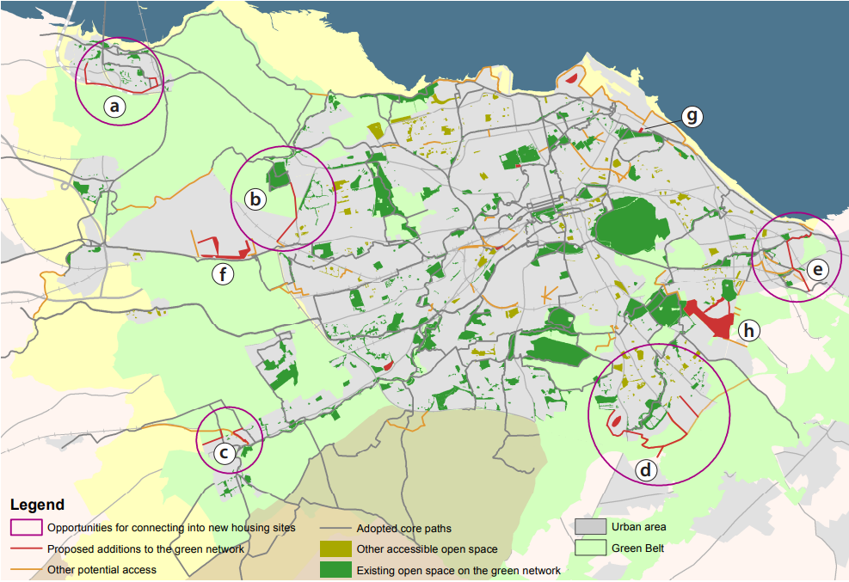

Figure 9: Edinburgh’s Green Network, part of the Open Space 2021 Strategy
The Open Space Strategy 2021 aims to improve and extend the city’s network of open space in order to improve quality of life, support economic vitality and build excellent places. The Strategy has a co-ordinating and interdependent role in terms of a number of Council plans and strategies, including those relating to parks and gardens, allotments, play, sports facilities, active travel, climate change adaptation, sustainability and biodiversity. It looks back at what has happened over the last five years and looks forward at the priorities for Open Space into the 2020s, whilst sharing inspiring examples from across the Council Area. Table A.2 outlines some of the key considerations from the strategy.
Table A.2: Key considerations outlined in the Open Space Strategy 2021
Benefits of Open Space in Edinburgh | How is Open Space in Edinburgh Changing?
82% of Edinburgh’s citizens are satisfied with parks and greenspaces compared to 76% nationally and around 71% of residents have taken part in 30 minutes physical activity each week | Comparisons between the 2010 Open Space Strategy and 1969 Open Space Plan found that open space had increased by some 200 hectares over the 40-year period. In the last five years, there has been a less marked change in the overall quantity and composition of greenspace
Studies in Edinburgh and Dundee found that better availability of greenspace within deprived communities is associated with significantly lower levels of stress and improved mental wellbeing | Across the types of open space quantified in the Open Space Audit (2016) there have been losses and gains since 2009. However, the overall amount of open space has remained relatively constant, with a net loss of under two hectares
Edinburgh’s open space network includes an urban forest of almost 630,000 trees, which help to filter air pollution, intercept and soak up flood waters, slow global warming by storing carbon and provide natural cooling during warmer weather | Some spaces have changed type to reflect changes in management practices, such as designating Magdalene Glen as a Community Park or via the introduction of new outdoor sports facilities, allotments or community growing spaces
Greenspaces can provide above ground storage for flood waters, reducing the need for costly defences. Along the Braid Burn, flood storage has been formalised at Firhill High School, Inch Park and Edinburgh University Playing Fields | Losses have tended to apply to bowling greens, playing fields, semi-natural greenspaces and residential amenity green space. In these cases, planning policy seeks to avoid losses which would impact on local character, recreational provision, biodiversity and green networks.
Whilst methods of comparing open space provision in different cities vary, one study by Greenspace Scotland found that Edinburgh had the highest proportion of public parks and gardens in Scotland, some 17% of all open space based on 2010 data. This compares with 13% in Glasgow and 8% across urban Scotland.

Biodiversity, Flora and Fauna
Edinburgh has a diverse range of valued areas, habitats and species, including sites designated under the European Union’s Wild Birds Directive (Directive 79/409/EEC, as amended). These ‘European Sites’ comprise:
- Firth of Forth Special Protection Area (SPA)
- Outer Firth of Forth and St Andrews Bay Complex SPA
- Imperial Dock Lock SPA
- Forth Islands SPA
The Firth of Forth is also a Ramsar site, which is an international designation for Wetlands of International Importance. At present, the Climate Strategy contains strategic policies rather than any site-specific policies, objectives or proposed interventions. As such, a screening under the Scottish Habitats Regulations, Conservation (Natural Habitats, &c.) Regulations 1994, (the first stage of a Habitats Regulations Appraisal - HRA) will not be undertaken. However, as the Climate Strategy develops, if any aspects of it have a spatial context (for example, public transport corridors) that could influence a European Site, the need for an HRA will need to be revisited and discussed with NatureScot.
There are also seven nationally designated Sites of Special Scientific Interest (SSSIs) within Edinburgh, covering a total area of 1,239 hectares and non-statutory designated sites. The non-statutory sites comprise 109 Local Nature Conservation Sites (including Local Biodiversity Sites and Local Geodiversity sites). Table A.3 shows the various natural heritage designations in Edinburgh.
Edinburgh has a Biodiversity Action Plan (EBAP 2019-21), which aims to: raise awareness of the rich biodiversity in Edinburgh; encourage Partners and others to take positive action to protect and enhance our natural environment; promote co-ordination and communication between Partners and others to further conservation within Edinburgh; and influence other plans, policies and strategies relating to Edinburgh.
Table A.3: Natural Heritage Designations
Designation | Number of Sites
SPA: Designated under the Wild Birds Directive for wild birds and their habitats | 3 and 1 proposed (Firth of Forth SPA, Imperial Dock Lock (Leith) SPA, Forth Islands SPA, Outer Firth of Forth and St Andrews Bay Complex (pSPA))
Ramsar sites: designated under the Conversion of Wetlands of International Importance | 1 (Within same boundary as Firth of Forth SPA)
SSSIs | 7 (Agassiz Rock, Arthurs Seat Volcano, Balerno Common, Duddingston Loch, Firth of Forth, Inchmickery, Wester Craiglockhart Hill)
Local Nature Reserves | 8 (Burdiehouse Burn Valley Park, Cammo Estate,  Corstorphine Hill, Easter Craiglockhart Hill,  Hermitage of Braid & Blackford Hill, Meadows Yard, Ravelston Woods
Local Nature Conservation Sites | 109  Local Biodiversity sites (LBS) 71  Local Geodiversity sites (LGS) 30

Material Assets
Public Transport Infrastructure: Generally, Edinburgh is well served by public transport, with an extensive bus and rail network and a developing tram and park and ride network. However, with a growing population, there is increasing pressure on public transport services. Many people travel to work by car, causing traffic congestion and significant pressure on parking spaces. There are several emerging transport schemes which will help improve existing public transport infrastructure, including the new tram service and additional park and ride sites. The Edinburgh Tram project is the largest infrastructure proposal to improve the city’s overall transport networks and to date connects the Airport to the city centre, with further development underway towards Leith and Newhaven.
Rights of Way: Edinburgh has an extensive network of off-road footpaths and cycle paths laid out over the past two decades, utilising abandoned railway alignments or following the banks of the city’s water courses. The area is traversed by a series of core paths that form the Core Path Network across the city.
Key transport infrastructure:
Key infrastructure can be defined as infrastructure which is regarded as important in a local geographic area and supports the delivery of essential services at a local level. In Edinburgh, key infrastructure includes:
- The Queensferry Crossing
- Forth Road Bridge and Forth Rail Bridge
- Edinburgh City Bypass
- Edinburgh Waverley and Haymarket Train Stations
- Edinburgh Bus Station
- Lothian Bus and Tram Routes
- Cycling and Walking RoutesForth Ports Leith
Natural Assets:
SEPA (2016) guidance on material assets in SEA’s outlines that natural assets are assets of the natural environment that consists of minerals (such as sand, gravel, rock, and slate), watercourses (supporting natural drainage and flood prevention processes), natural flood management processes, forestry and woodlands, agricultural land and associated elements such as field boundaries (e.g. hedges, stone walls).
With reference to the other environmental topics outlined in this SEA, natural assets in Edinburgh include:
Soil - Farmland located in prime agricultural land (Soil Survey of Scotland – Land Capability for Agriculture, Macaulay Institute for Soil Research). Limited amount of carbon-rich and peatland soil, found in the Pentland Hills which is a designated Special Landscape Area.
Water - Areas of importance for flood management include the Water of Leith and Forth Estuary. The Water of Leith has been subject to intermittent flooding since people first settled in Edinburgh. The Murrayfield, Roseburn and Gogarburn areas have a history of flooding. There are a number of short rivers in Edinburgh, rising in and around the Pentland Hills and discharging into the Firth and Forth.
Biodiversity - Edinburgh has three Special Protection Areas and one proposed Special Protection Area. The Firth of Forth is a Ramsar site which is an international designation for Wetlands of International Importance. There are also seven nationally designated Sites of Special Scientific Interest within Edinburgh, eight Local Nature Reserves and 109 Local Nature Conservation Sites.

Population and Human Health
Figure 10 shows the total resident population of Edinburgh was 527, 620 at the 2020 mid-year estimate and covers an area of 26,373 hectares (National Records Scotland, 2022). The age structure of Edinburgh’s population differs significantly from the national average, with fewer children and older people and more young adults. The population of the City of Edinburgh is projected to increase by 15% (or 75,965 people) between 2016 and 2041 (see Figure 11).
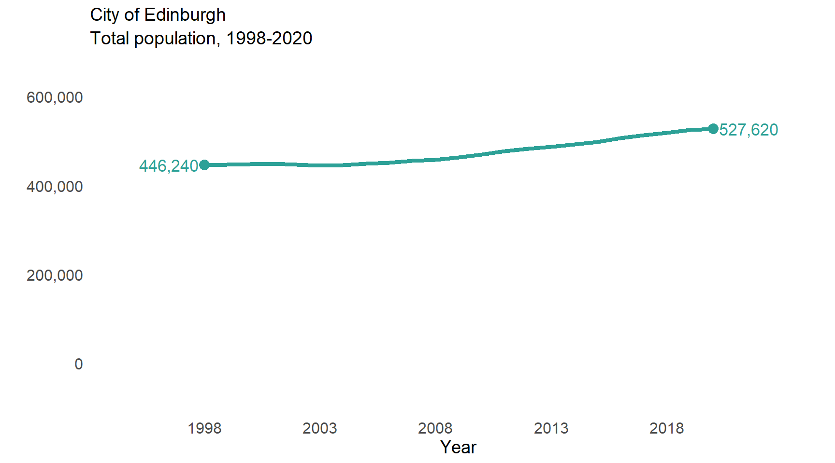

Figure 10: Edinburgh’s total population 1998-2020 (NRS Scotland, 2021)
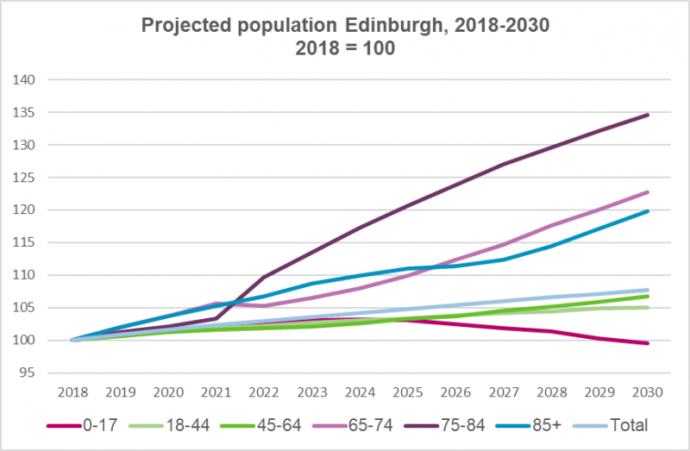

Figure 11: Projected population Edinburgh 2018-2030 (Edinburgh Health and Social Care Partnership, 2021)
In general, the population of Edinburgh enjoys a high standard of health. Life expectancy is high, with females living 81.1 years on average and males living to 77.1 years on average. However, there are significant inequalities in general health and mortality rates between different neighbourhoods within the city.
Noise can be a serious problem to people living in urban areas. In line with the Environmental Noise (Scotland) Regulations 2006, an Edinburgh Noise Action Plan was published in 2008. The Council identified three Noise Management Areas and 10 Quiet Areas in 2014 as part of round 1 of the noise mapping process. Following round 2, 18 Noise Management Areas and 10 Quiet areas were identified in the city (see Table A.4). Work by the Edinburgh Agglomeration Working Group is now commencing on the fieldwork for round 3. The working group will continue to co-ordinate the action planning process and work with the Environmental Noise Steering Group and the Scottish Government in its delivery of the requirements of the Environmental Noise Regulations.
Table A.4: Candidate Noise Management Areas and Quiet Areas
Noise Management Areas | Quiet Areas
A70 at Moat Street, Fountainbridge/Craiglockhart | Inverleith Park
A71 at Gorgie Road near Robertson Avenue, Fountainbridge/Craiglockhart | Royal Botanic Gardens
A70 at Slateford Road, Fountainbridge/Craiglockhart | Lochend Park
A702 at Morningside Road, near Steel’s Place, Meadows/Morningside | Arthur’s Seat Volcano, Holyrood Park and Duddingston Loch
A8 at Roseburn Gardens, Roseburn Street, Corstorphine/Murrayfield | Jewel Park
A70 at Orwell Place, West Park Place, Sighthill/Gorgie | Craiglockhart Dell
A702 at Gilmore Place, Home Street, Lochrin Terrace, West Tollcross, City Centre | Easter Craiglockhart Hill
A702 Lauriston Place at Glen Street, City Centre | Hermitage of Braid/Blackford Hill
East Fountainbridge, West Port at Lady Lawson Street, City Centre | Galachlaw
At West Nicholson Street, Southside/Newington | Burdiehouse Burn Valley Park
Deanhaugh Street, Raeburn Place, Inverleith
Broughton Road at Dunedin Street, Leith Walk
Easter Road at London Road, City Centre
Brunswick Road, Easter Road, Leith Walk
A902 at Ferry Road, Forth
Lindsay Road at Portland Street, Leith
Ferry Road at Madeira Street, Leith Walk
Great Junction Street at Bangor Road, Leith
An emerging public health priority in Edinburgh as well as many cities in the UK and across the world, is poor air quality. This is primarily caused by road transport emissions of gases such as nitrogen oxides (NOx) and particulate matter (PM_{2.5} and PM₁₀). These can have significant impacts on health, child development and environmental quality. In Scotland, recent work by Health Protection Scotland estimates that in 2016 there were 1,724 attributable deaths (not actual deaths, but modelled estimates that would be attributable to long-term exposure) associated with man-made PM_{2.5}. In Edinburgh, this is equivalent to 153 attributable deaths in the same year. The council’s Air Quality Action Plan (AQAP) and Active Travel Action Plan both aim to increase health benefits in Edinburgh, through implementing controlled parking zones to improve air quality and by encouraging modal shift to more active travel.
The Council’s administrative area includes several establishments controlled under Major Hazards legislation. There is a requirement to ensure that new development is not located in an area where it will put occupants at undue risk from these hazards.

Cultural Heritage
Conservation Areas: There are 50 conservation areas in Edinburgh, an increase of 10 since 2011 (see Figure 12) of widely varying character, ranging from the mediaeval Old Town, the Georgian New Town, Victorian suburbs and former villages which have been absorbed as the city has grown.
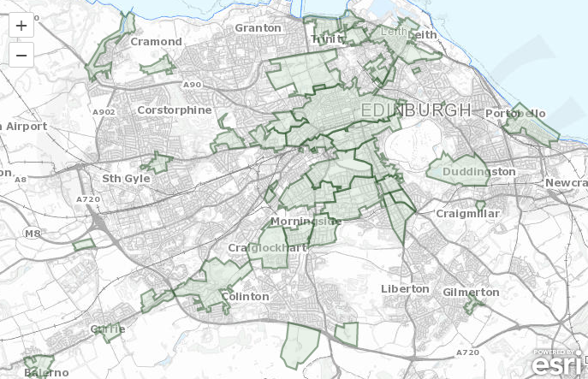

Figure 12: Conservation areas in Edinburgh (City of Edinburgh Council, 2022)
Historic gardens and designed landscapes: Historic Environment Scotland maintain the Inventory of Gardens and Designed Landscapes, which was initiated in 1987. The purpose is to record assets of national, regional and local importance. They are valuable in terms of contribution to scenery, history, artistic design, wildlife, horticulture or tourism. A total of 17 sites, a reduction of three since 2011, are listed within the Council’s area.
Listed Buildings: Edinburgh has the largest concentration of listed buildings in the UK outside London, with 4,830 listed items, comprising approximately 34,000 individual properties (as of June 2018).
Scheduled Monuments: Scotland has a rich heritage of scheduled monuments. They are important both in their own right and as a resource for research, education, leisure and tourism. There are currently 56 scheduled monuments within the City of Edinburgh Council boundary.
World Heritage site: The key historic designation in Edinburgh is the New and Old Town World Heritage Site, which was inscribed by UNESCO (United Educational Scientific and Cultural Organisation) in 1995. One of only six in Scotland, it covers approximately 4.5sq kms of the city’s historic core. Another key World Heritage site in the Edinburgh area is the Forth Bridge (a railway bridge) which was inscribed in 2015. Its three diamond-shaped towers form a cantilever bridge which was completed in 1890 and carries a dual-track railway line 46 metres above the Firth of Forth.
In addition to the designated sites above there are a variety of non-designated heritage assets and sites of known or suspected archaeological significance that can be found across the wider Edinburgh area.

Air Quality in Scotland (2021). Available from https://www.scottishairquality.scot/laqm/aqma#!/la/461
The Scottish Government (2019). Available from https://www.gov.scot/policies/climate-change/reducing-emissions/
The City of Edinburgh Council (2015). Available from https://www.edinburgh.gov.uk/downloads/download/13734/sustainable-energy-action-plan
Met Office (2021). Available from https://www.metoffice.gov.uk/research/climate/maps-and-data/uk-climate-averages
Centre of Expertise for Waters (2021). Available from: https://www.crew.ac.uk/dynamic-coast
The Edinburgh Partnership (2014). Available from https://www.edinburgh.gov.uk/downloads/file/24709/resilient-edinburgh-evidence-base-and-risk-analysis
Met Office (2018) UKCP18 Science Overview Report. Available from https://www.metoffice.gov.uk/pub/data/weather/uk/ukcp18/science-reports/UKCP18-Overview-report.pdf
Edinburgh Sustainable Development Partnership (2016). Available from https://www.edinburgh.gov.uk/downloads/file/24705/edinburgh-adapts-our-vision-2016-to-2050
Williamson, E., Sudmant, A., Gouldson, A. and Brogan, J (2020). Available from https://www.researchgate.net/publication/349769809_A_Net-Zero_Carbon_Roadmap_for_Edinburgh
Williamson, E., Sudmant, A., Gouldson, A. and Brogan, J (2020). Available from https://www.researchgate.net/publication/349769809_A_Net-Zero_Carbon_Roadmap_for_Edinburgh
The James Hutton Institute (2019). Available from https://www.hutton.ac.uk/learning/natural-resource-datasets/soilshutton/soils-maps-scotland/download
The City of Edinburgh Council (2021). Available from https://consultationhub.edinburgh.gov.uk/sfc/choicesforcityplan2030/user_uploads/choices_for_city_plan_2030___city_plan_environmental_report___january_2020.pdf
The City of Edinburgh Council (2017). Available from https://www.gov.scot/publications/maps-of-vacant-and-derelict-land-in-edinburgh/
SEPA (2022). Forth Estuary Local Plan District. Available at: https://www2.sepa.org.uk/frmstrategies/forth-estuary.html
The City of Edinburgh Council (2016). Available from http://www.edinburgh.gov.uk/info/20006/emergencies_safety_and_crime/1433/flood_risk_management_plan
SEPA (2015). Available from https://www.sepa.org.uk/data-visualisation/water-classification-hub
The City of Edinburgh Council (2021). Available from https://www.edinburgh.gov.uk/downloads/file/30101/vision-for-water-management-in-the-city-of-edinburgh#:~:text=Our%20vision%20is%3B,respecting%20our%20unique%20historic%20heritage.
The City of Edinburgh Council (2016). Available from https://www.edinburgh.gov.uk/downloads/file/22616/open-space-2021
Greenspace Scotland (2012). Available from: https://www.nature.scot/sites/default/files/2017-06/The%20Second%20State%20of%20Scotland%27s%20Greenspace%20Report%20-%20greenspace%20scotland%20-%20Jan%202012.pdf
East Coast Buses (2020) Lothian Network Map. Available from https://www.lothianbuses.com/wp-content/uploads/2021/09/210912-LB-Network-Map.pdf
The City of Edinburgh Council (2022) Cycling and Walking Routes Maps. Available from https://www.edinburgh.gov.uk/cycling-walking/explore-quietroutes/1
SEPA (2016). Available from: https://www.sepa.org.uk/media/219432/lups-sea-gu4-consideration-of-material-assets-in-sea.pdf
The James Hutton Institute (2019). Available from: https://www.hutton.ac.uk/learning/natural-resource-datasets/soilshutton/soils-maps-scotland/download
National Records of Scotland (2022). Available from: https://www.nrscotland.gov.uk/statistics-and-data/statistics/statistics-by-theme/population/population-estimates/mid-year-population-estimates/mid-2020
'2016-based principal population projections for 2016-2041, by sex, council area and single year of age’, National Records of Scotland (2018)
City of Edinburgh Council (2021). Available from https://www.nrscotland.gov.uk/files/statistics/council-area-data-sheets/city-of-edinburgh-council-profile.html
Edinburgh Health and Social Care Partnership (2022). Available from https://www.edinburghhsc.scot/the-ijb/jsna/populationanddemographics/#:~:text=Key%20points%20include%3A-,The%20population%20of%20Edinburgh%20in%20mid%2D2019%20was%20estimated%20to,of%20the%20population%20are%2065%2B
The Control of Major Accident Hazards (COMAH) Regulations 2015
The City of Edinburgh Council (2022). Available from https://www.edinburgh.gov.uk/conservation-2/listed-buildings/1

