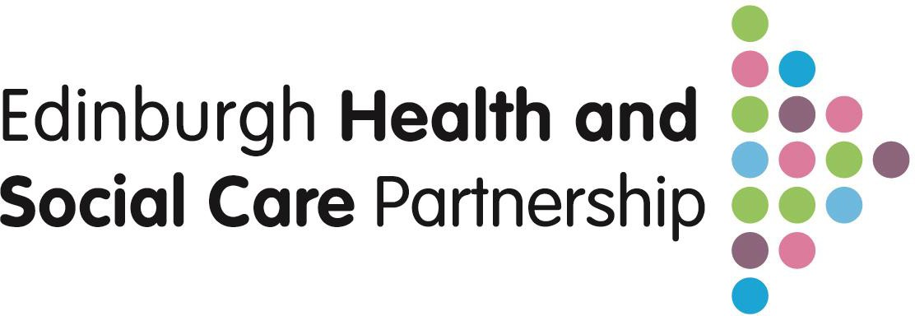

**More Good Days**

Health and Social Care Plan (2024-27)

**This is our Health and Social Care Plan (2024-27)**

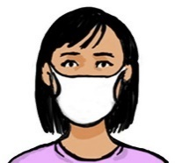

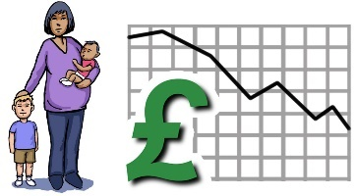A lot has happened since our last plan. The Covid pandemic has affected health and wellbeing. This has made inequalities worse. It has been harder for the most vulnerable in our communities.

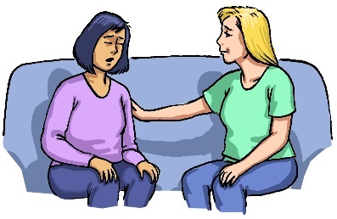

We need to help everyone at the right time in the right place. However, we need to help those that need it most first.

Difficulties since the pandemic:

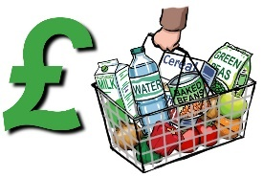

* a cost-of-living crisis
* 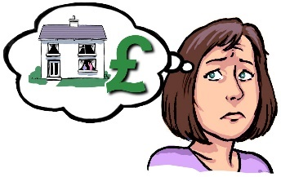a crisis in housing
* services under pressure
* financial difficulties.



We need everyone to work together to overcome these difficulties. Health and Social Care staff, voluntary sector and carers.

The pandemic made people work in new ways. People were kind and brave. We need to keep this feeling to deal with the financial difficulties.

Workforce strategy

Data and digital strategy

Medium term financial plan

**4**

Healthy and valued workforce and using our resources effectively

Partnership working to ensure sustainability

**ytainability**

Our behaviours

Tackle inequalities

Share resources

Involve communities and share power

Invite challenge, take action

Focus on names not numbers

Spread, adopt, adapt, be open

## **Who are the Health and Social Care Partnership?**

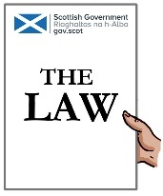

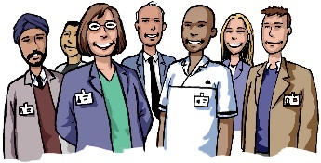The law says Councils and Health Boards need to plan services for adults. The Council and Health Board working together is known as health and social care integration.



NHS Lothian and Edinburgh Council integrated services are known as the Edinburgh Health and Social Care Partnership (HSCP).

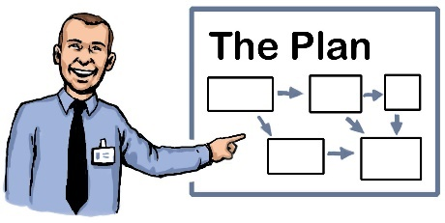

The HSCP is the staff from both organisations. They work in partnership to plan and deliver the services for the Integration Joint Board (IJB).

The IJB make the decisions about how health and social care services are delivered.



Our vision is to enable people living in Edinburgh to have more good days. This statement shows our plan is not just about services. It is about wider social factors.

## **Edinburgh Health and Social Care Partnership Priorities**

1. Wellbeing, prevention, and early intervention

We want people to have good healthy lives. We want to avoid problems before they happen. We want to help people as soon as we can.

1. Building resilient communities to maximise independence

We want communities to be strong and to work well. We want people to be as independent as they can be.

1. Protecting our most vulnerable

We need to look after the people in our communities that are most at risk.

1. Healthy and valued workforce.

We want our staff to be looked after and be as happy and healthy as they can be

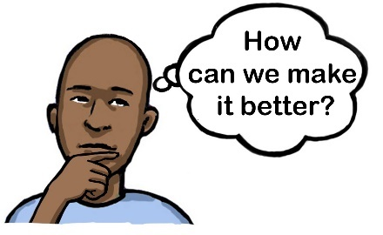

We will inform you of some of our plans for these areas. We will then ask you some questions about these.

1. **Wellbeing, prevention, and early intervention**

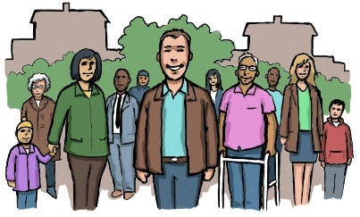There are wide social impacts on health. We will develop clean green neighbourhoods. Communities can come together. This will improve physical and emotional health.

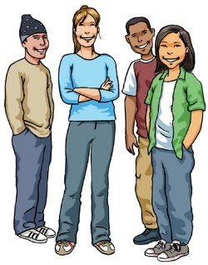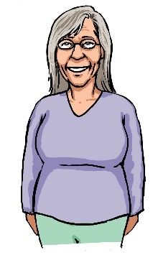

We will work with partners to make sure places are inclusive for all ages. Everyone can take part and local people have more control.



We will work with partners to support more people to help themselves. We will develop services based on evidence.

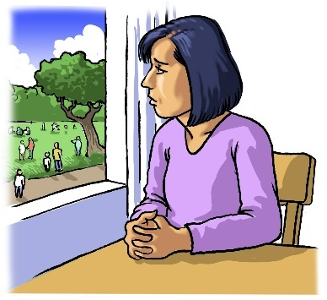

More people are lonely and socially isolated. We will support services and groups to be inclusive. Make sure staff can offer the right information on support and local activities.

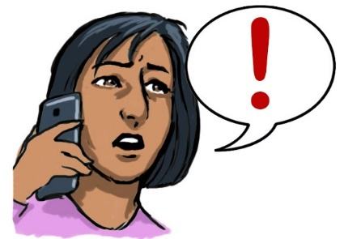Our current social care direct system refers people for social care support. We will update this so we can connect people to the right support at the right time.



We will have services that are based on evidence. We will work with 3rd sector partners to develop services. These will reduce poverty.

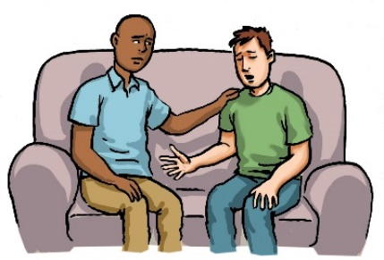More people are ending their lives by suicide. We will deliver the Edinburgh Creating Hope Together Action Plan. This was made to meet the outcomes of the national Suicide Prevention Strategy.

1. **Building resilient communities to maximise** A couple of doctors smiling

   Description automatically generated**independence**

Develop Primary Care such as G.Ps so they work as well as they can.

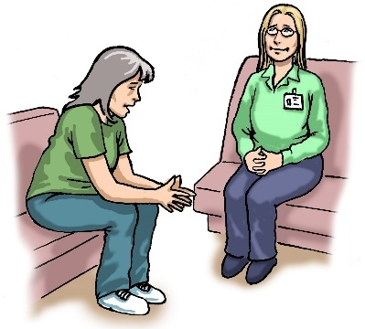

Understand the impact of trauma for people. We will make sure services are aware of trauma. We will support staff to deliver trauma support.

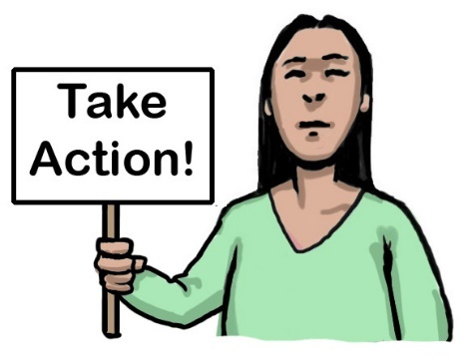Unpaid Carers not being recognised and feel overwhelmed and under supported. We will speed up actions in our Carers Plan. We will make sure carers receive the support they need. We know more women are carers.

Falls in the house can be difficult to manage and cause other issues. We will focus on how to prevent and how to work with people as soon as possible.

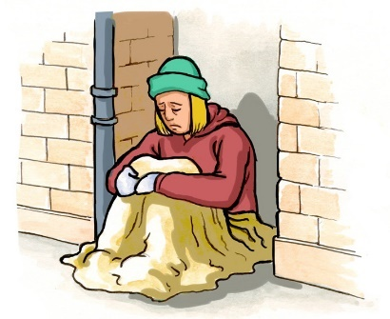

Too many people are in crisis. We will use evidence to understand people’s needs. We will provide support and care to prevent crisis.

We want people to be able to live at home as long as possible. We will use more technology support to help people do this.

We need urgent care support and community services to work together. This will reduce the need for ambulances or hospital support.

More people have poor mental health. We will learn from other teams to meet the needs of people. These teams work in partnership to provide ongoing support.

We want people to die well. We want to enable

people to spend their final years in their community and not hospital.

1. **Protecting our most vulnerable**

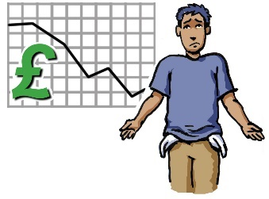

There are more people dying young in poor parts of the city. We will use more resources in these areas.

There are more adults under adult protection and mental health laws. We will make sure that all staff understand the law. We want to support people to make informed decisions.

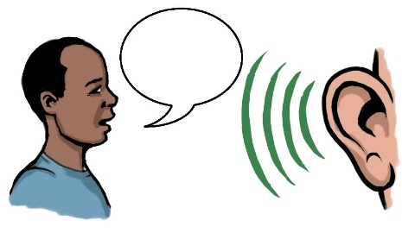

It can be hard to support people who suffer from barriers and inequalities. We will make sure staff are trained and have the skills to listen and respond to people’s needs.



It can be difficult to use our resources to support people with complex needs. We will use evidence to help us.

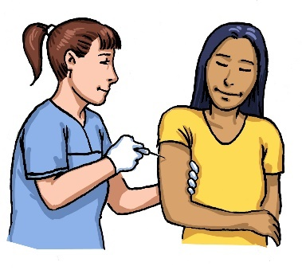More people to attend screening and immunisations. We will work out who is most at risk and offer support.



Poverty is a challenge. We will work to make local communities stronger. We will support community development.

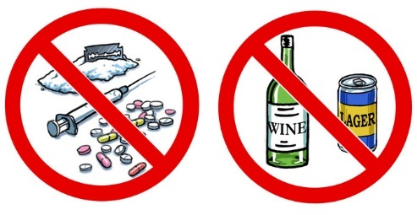

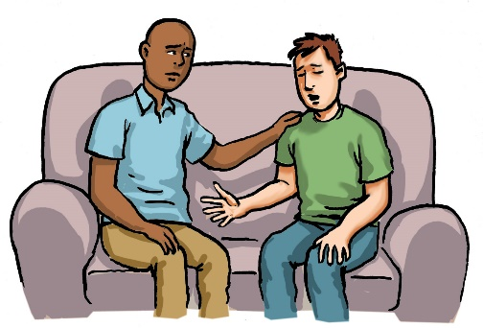There is a high number of deaths due to drugs and alcohol. We will support the Scottish Government’s plans for safe, accessible and good drug treatments. Edinburgh Alcohol and Drug Partnership will tackle the harm caused by alcohol and drugs.

## **4. Healthy and valued workforce**

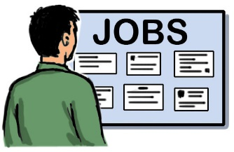

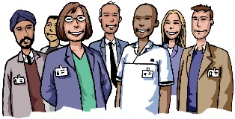It can be difficult to employ good staff. We will plan so we know when we need staff. We will promote working with us. We will work with partners to look at placements and college courses.

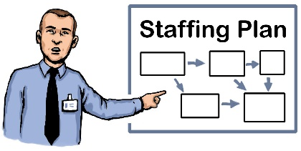

It can be difficult to keep good staff. We will make plans so that when staff leave it does not affect services.

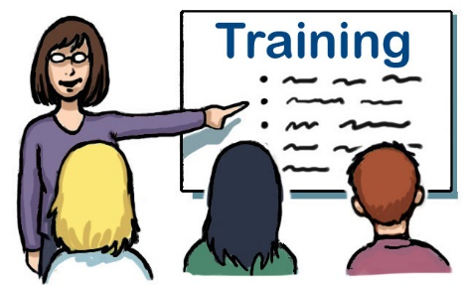

We will raise awareness of mental health and wellbeing information. Support staff who have health conditions. Make sure staff have time to access training.

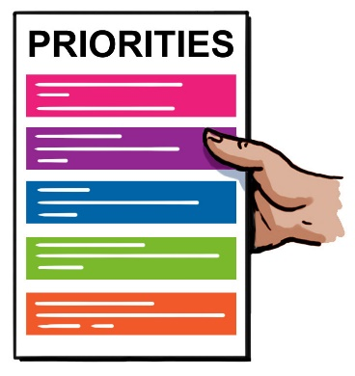

It can be difficult for staff to work on our priorities. We will speak with staff and develop a health and social care service we can maintain.

Staff will have digital skills training. We will offer support and training.

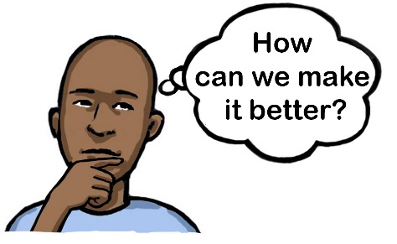

It can be difficult to have a balance to plan good services due to financial difficulties. We still want to plan good services.

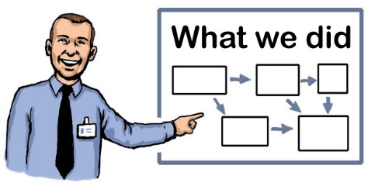

We need to use our resources and finances in the best way possible. We will be honest. We will use good data to plan our services.

If you or your team or group would like a member of the **More Good Days** Consultation team to come along to a staff meeting or if you would like to set up a meeting to discuss the draft strategy then please email [loth.moregooddays@nhs.scot](mailto:loth.moregooddays@nhs.scot) .

Easy Read document developed by FAIR Ltd. with Edinburgh Learning Disability Advisory Group (ELDAG).

Images © FAIR Ltd.