REPORT

118072

Arboretum Place to Royal Botanic Gardens cycling & walking scheme
Edinburgh

Public consultation event

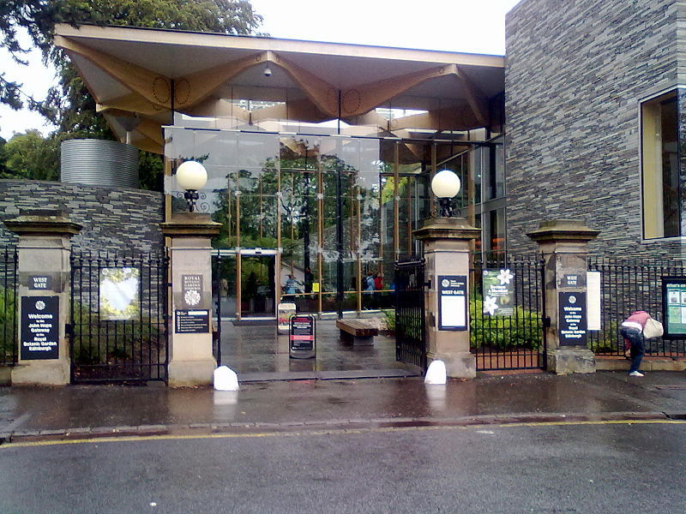

Contents
1 Introduction 3
1.1 Commission 3
1.2 Background 3
1.3 The Proposal 4
2 Methodology 6
2.1 Advertisement 6
2.2 Public Consultation 6
2.3 Data Analyses 6
3 Results 7
3.1 Participation 7
3.2 Question 1 7
3.3 Question 2 8
3.4 Question 3 9
3.5 Question 4 10
3.6 Question 5 11
3.7 Question 6 12
3.8 Question 7 13
3.9 Question 8 13
3.10 Question 9 14
3.11 Question 10 14
3.12 Question 11 15
4 Summary 16
Appendix A: Concept Design Visualisations 17
Appendix B: Example Survey 19
Appendix C: Question 1 – Further Comments 21
Appendix D: Question 2 – Further Comments 28
Appendix E: Question 3 - Further comments 34
Appendix F: Question 4 - Comments 42
Appendix G: Question 6 - Further Comments 44
Appendix H: Question 7 - Comments 50
Appendix I: Question 11 - Further Comments 58

Introduction

Commission
Sweco UK Ltd. was commissioned by The City of Edinburgh Council (CEC) to develop proposals to convert the circular area between the John Hope Gateway at the western entrance to the Royal Botanic Gardens Edinburgh (RBGE) and Inverleith Park into a new public space.

Background
The scheme is located on Arboretum Place between the west gate of the RBGE and the east entrance of Inverleith Park as shown in Figure 1.1. The area between the entrances is a large circular carriageway which forms part of the through road where the 20-mph speed limit complements the areas’ use as key attractor for people using the Park and visiting the RBGE. The road is also used by drivers during peak periods to avoid congestion at the Goldenacre traffic signal junction. The circular area is used as car parking with eight enforced disabled bays marked on the east side and two large bay areas on the west side. The west side parking is doubled parked during the weekend when there is no parking enforcement and vehicles park indiscriminately. There is also a semi-permanent vendor of ice creams and snacks that is located adjacent to the south of the Inverleith Park entrance.
A previous outline design was produced to improve the public realm here and create a better link to/from Inverleith Park and make it easier for people to cross the road. This proposal centred on creating a better public space for visitors to enjoy and remove hazardous parking which can create problems for people crossing the road.
In partnership with the Council we were appointed to develop the previous plans and make any necessary improvements and provide final designs with costs estimates for implementation at a future time. The design should:

- Improve the landscape and public realm around RBGE western entrance gate;
- Provide crossing facilities for pedestrians such as a raised table, narrower, zebra crossing etc;
- Align with the redeveloped Waverley Bridge;
- Maintain taxi rank, bus stop, disabled parking places and the ‘ice cream van’; and
- Improve cycle and scooter parking.

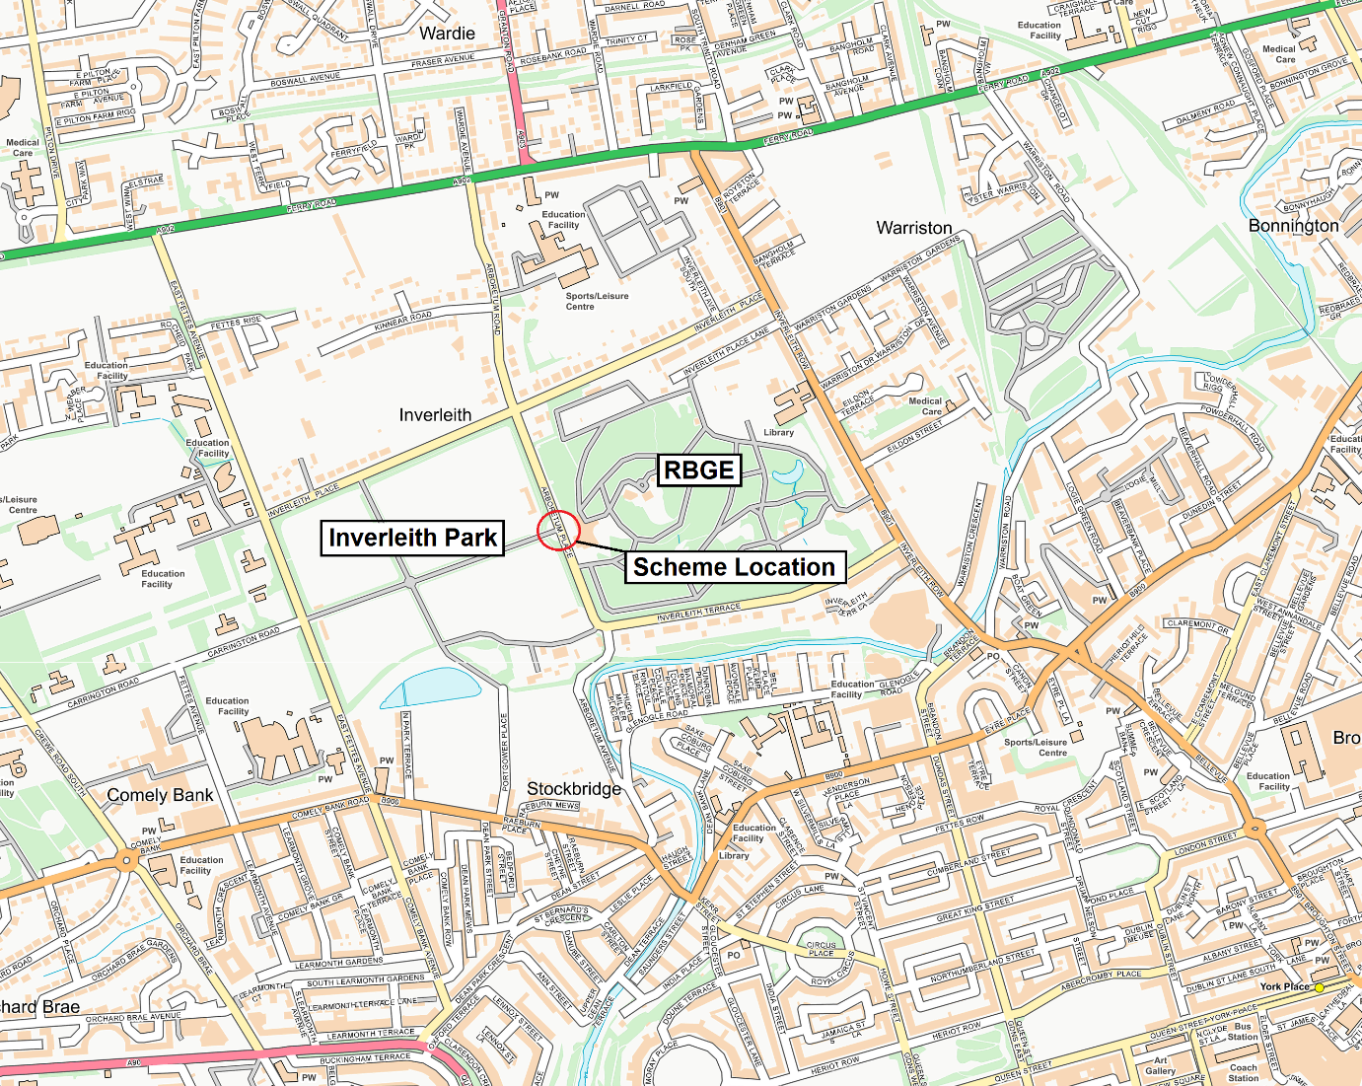
Figure 1.1 Location plan

The Proposal
The proposal is to create a space more suitable for pedestrians and cyclists with retained disabled parking at the kerbside. Working with the RBGE a mix of tree species will be selected to provide interest throughout the area. New seating, lighting and crossing will allow to enjoy the space and move through the area more easily and safely.
As part of any design development process, stakeholder engagement, is required and is one of the most important ingredients for successful project delivery.
To that end Sweco developed the concept design in the form of high quality visualisations that could be taken forward to a public consultation exercise. These visualisations are shown in Figure 1.2 & Figure 1.3 below, with larger views found in Appendix A.

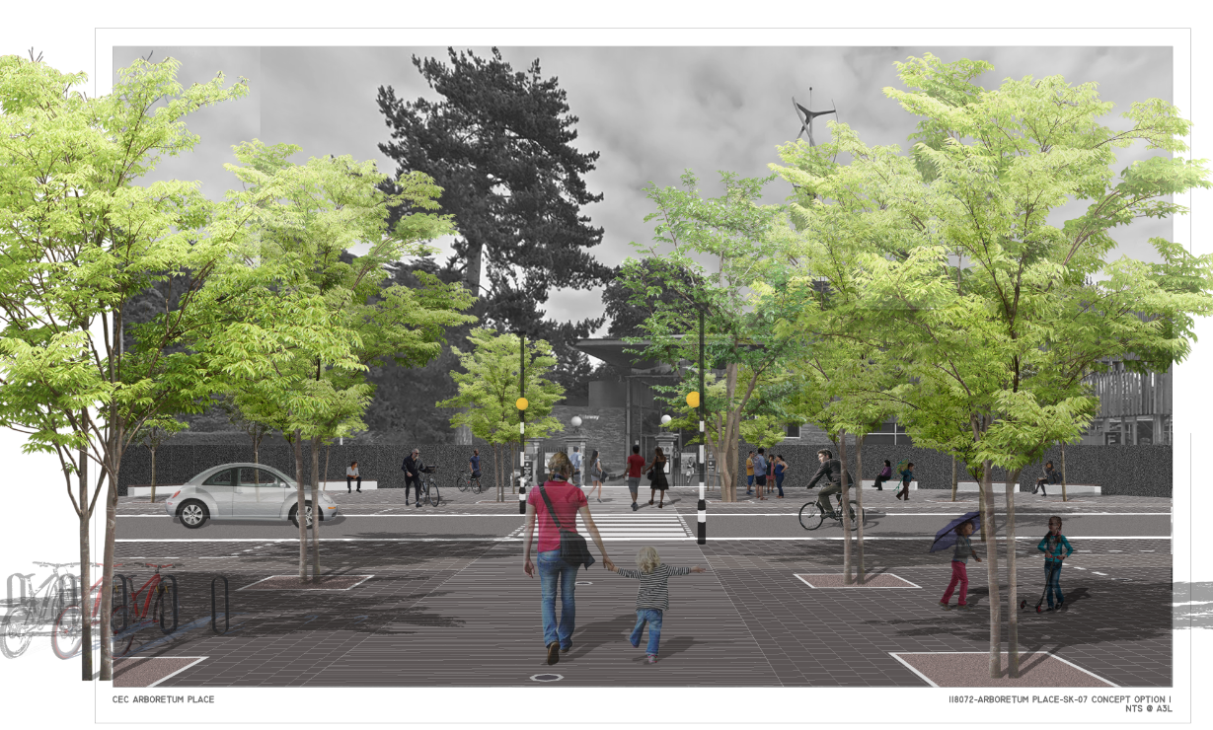
Figure 1.2 Looking towards the John Hope Gateway

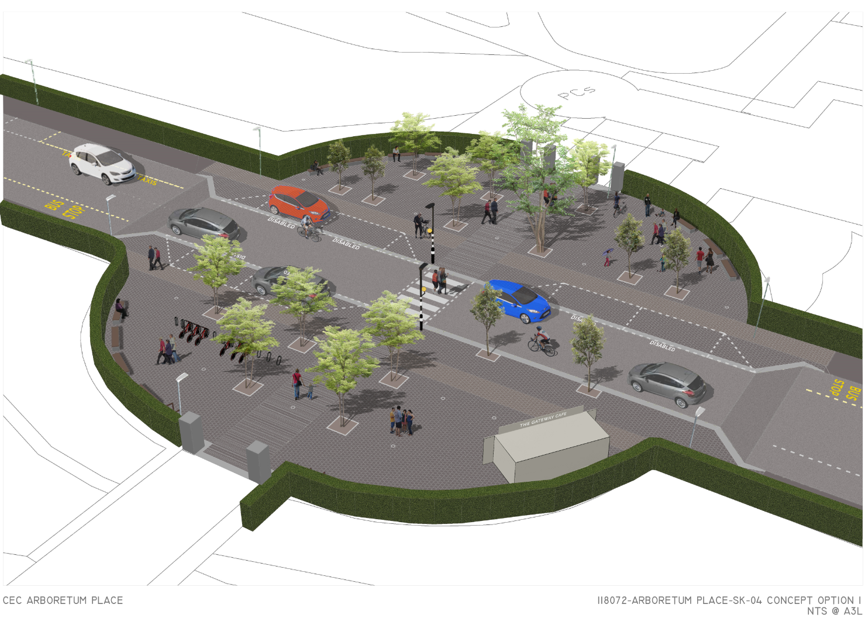
Figure 1.3 Birds eye view

Methodology

Advertisement
To get as much stakeholder engagement as possible the following methods were adopted to advertise the event. These were:
- Nearly 2000 leaflets were distributed to households within the area;
- Advertisement on the Councils internet;
- Advertisement on the Royal Botanic Gardens website; and
- E-mail invitations to the ward councillors, MSPs and the community councils.

Public Consultation
Two informal drop-in sessions were held in the Science room of the John Hope Gateway Centre (RBGE) and one at the Inverleith Park Festival of Walking and Cycling. The two events held at the RBGE were held from 2 pm-6 pm on Friday the 31st and then again on the Saturday between 10 am and 2 pm. The event at Inverleith Park was held between 1 pm and 4 pm the following day. Informal drop in sessions were adopted as the best way to obtain as much feedback as possible as they can provide the desired one-to-one, personalised, hands on discussion which most people feel most comfortable with.

The event was staffed by two staff members from Sweco and one from the Council to allow three sets of visualisations be placed around the room and allow attendees an opportunity, and plenty of space, to view the visualisations and ask questions. They were then asked to complete a survey at the venue or at a time of their convenience, via the online survey.
It is understood that weather conditions can influence the level of footfall attending the public consultation events. However, the weather on three days were dry with temperatures around the 17-20° C which may have helped with the good turnout.

Data Analyses
A number of paper surveys were completed and collected over the three days whilst the larger amount was received through the online survey portal ( https://www.surveymonkey.com. ) which remained open throughout the month of September and contained the same questions as the paper version. A copy can be found in Appendix B. This report summarises the results from these surveys and is discussed in the next chapter.

Results

Participation
A total of 301 surveys were received with 102 paper surveys over the three days public consultation, and a further 199 through the online survey.

Question 1
‘Do you support the aim of improving the layout of the area for pedestrians?’
As shown in Figure 3.1 63% (189) stated that they strongly supported improving the area for pedestrians against 5% (14) that strongly opposed it.

Figure 3.1
Participants were then asked if they would like to provide further comment of which 122 did so and are provided verbatim in Appendix C.
The most common ones were about safety in the area, both pedestrians crossing the road and traffic speeds on Arboretum Place. There was also comments around car parking spaces, many were in favour of less cars however there were a number that did not support this.

Question 2
‘Do you support the aim of improving the layout of the area for cycling?’
291 participants completed this question and the results are shown in Figure 3.2 below, which show 46% (133) of participants stated that they strongly supported improving the area for cyclists against 5% (14) that strongly opposed this.

Figure 3.2
Again, participants were then asked if they would like to expand on their view, of which 106 did. The most frequent type of comments where around safety, both for cyclists using the space and pedestrian’s safety from cyclists. Many comments thought that the proposed design did not provide any improvement for cyclists with others wanting to see this scheme tied into additional cycle lanes or routes through the park. A full list of responses can be found in Appendix D.

Question 3
‘To what extent do you support or oppose the proposed design?’
290 participants completed this question and the results are shown in Figure 3.3, where 40% (116) of participants stated that they strongly supported the proposed design, against 7% (20) that strongly opposed this.

Figure 3.3
120 responders provided further comment and are listed in Appendix E. The most popular ones were:
- Support of the need to retain disabled bays or the number;
- Mixed views on the installation of trees in the space, many support, and many do not;
- Coach drop off location queried, with some stating multiple bus drop offs from cruise ships;
- Support of a crossing point however some feel a signalised crossing point would be better;
- Many feel the design is too ‘dull’ with many hard surfaces; and
- Support of traffic calming measures.

Question 4
‘How often do you come to the area? (Please select all that apply)’
Of the 280 participants, 314 answers were collected as multiple options could be selected. As shown in Figure 3.4, 51% (160) stated that they visited more than once a week with only two visiting once a year.

Figure 3.4
Of the 280 participants 30 selected ‘other’ with the most frequent comment that they are residents of the area or use/pass through the scheme location daily. A full list of answers can be found in Appendix F.

Question 5
‘How do you normally travel to the area? (Please select all that apply)’
Of the 292 participants, 467 answers were collected as multiple options could be selected. As shown in Figure 3.5, 51% (236) walked to the area with 23% (108) arriving by private car.

Figure 3.5

Question 6
‘To what extent do you support or oppose the changes to parking? (Removal of 11 spaces from the circular area and conversion of 6 spaces from pay and display to disabled, leaving 98 pay and display bays on Arboretum Place)’
289 participants completed this question and the results in Figure 3.6 show 47% (135) strongly supported the change whilst 7% (19) were strongly opposed to the proposal.

Figure 3.6
Again, there was an opportunity to expand on their selection with 112 responses collected and all detailed in Appendix G. These comments include:
- Support of the need to retain disabled bays or an increase in disabled bays;
- A mix between supporting parking removal and opposition it;
- Many worried about the provision for buses and
- Many worried about private cars dropping off elderly or disabled reduced in design.

When considering the 108 that responded in question 5, by saying they arrived by private car, 35% (38) strongly supported the changes in parking stated above and 25% (27) supported it. At the other end of the scale 13% (14) strongly opposed it with a further 15% (16) opposing it.

Question 7
‘Do you have any other comments about the proposed design?’
Participants were asked to provide additional written comments on the proposed design of which 142 responses were received, including:
- Pedestrian safety important;
- Many different opinions in support and opposition to the installation of trees;
- Many commenting on the condition of the road surface, not limited to the scheme locus;
- Support of a pedestrian crossing, some wanting signalised;
- Further cycle parking; and
- Some questioning the need of the scheme in the first place.
A full list of comments can be found in Appendix H.

Question 8
‘Your age?’
290 participants completed this question and the results in Figure 3.7 below show the most popular age group was 45-54 whereas only 3 responders were below the age of 25.

Figure 3.7

Question 9
‘Your Gender?’
289 participants completed this question with the results shown in Figure 3.8 below which shows near parity on male/female responses.

Figure 3.8

Question 10
‘Do you have a long-term illness or disability that limits your daily activities?’
288 participants completed this question with the results shown in Figure 3.9 below. 88% (252) stated No and 8% (24) stated Yes.

Figure 3.9

Question 11
‘What is your ethnicity?’
294 participants completed this question and the results are shown in Figure 3.10 below. The most common answer was ‘White Scottish’ with 144 and the second was ‘White or other British’ at 86.
13 selected other and a full list of comments can be found in Appendix I.

Figure 3.10

Summary
Sweco was commissioned by The City of Edinburgh Council (CEC) to refresh previous concept designs and conduct stakeholder engagement to help shape the design development stage.
With over 300 responses, a third of which attended the event, shows that there was notable interest in the project. There was near parity in the gender responses with 232 people in the 35-74 age group.
The results reflect that there is strong support for improvements for both pedestrians and cyclists within the circular area. Although this should not be to the detriment of other road users by reducing parking availability or access to the area. There was support for more disabled spaces as the existing ones are very much fully utilised during the day and that the drop off zone should be retained as well as the bus stop areas.
More should also be done for cycling such as more stands to avoid having to secure to the railings. The need for more trees in an area where there is already a bountiful of trees, should be revisited, possibly with lower level planters.
There were 108 people that confirmed that there their preferred mode of transport to the area was by private car and of this amount 60% (65) were in favour of the proposal with 28 (30%) opposing it.

During the two events at the RBGE there was a lot of support of keeping the ‘ice cream’ van in its current spot with various attendees describing it as an ‘institution’ and even reminiscing about it, during their childhood. Having spoken to the proprietor, several generations of the same family have held this ’pitch’ for over 40 years.

Appendix A: Concept Design Visualisations

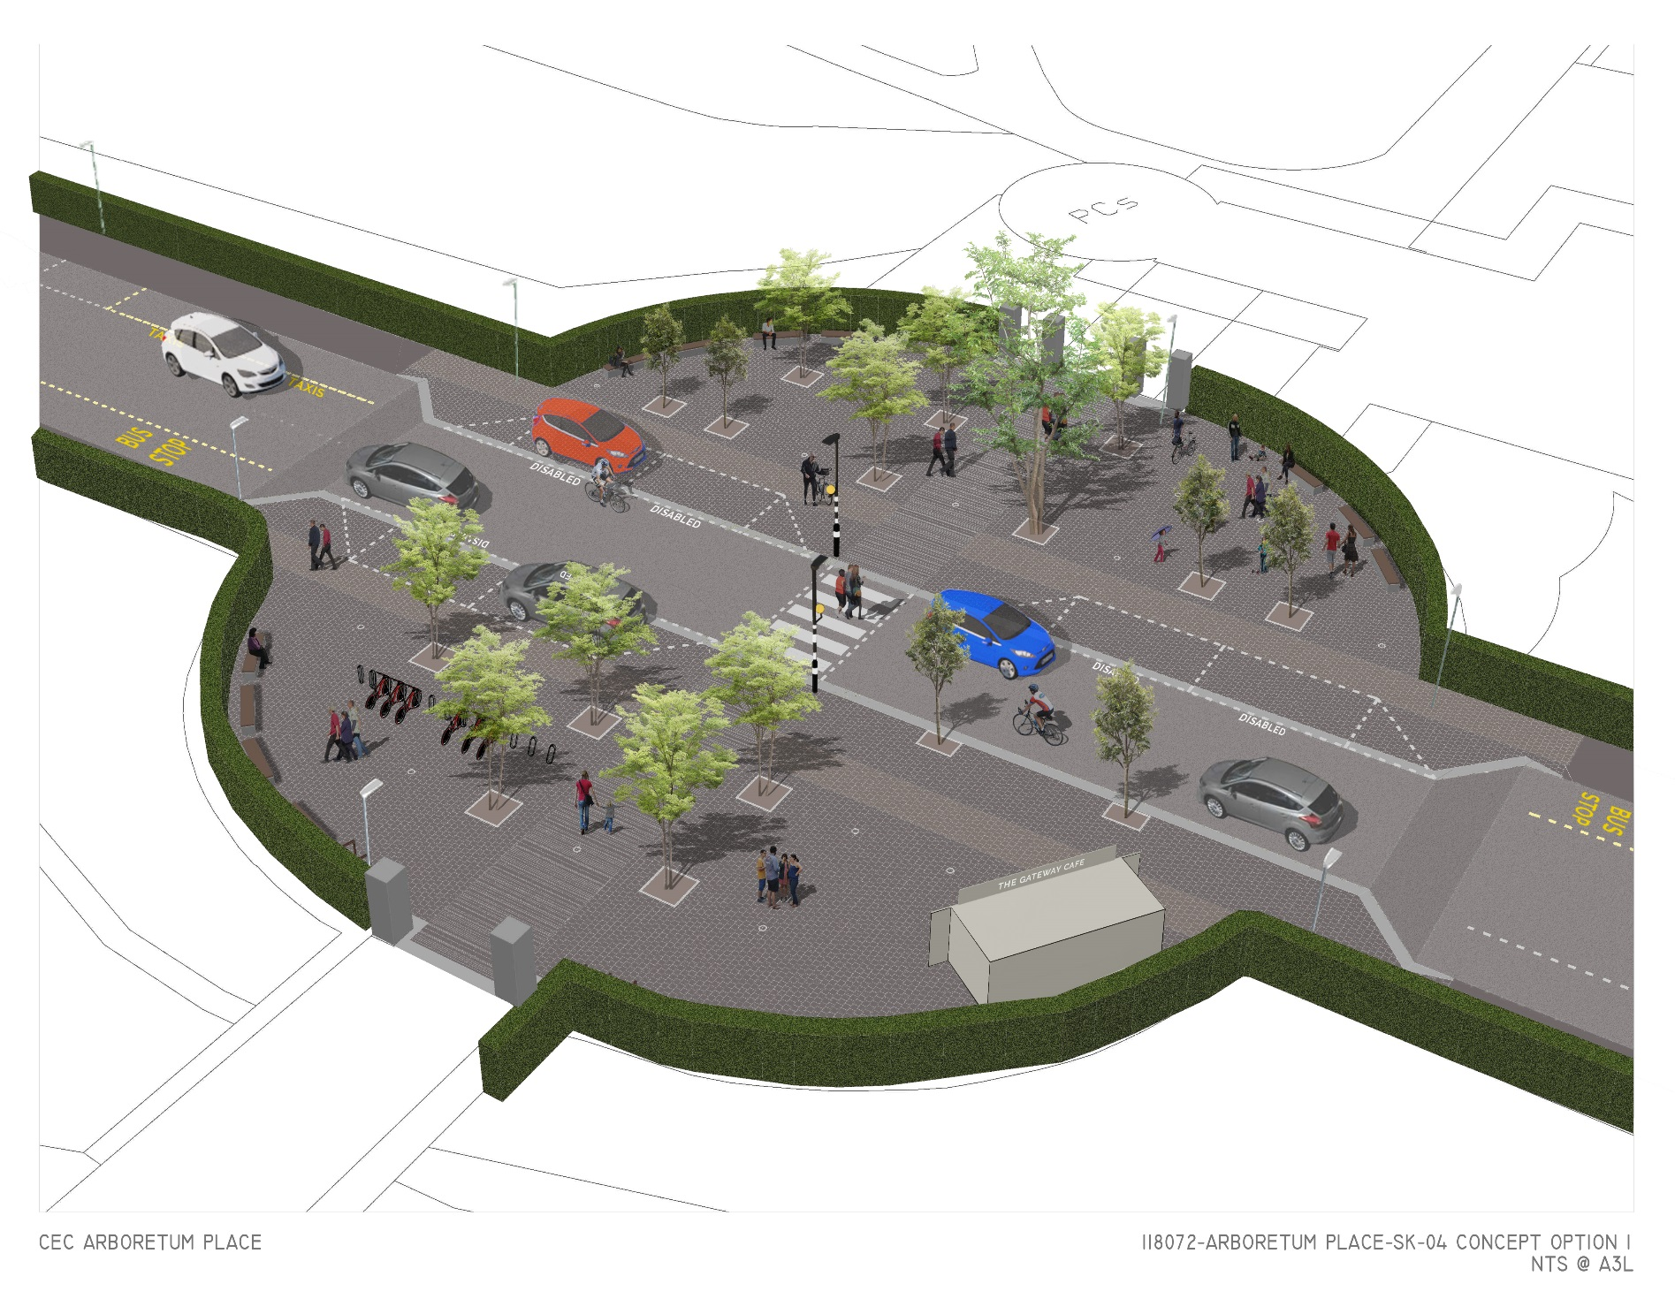
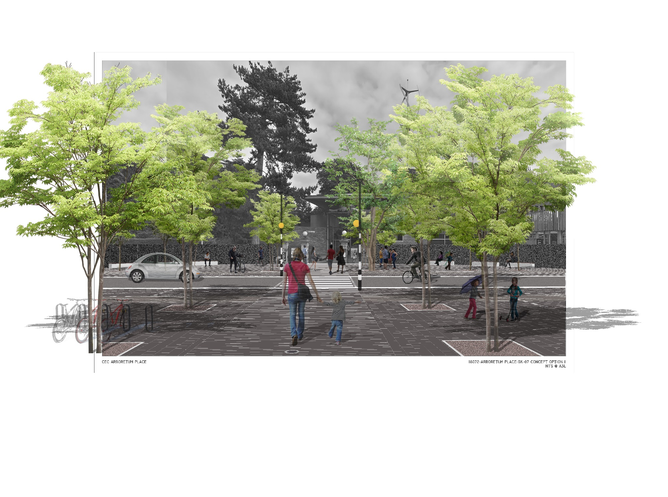

Appendix B: Example Survey
1. Do you support the aim of improving the layout of the area for pedestrians?
 | Strongly support | Support | Neither Support nor oppose | Oppose | Strongly Oppose
Please select which most closely reflects your view
Please use this box if you would like to expand on your view

- Do you support the aim of improving the layout of the area for cycling?
 | Strongly support | Support | Neither Support nor oppose | Oppose | Strongly Oppose
Please select which most closely reflects your view
Please use this box if you would like to expand on your view

- To what extent do you support or oppose the proposed design?
 | Strongly support | Support | Neither Support nor oppose | Oppose | Strongly Oppose
Please select which most closely reflects your view
Please use this box if you would like to expand on your view

- How often do you come to the area?
 | More than once a week |  | Monthly |  | Yearly
 | Weekly |  | Every 6 months |  | Other (Please Specify)

- How do you normally travel to the area? (Select more than one)
 | Walk |  | Bus |  | Train |  | Private Car
 | Bicycle |  | Tram |  | Taxi

- To what extent do you support or oppose the changes to parking? (Removal of 11 spaces from the circular area and conversion of 6 spaces from pay and display to disabled, leaving 98 pay and display bays on Arboretum Place).
 | Strongly support | Support | Neither Support nor oppose | Oppose | Strongly Oppose
Please select which most closely reflects your view
Please use this box if you would like to expand on your view

- Do you have any other comments about the proposed design?

About you
- Your age
 | Under 16 |  | 35-44 |  | 65-74
 | 16-24 |  | 45-54 |  | 75+
 | 25-34 |  | 55-64 |  | Prefer not to say

- Your gender
 | Male |  | Other gender identity
 | Female |  | Prefer not to say

- Do you have a long-term illness or disability that limits your daily activities?
 | Yes |  | No |  | Prefer not to say

- What is your ethnicity?
 | White Scottish |  | Chinese, Chinese Scottish or Chinese British
 | White or other British |  | Black African, Black Scottish, African British
 | White Irish |  | Black Caribbean, Caribbean Scottish or Caribbean British
 | White other |  | Arab, Arab Scottish or Arab British
 | Travellers |  | Prefer not to say
 | Asian |  | Any other mixed background, please specify below
Other (please specify)

- Please tick this box if you would like to be kept informed about the results of the consultation, and to contribute to further consultation.
Yes, I’d like to be kept informed
If you haven’t already provided us with your email address, please provide it below. We will only use this information to keep you informed about this consultation and to invite you to take part in further consultations on cycling and walking improvements in Edinburgh.

- Email:
If you’d like to provide feedback by letter, please post to:
Freepost-RTCHJJ-EK-TCCK, Arboretum Place – Active Travel, The City of Edinburgh Council, G4 Waverly Court, 4 East Market Street, Edinburgh, EH8 8BG.

Appendix C: Question 1 – Further comments
less pandering to cars the better, I drive but they ruin the places they are in.
I agree with a pedestrian crossing but think you should leave the current amount of parking spaces.
Yes, but I think that cyclists and pedestrians should be equally encouraged
What would help safety in the area and surrounding streets is police resource to enforce the 20-mph speed limit, very few drivers maintain a speed close to 20mph around there.
If you reduce parking and through put of cars why do you need to spend thousands of pounds putting in crossings and planting trees that the Council never maintains and will be dead within 5 years.
This area is dangerous with pedestrians walking from Botanics to the gate without looking
Quite unnecessary. 2 lovely parks on both sides of the road already.
I think it's about time pedestrians took back control of the road.
I am anxious about any possible reduction in the provision of disabled parking spaces. I don’t need one for myself, but I have several friends for whom they are a lifeline, allowing them to visit the Botanics, which is such a pleasure and can be therapeutic. Their experience is that there are already too few disabled spaces available.
Trees would be good - a pity the area can’t be car free. There is an urgent need for a safe crossing here
If you lose too many parking spots you need to compensate residents somehow. On the weekends - especially in the summer - parking is an issue since visitors can park on resident parking.
The current set up is dangerous for pedestrians and unnecessarily prioritises drivers in an area of high pedestrian traffic. This change is long overdue
I often cycle through this area. Now pedestrians, cyclists and motorists can all legitimately be sharing spaces near and its risky.
Inclusion of blue green infrastructure and sustainable materials.
Adding a crossing and removing most of the parking will have a benefit for pedestrians.
It is currently car dominated and unpleasant for those arriving by foot and on two wheels.
should you not make the vehicle carriageway one wide
and humped to slow the traffic, disabled bays should be square to the carriageway to lessen the impact visually to the pedestrians and to put off the high-end car users from risking making use of them
The current space is dominated by cars and makes the entrance to the Botanics very unwelcoming, especially if coming from Inverleith Park. This is a very welcome project!
It's fine as is. Parking required so leave it alone
And get rid of more parking, great! Why don't you stop buggering about with things like this and just fix the roads and pavements that we already have?
Even with the supposedly speed limit car still speed down that road and the double car parking in that circle makes it very difficult and dangerous to cross at that point especially considering it's the junction of two very popular area for families. The proposal is well over due I would even increase the cross to green lights etc
It's much safer for crossing and should slow the cars.
Insufficient parking in the area as it is and it’s useful to have disabled parking in the area.
Suitable usage by all people and vehicles already exists.
On a sunny day there is a strong demand for parking places and the park and botanical gardens are lovely, why sit in the road?
I drive this road often and think this will improve safety for pedestrians between the park and the Botanics and is just a good idea!
I'm concerned that the road will be difficult to use as a motorist. Also - where will the lovely ice cream man go? He is very much valued by the local resident community.
I don't really see it being a huge problem the way it is. live a 5-minute walk away and pass this area almost every day, sometimes on foot, sometimes on a bike and sometimes in the car. It is not a busy street and works fine the way it is. Council money should be spent on something else.
My only concern would be the reduction in parking spaces and where else would be available to park for access to the Botanics and the park?
close it to motor vehicles
Its fine this is being done. Not sure in whole range of needed improvements in area this is such a priority. But to be fair the Botanic Gardens has invested a lot so fair enough to mirror this nearby.
the problem, if it exists, is due to the closure of St Bernard's Row (and the widening of the pavement and therefore narrowing of Glenogle Road), causing the deviation via the park
For reasons of pedestrian safety, traffic speed control and natural aesthetic linkage between RBG and Inverleith Park.
It is currently a horrible car-focused environment. The proposals look so much more pleasant and safe!
We go to the Botanics a lot with our young daughter and it's not safe to cross Arboretum Place just now
This area is currently a vehicle dominated area that is in desperate need of changing. Two of the most important natural assets to the north of the city centre demands a strong connection for people of all ages and abilities to enjoy.
It looks over designed with little aesthetic input. An opportunity for some real ideas to come forward yet this design is generic to most city centres. Making the road become seamless using cobles or such like slows traffic and makes a unified look between road and pavement.
I fully support this excellent plan. It is good to see a zebra crossing to give pedestrians priority but non-compliance with the speed limits is a problem that needs to be addressed, perhaps some speed displays on approach.
Looks good. Would like to see more seating and ensure that traffic really slows down to allow safe pedestrian crossing. How does cycling movement work?
Safer road crossing needed
At weekends the road would become unusable by cars as the plan currently stands. It would be workable if there were traffic lights instead of the zebra crossing because the numbers of pedestrians can be very great which would bring traffic to a stand still.
I have lived in Edinburgh for 11 years, have young kids, and this is probably the crossing I have worried about most. Cars drive really quickly, and with the chaotic parking on the sides in the circle currently, it is a minefield. *Delighted* to see a dedicated crossing, and parking removed, except for marked disabled spots
Significantly better for people, much better that the crap car park it is now.
The present area is a free-for-all. A safe pedestrian crossing is needed.
Long overdue. Pedestrians currently have to run across a wide road which has traffic typically exceeding 20mph.
I think it will cause more problems than it solves. Most of the current problems are caused by the disabled spaces, the taxis dropping people off and the large coaches, none of which will change. Cyclists locally have poor road skills and pedestrians yet again will be the losers.
I support the aim but not necessarily the proposed plans
An excellent idea. Why not go all the way and close the road off to cars other that taxi and disabilities
There is a severe lack of suitable car parking options. In the area
The one improvement to pedestrian flow would be a pedestrian crossing either to the north or south of this turning area.
As a local resident and parent of young children, I am very concerned with the reckless driving exhibited in the area, anything that can be done to make it safer for pedestrians would definitely get my support.
This is currently quite a dangerous area with cars travelling rather fast, so I think the proposed improvements look great!
It would be safer for children and elderly people to cross that way. It would also reduce the speed of the cars who use it at peak traffic time as a short cut.
I would like to see improvement for pedestrians everywhere not just here.
It can be hard to cross normally, even worse with small children and elderly, cars speed down here.
Nice idea to bring the Botanics outside the gate.
More pedestrian and cycling are good.
Anything that reduces the speed of cars will be welcome, the police are obviously not interested, and it is only a matter of time before there is an accident. One has to say that the use of trees may reduce the sight lines for pedestrians seeing oncoming traffic. One also must question the need for cyclists when the recent plans for a cycle route went along Inverleith Place to the park entrance opposite 82 Inverleith Place. If the cycle route returned to Inverleith Terrace, then this proposal would make more sense.
It is currently a danger point
I support this if sufficient parking is provided for disabled drivers, coach drop-off points etc. This does not look as if it has been considered.
It is currently a danger area
Proposal does not improve the layout for pedestrians, who will be harder to see when you fill the wide open space with street furniture. Anyway, people can cross the road perfectly well already. This is just an excuse for the council to throw money to their SWECO buddies.
The proposed scheme risks reducing pedestrian safety and would create an ugly chokepoint of street furniture in one of Edinburgh's most beautiful, historic, wide, open streets. The existing layout creates excellent visibility for pedestrians, drivers and cyclists. The proposed design would reduce visibility for pedestrians and motorists due to the proposed trees. You could consider keeping the current layout but restricting parking near the gates to ensure good visibility is maintained at all times.
Yes, but don't forgot those who have little practical option to car use.
Current space very wide - especially when you have children in tow
Should have been done.
Space for safe drop by coaches /tour bus
Yes, it really needs it!
The areas outside the park/gardens is a bit of a 'free for all' especially at weekends so i believe something should be done.
It's so busy it self-regulates
Great contribution for access from /to both facilities - safety really enhanced
A zebra crossing is welcome. The plan is a waste of money
Needed - we sue the park and gardens almost weekly.
Please don't use slippy paving remember the weather we get.
The turning circle is in my view dangerous to pedestrians and needs to be improved for crossing.
I live in Stockbridge Colonies. I would object strongly if there was further hinderance to the ability to travel to the west i.e. a closure of Arboretum Place to road vehicles. Most journeys to the west of Edinburgh I cannot undertake by public transport.
Yes, but as cars/buses will still be using the caution over layout making it pleasurable for pedestrians.
It’s much safer as traffic has to slow down. It looks more welcoming for visitors.
Litter bins and recycling large underground storage like ones in Grassmarket.
Basic proposal very good. Choice of surface material crucial: would be good if public given chance to see options for this.
There is no public transport for pedestrians to the west gate. LRT at one time provided a summer service from there to the centre of town but that has disappeared, and visitors would normally travel by bus to the east gate.
anything to make access safer is welcome
Given this situation between gardens and park is it a good idea to encourage pedestrians including children to wander about on the edge of a busy road.
Pedestrian corridor is necessary to connect two green areas of which is a major international visitor attraction in Edinburgh.
Has been an ongoing issue for several years - minimum - crossing must be provided.
This is bringing pedestrians closer to traffic which increases risk of accident, especially since they will be in the frame of mind they are in a pedestrian zone especially tourists.
Concerned that by placing trees or shrubs in the pedestrian area that you will obstruct drivers view of anyone trying to cross the road (especially children running around not under adult supervision) Will there be any form of fencing to direct people to the crossing point ?
I think the area needs it, the 20mph limit is seldom adhered to and the area is becoming more and more a bub for people to enjoy the park and botanic garden.
I think the area needs a traffic calming strategy. Making this green and pleasant, as a link between Botanics and Inverleith Park is a great idea.
I live and work nearby and am a regular visitor to both Inverleith Park and the Botanic Gardens. I feel that some sort of traffic management is long overdue. Despite measures such as the introduction of the 20mph zone , the wider, less congested nature of Arboretum Place and the surrounding streets means that many drivers use this as an opportunity to increase speed. At the section of road in question, between the park and gardens, It feels that the risk of a serious accident is particularly high as the speeding traffic passes through a zone where many pedestrians congregate and taxis, buses and coaches disembark their passengers, many of whom are either tourists, young or elderly and who may therefore have a less immediate sense of the danger. The risk is increased by the use of the circular area for loitering traffic, car parking and the tendency for some road users to patrol the stretch of road outside the Gardens entrance until a parking space becomes available. Those doing so tend to perform non-standard actions (U-turns, sharp braking, crawling) and force other traffic to take evasive manoeuvres thus increasing the unpredictability for pedestrians.
I feel that what is needed is a system of traffic management that consciously and subconsciously signals to drivers that this section of road is the domain of pedestrians rather than traffic and that to speed is dangerous. This could be achieved through a narrowing of the roadway, a change in type or elevation of road surface and installation of bollards/trees and other visible delineation of the area. There also needs to be a reduction of the space available to traffic in the circular area and for some distance either side in order to deter vehicles from loitering/parking/manoeuvring in close proximity to the entrances. Finally, I'd like to see a pedestrian crossing that firmly places the priority on pedestrians over traffic.
Will be good with seating areas outside and the link between the gardens and park is ideal.
A safe pedestrian crossing between the Botanics and Inverleith Park is long overdue.
The rather random parking within the circle creates an unusual hazard
Cars drive far too quickly down here. It is a natural thing for people to wander out of the Botanics through to Inverleith Park. Anything that makes this transfer more safe and pleasant is a fantastic addition
And cyclists
This is currently a dangerous crossing - particularly for children, young people, elderly and people with restricted mobility. The 20mile per hour speed limit has helped, but unfortunately not all drivers observe this.
Traffic calming measures and a pedestrian crossing is very much needed.
Bike parking should for all new developments be lit and have CCTV to encourage the use without cycles being stolen.
I have found it difficult to cross the road here with children - which is a common requirement to a) access car parking on other side of street b) to get to the ice cream unit or c) to access Inverleith park from the gardens
changes not required
It is essential to maintain a safe separation between cyclists and pedestrians
As a local resident and a cyclist, I see no demand for this development. I use the park and the Gardens as two separate amenities. You cannot cycle, run nor take pets into the Gardens. This means we are losing parking places for no extra amenity. Parking at the park gates is generally cheerful and non obstructive and itself acts as a calming measure on through traffic.
Two major public spaces that need better pedestrian access between them.
Many people visit both the Botanics and the park and I have always felt a pedestrian crossing between the two would make the area safer. This proposal makes it more aesthetically pleasing too. I am pleased the ice cream van is being included in the proposal.
crossing between the two parks is very difficult just now. I regularly make this crossing with my 5 year old daughter and the traffic speed and volume is off putting
Great idea!
Would it be possible to put in a crossing between Fettes & Newfield hockey pitches on East Fettes Avenue as this is a very dangerous busy road with lots of children crossing to get to & from the hockey pitches?
Safety is a huge issue for pedestrians attempting to cross the road in the area of the proposed developments at Arboretum Place. The road is incredibly wide at present and cars often break the speed limit - very dangerous for pedestrians. The new proposal would slow traffic and create a safer environment for pedestrians, allowing them to cross with relative ease.
Whilst I support the scheme in principle, I am much concerned by the reduction in disabled parking facilities while the number of disabled people in society continues to rise. I cannot imagine that 4 spaces give any realistic possibility that a disabled person can make plans to visit the facility and not have to risk turning around and going home again because there is nowhere to get out of the car. The plans should be upgraded to have one disabled only drop off space, and the taxi and bus facilities further down the street to accommodate more disabled parking - at least 8 bays in addition to the drop off, including at least one bay which will accommodate a van with tail lift.
traffic restriction essential to improve safety and enhance environment
Provided disabled parking is retained, and the ice cream van, this will improve both the appearance and safety of the area. Currently it can be difficult to cross the road.
It would be nice if this wasn’t a through road at all, why cars have to drive along arboretum place, there’s no housing north of the gate surely it would make the area nicer if the whole road was closed.
Also, it would be nice if there was a dedicated cycle lane along the road segregated from the carriage way. Or potentially make the turning circle into a cycle gate.
Concerned about where the funding is coming from. Higher Council Tax? Wonder if there was a better use in Edinburgh than the Botanics which is already lovely.
This is a key pedestrian crossing point between two major leisure sites, yet it is used as a car park and made unsafe by speeding traffic and manoeuvring vehicles.
The current layout caters entirely for cars/vehicles to the detriment of pedestrians and cyclists.
Please ensure that the current number of blue badge parking spaces outside RBG is at least maintained although it would be acceptable if some of these spaces were slightly further away from the gate than now.
Traffic lights would be better than zebra crossing which are detrimental to traffic flow and much safer for pedestrians
This is complete overkill. A pedestrian crossing would suffice.
More seating required for visitors to the park and botanical gardens. Lots of benches and an improved bus stop with seating would help the many tourists who stand in the rain without a seat. Plus easier to cross the road.
A pedestrian crossing is good.
Currently sometimes difficult to cross at present - very wide street at the gates, and cars DO NOT stick to the 20mph limit
This is the main entrance to a very important visitor facility and as such needs to be as welcoming and easy as possible catering for all physical needs
this is tremendous
I do agree that a zebra crossing would be a good idea however I do not agree with the proposed plans for removing disabled parking bays and planting trees

Appendix D: Question 2 – Further comments
cycling around Edinburgh should be easier than it currently is more infrastructure for cycling the better.
As before, yes but you should leave car parking spaces.
This design does not improve the area for cycling
cyclists have to obey the Highway Code too many have a cavalier attitude to pedestrians
As before, a resource to actually enforce the 20mph speed limit in the area would help to make the roads safer for pedestrians and also cyclists
The funnelling will be dangerous to cyclist. Especially less confident ones, who will cycle near to the edge, in the bus stop / lane and then have to merge into the narrow bit in front of the gardens.
There should be clearly painted wide cycle lanes through the narrowed bit and extending straight out for a bit to give cyclists and motorists plenty of time to adjust to the narrowing road.
Further, there seems to be no consideration for cyclists coming through Inverleith Park
I would go further. I think all road and pavement users would benefit from a dedicated cycle route installed on this road.
I can’t tell from the illustration where the cyclists would go. My feeling is it should primarily be an area for walkers, with generous provision for the disabled.
However, I am very worried at the way some cyclists behave. They ride through Inverleith Park at high speed with no regard for pedestrians or dogs. They have no speed limits and modern bikes enable bikes to go very fast. I want to see care taken in the design to cut down the speed of cyclists in the area.
Don't see how it improves the cycling?
Active travel is a vital part of a healthy city and design should support both walking and cycling ahead of driving in this kind of area in the city
I have cycled in Edinburgh since 1981 - another improvement first cycling. Yes please.
Segregated cycle ways are crucial
Aside from secure bike parking facilities, this isn't really an improvement for cyclists, except for general improved safety from cars no longer being able to park there. Proper bike lanes and access would be most welcome.
Currently feels dangerous for cyclists despite the width of the road. There is plenty of space available to improve for all, and to make more pleasant and safer for those not using 4 wheels.
how does the cyclist get there in the first place?
Again, the area is dominated by cars and I'd feel very nervous about letting my wee girl cycle in this area what with all the cars manoeuvring in and out of parking spaces. This project should greatly improve safety for family cyclists.
Stop being anti cars
There is no need. Cyclist of which I am one can look after ourselves simply by obeying the high way code
It's pedestrians at greater risk
As a cyclist.
See previous comment.
The RBG in particular attracts visitors from a wide catchment area much of which is beyond practical cycling distance. Many of its visitors are either elderly or have young children
Our lives are not lived for the benefit of cyclists alone.
I would support keeping cyclists away from pedestrians.
It depends - the cyclists on this road often ride fast and without due concern for pedestrians. If this would help reduce this then yes...
What is the problem with it at the moment? I regularly cycle through here with no problems.
dedicate a cycle lane through the Botanics at the same time
cyclists need to pass a test as many of them are unaware of the rules in the Highway Code - giving them priority would just cause more problems
As long as cycle provision is observed and imposed.
I use my bike here occasionally and when busy it can be a nightmare to cross.
You are not able to cycle through the Botanical Gardens so why should/would cyclists require to be included in this development?
More people cycling is better for safety and air quality (as long as they're cycling safely, of course!)
Walking should be a priority but also to improve for cycling to ensure a reduction in traffic.
This is a great aim; Edinburgh City Council needs though to look to Nordic Countries rather than develop plans internally using non cycling planners. These ideas never work for Edinburgh.
Not at expense of pedestrian movements.
Can’t see why it need to change for cycling, roadway is there, and cycling permitted in Inverleith Park.
Strongly support improvement of cycling everywhere in Edinburgh. I don't currently cycle, or let my kids cycle as a means of transport -- far too dangerous in this city. They cycle only in the park. Very sad.
Cyclists will approach this area from three different directions, north, south and west. If they are to be encouraged to park as soon as they enter the area and not cycle around in it there will need to be cycle parking on both sides of it.
Consider implementing separate cycle lane along Inverleith Terrace to link up with this plan.
Cyclists often have very few road skills and are not interested in the safety of pedestrians. Children cycling on pavements are a hazard for older people and small children walking
I believe that cyclists are currently adequately accommodated and do not need extra specialist considerations
Cycle path around the perimeter of the Botanic Gardens and link to Eildon Street
There is a lack of awareness amongst cyclists of pedestrians they ride on pavements etc I doubt this plan will encourage better behaviour
I cannot see what this plan does to improve area for cycling - there will still be traffic - which will have to negotiate humps, buses, pedestrians etc etc. Bicycle parking would be appreciated, but they can still be installed in the existing plan.
Very supportive of make this area safer and linking it up with other cycle routes
As everywhere else in Edinburgh we need to make cycling safer, so yes I strongly support.
It's quite an important through-route for cyclists, and one that I use regularly. I always feel as a cyclist that I'm 'squeezing' my way through an area that isn’t designed to accommodate bikes at all, with potential conflict with cars. Anything which improves things for both cyclists and pedestrians is a good thing, and they should be prioritised over passing traffic. Local needs and a sense of place are far more important in this locality than the needs of through-traffic.
I don't think it does improve it for the cyclists! Bike racks need to be at the Botanics gate not on park entrance! Cycling along Arboretum Road is not straight forward but will be impeded by the new proposed layout. Definitely need more bike parking than currently is as they're nearly always full.
Should retain some cycle parking provision.
Some clarity needed on how cyclists heading south will turn right into the park
Uncertain of benefits for cyclists, no change to current route for exiting park.
I am a keen cyclist and in my view the project doesn't go far enough! What about cycle lanes along Arboretum Road - it is a big wide road. There must be enough space, it would also provide alternate cycle routes to the busy Inverleith Row.
If you want to make it more attractive you need to reduce the number of cars and make it more attractive to cycle to the gardens i.e make the surrounding roads more attractive to cyclists and less attractive to cars.
Trying to incur more cycling and parking is good.
See previous reply in 3
Make no real difference
Unless the cycle path is allowed to go straight through the Botanics, I can't see how this will be improved.
Have you ever been on a bicycle? Have you seen the crazy things cars do when the road suddenly narrows? This proposal is dangerous to cyclists. How about giving us cycle lanes instead?
The proposal is potentially unsafe for cyclists. The current layout (wide street) creates safe opportunities for motorists to pass cyclists. Chokepoints like the one proposed present a risk to cyclists. The proposed layout will make it harder for cyclists and pedestrians crossing to see each other. As an alternative, to improve the layout of the area for cycling, you could add a cycle lane and some cycle locking facilities in the current parking spaces.
Not all can use a bike.
Can be part of main cycle route
Hire cycle dock good to encourage tourists to cycle in
Very keen for traffic flow to be slowed down.
we try not to drive, but find the Botanics area very busy with cars.
Too much emphasis on community cyclists over pedestrians.
I support the aim but cannot see improvements for cycling from the drawings shown. No cycle parking for private bikes (except e-bikes) and no cycle lane.
Too many cyclists hold up other traffic
Would like a separate cycle path.
This area is used by older people who need parking as close to gates as possible.
Space is currently wasted.
As this is principally a plan for pedestrians suggest encourage cyclists to dismount in this area!
Cycling stands to be at edge of area to take up less space.
I don't see where the cycling improvement is
Many cyclists are a real danger to pedestrians and those in Inverleith Park
Existing cycle rails are adequate, it is very unlikely that many visitors especially older ones will be cycling.
Too big an area given to cycles - racks etc - they are mobile - why not use an area for racks further away or inside park gates.
Cycling is one of the major transportation modes in Edinburgh and this area lies on route between city councils promoted 'quiet area network'
Cyclists use in conjunction with others. - Should be predominantly for pedestrians.
Unless pay and display is removed to give more space for cycle lane.
Would support this idea if the cycling community respected driver and pedestrian needs.
E bike hiring is a nice touch, it is green and puts Edinburgh in line with many other major cities. Bike lock points would be good, like the existing ones outside RBGE but turned 90 degrees.
No apparent additional cycling facility parking, not ideal.
Cyclists very frequently disregard pedestrian access, so this would cancel out the improved pedestrian access
Although the consultation mentions making the area more inviting for cyclists as well as pedestrians, the addition of a couple of bike racks smacks of tokenism and does nothing to improve safety for cyclists. As a generally less traffic-congested area there is an opportunity to create a segregated cycleway along the length of Arboretum place that could act as a useful connector between Stockbridge/Rocheid path and the wider Edinburgh cycle path network accessible from Granton Road. This would make the park and gardens more readily accessible by bicycle to those living in Granton, Drylaw, Muirhouse and Trinity which could contribute to a general reduction in vehicle use.
Edinburgh Council needs to be bold in its provision of safe cycling routes, build them and they will be used!
Cycle racks covered by CCTV - some from protected raw
More bike stands to encourage visitors to cycle to both Inverleith Park and the Royal Botanic Gardens.
Lots of cyclists around this area - excellent idea
The cycle parking provided does not represent a good solution, all new developments should include cycle parking that is well lit and have CCTV.
I both drive and cycle with children to the Botanics west gate. Both the park and the botanic gardens are family friendly destinations for leisure time - therefore anything to encourage active travel as a family (e.g. cycling or walking) is well worthwhile.
The proposed design does nothing to improve the cycling experience! In fact, it is far more likely to bring cyclists into conflict with pedestrians. It has been my experience that wherever there is any form of traffic calming, pedestrians become complacent and careless. The addition of trees may serve to restrict visibility also. Bike racks should be in a highly visible position, outside the Botanics, not tucked away at Inverleith Park where they are more likely to be subject to theft.
cycling is overprovided for.
Need to ensure there is a charge of levels which can be recognised by A Guide Dog or Assistance Dog
As a cyclist I regularly cycle into the park as well as along Arboretum Road. I see no improvement to my experience from the changes.
As long as they are separate from pedestrians. Sometimes cyclists can ride "aggressively" in Inverleith Park.
I use this route for my commute every day, cycling southbound before turning right into Inverleith park
There are no places to park your bicycle in the plans. I suggest that such facilities are included at both the Botanics end and the Inverleith Park end.
Where cycling facilities are added off-road, I believe that it should become mandatory to use them. There have been several cycle facilities installed throughout the city where cyclists continue to use the road nearby. This is a waste of money installing facilities that people don't use.
Important to do this where ever possible
Recreational Cycling yes but sometimes Cycling & Pedestrians don’t mix well - right of way etc.
At this location cyclists should be treated as is any other form of traffic.
Please ensure segregation of cyclists from pedestrians, especially if cycle paths are to be created at pavement level.
So here’s the thing: pedestrians are NOT a good mix.
A better designated cycle lane should be separate to the walk way but allow a link for cyclists wanting to exit the park and follow onto the road and a clear separation of a cycle lane could be added also so cars can steer clear of the bikes.
Also more bike storage needed
The area is too small for cycling and you can’t cycle in the Botanic Gardens anyway. Nothing in the plans to help cyclists.
Bicycling is an easy and clean form of transport, though possible conflicts of pedestrians and cyclists need to be carefully thought out
this will improve safety due to the slowing of vehicles
Currently there are 8 disabled parking bays outside the Botanic west gate which are in constant use by older people who use the Botanics a lot. I believe their needs are a higher priority than those who a fit enough to cycle. If you really want to add parking for cycles there is plenty of space in Inverleith park

Appendix E: Question 3 - Further comments
I would prefer a proper pedestrian crossing with lights and beeping noise to help blind people, not a zebra crossing. Also, the trees are unnecessary as there is lots of greenery already and you are just removing much needed parking space for visitors.
The main move is good - reducing redundant road space and reducing crossing distances. However, the design creates a pinch point for cyclists and motorists. The design should incorporate a bicycle lane through the area.
Too car focused -- breaks up circle into a dominant road for traffic, parking for cars, with pedestrian views for crossing blocked behind trees.
As ever, artist's impression is not to scale - makes the actual area look much grander. Is grandeur what EC are after? However, pedestrian safety is at a premium here - not fancy trees. Traffic calming is essential.
I would like to see more cycle parking
It’s not a stunning design but arguably better than the non-entity that is the current space. Given the popularity of the mobile cafe at the gates to Inverleith Park, perhaps some seating near the cafe in the pedestrian zone would be welcomed by users. One potential problem with removing parking directly outside the West Gate is that taxi drivers will just stop in the road and double park to drop off and pick up - and cause a blockage on the road. This will frustrate other road users. They (taxi drivers) also stop frequently on the zig zags outside the East Gate (illegally) as never any police presence to catch them. This is a daily occurrence.
Think there are other areas of the City which should be prioritised.
In general, I support the plan with the proviso that there should be more provision for the disabled.
It will be a green and pleasant area to be in.
could be more ambitious / innovative
Not enough parking. No need for more trees - already placed between too parks. Could have pedestrian crossing on the side of the circle to allow for parking to stay. Even though current parking only placed around the sides of circles a lot of cars are parked along the middle of the semi-circles that will be lost if the crossing is placed in the middle.
more green space
It's better. But it's humdrum and functional. I would have welcomed a more drastic transformation away from vehicle access.
It's better than what is there currently, but is a very dull plan, it's 90% concrete, surely it could include more seating and planted space.
The proposed design looks like a good starting point. A few comments:
* I welcome the introduction of greenery in the space but am strongly against anything taller than person height (i.e. trees). The sense of open space in front of the Botanics is very important for setting it and creating a sense of arrival, particularly when coming from Inverleith Park. Greenery that is too tall will obscure this view which would be a great shame.
* It's also very important than any greenery doesn't compromise sight lines for folk crossing the road.
* We should remember that the space is also a thoroughfare for pedestrians heading north and south along Arboretum Place. I'd therefore favour that tarmac surfacing is used on the sections of footway that align with the footway on the rest of the street. Tarmac would provide consistency with the rest of the street and emphasise the north-south line. The proposed paving is fine in all the other spaces as I like the idea of delineating them as lingering spaces.
* Please ensure there's an increase in bike parking provision. The current racks are often full, and with the proposals to enhance QuietRoute 20 I hope we'll see many more people cycling to the Botanics. You may wish to consider bike racks on both sides to avoid cyclists needing to cross the road.
* The raised table to slow cars down is very welcome, as is the paving on the road to emphasise to cars that this is a pedestrian priority space. You should consider whether Arboretum Place can be closed to through traffic altogether outside the Botanics -- it's largely a rat run from Canonmills to Ferry Road.
Waste of money. Repair roads instead
Leave it alone and go fix some potholes / pavements!
Upgrade it to green man red man crossing etc
I don't see any improvements for cyclists. There should be segregated cycle lanes so that people of any age and ability can cycle safely without fear of traffic.
How will you develop way of enforcing the 20-mph speed limit which is regularly broken?
I feel the RBGE and Inverleith Park are beautiful green spaces for pedestrians and in the case of the Park, cyclists. These proposals do nothing to improve them and the impact vs costs and loss of parking do not justify the project.
It does not fit in with the adjoining approach roads or area period.
I cannot see who will gain from it, not road users, not people wanting to park near the entrance to the Botanics and not visitors who would like to sit somewhere with a view.
It looks fine. But so, does the status quo.
looks similar to what is there at present. think more
The circle is a feature of that street, part of the initial design. To change it would remove the vista from the Botanics gate through the Park (further damaging a major piece of 18th/19th century landscape architecture compromised by the John Hope Gateway building which destroys the original vista of the path through the Park as designed to be seen from Inverleith House). Narrowing the street, putting in a pedestrian crossing etc would increase the number of idling vehicles and there are plenty of trees in the Botanics and in the Park already. Moreover, if these trees are like the miserable ones put in along the riverside and at the Grange Sports wall hardly a worthy addition to the scenery.
The information is barely sufficient to allow any definitive view but looks like an adequate basis for progress.
See previous comments- looks awesome!
I like the inclusion of trees and the 'mingling' spaces, plus the zebra crossing
Looks good
Poorly designed, cheap looking, not much change on the existing layout apart from a zebra crossing. Avoid the disastrous mistakes of Leith walk and employ a world travelled architect to re design this.
Narrowing of roadway, difficulty for disembarking coach parties to RBGE, no obvious drop off area close Garden entrance
I wonder if more cycle parking would be useful, or if the current design contains adequate parking. I hope traffic calming measures are to be taken along that whole stretch, otherwise vehicles will be screeching to a halt for that crossing.
I suggest that a low barrier be erected either side of the reduced road width to prevent children, cyclists and all thoughtless adults from trying to cross the road indiscriminately. I think this is an excellent scheme which I hope to live long enough to see completed.
The present state is not a good advertisement for such an important location.
I feel that the removal of the majority of disabled and accessible parking is a deterrent to those who require it. Residents are also inconvenienced by the relocation of visitor parking. The large number of elderly and/or infirm visitors and residents should be considered in the new plans over cyclists
The should be no disabled parking bays within the circle. They will only get abused (like they do everywhere else) and restrict the view of the road for pedestrians. Disabled parking bays should be placed to the immediate north and south of the circle.
I think the bus stops are in the wrong place. The northbound bus stop should be on the south side of the circle and the southbound bus stop should be on the north side of the circle.
It does not enhance the area visually
I cannot see the sense in planting trees here - frankly, there are so many awful roads in Edinburgh - would prefer to see resources put into resurfacing rather than supposedly prettifying the entrances to the RBGE and Inverleith Park.
Other traffic slowing measures should also be added.
Great idea to improve the area for pedestrians and cyclists. What about having dedicated cycle paths (Inverleith Place/ Arboretum Road) like in red colour? The streets are wide enough for this.
I support this with the qualification that I don't want to see the improved space as a potential site to fill with commercial outlets in the future that is more street stalls than currently exist. If that is the real motive then I reluctantly oppose it.
Will help with safety around parking, shut exits at present.
It is fine but a bit boring and unimaginative, good to have zebra crossings.
I'm all for linking the park with the Botanics and for slowing vehicular traffic down along Arboretum Road.
Like the use of raised area to slow traffic down.
So long as the proposal does not increase the traffic on Inverleith Row. The main road is busy enough.
There should be more than 6 disabled bays. In the proposed design, the disabled bays are too close to the road - not safe for people getting into wheelchairs etc which will be done on the road.
The bus stop needs to be removed - not in use for about 2 years. To make more of the road accessible/suitable for disabled parking. The road needs to be resurfaced to remove the excessive camber and many potholes.
It looks quite good to me - overdue
More disabled spaces needed than shown on the outline.
No traffic count of the impact of this traffic calming proposal on the surrounding roads that may see an increase in volume.
More trees
More consideration to tour buses (seasonal) stopping and dropping off in area need more exploration.
See 3
Disabled parking not as good exiting their vehicles and access to wheelchairs in boot etc. cars needing to face in the direction to achieve safe dis embankment - less parking for disabled.
Subject to:
- Providing sufficient disabled parking
- Providing drop-off for coaches
- Query why you have a taxi rank when no taxis use it
- I think there are too many trees in the proposed scheme as the one thing that Inverleith Park and the Botanics have is a lot of trees
Disabled parking not as good, exiting up their vehicles and access to wheelchairs in boot etc - cars need to face in the direction to achieve safe dis embankment - less parking for disabled.
Dangerous for cyclists due to narrowing the road, doesn't help pedestrians and they didn't need help anyway. Waste of money and I see SWECO even have their logo on this survey - absolutely blatant.
Overall, this proposal increases risks for pedestrians and cyclists and introduces a chokepoint of ugly street furniture into one of Edinburgh's historic, beautiful, wide, open streets. The chokepoint will make it harder for motorists and cyclists to see pedestrians trying to cross (the proposed trees are particularly problematic). The chokepoint presents a risk to cyclists - the current road layout makes it easier for motorists to safely overtake cyclists. As an alternative, simply keep the existing layout, consider restricting parking near the gates, consider adding a cycle lane and facilities for cyclists to lock their bicycles near the parks.
Would a traffic light crossing be better than zebra crossing. Possibly shrubs as well as trees (fewer trees interspersed with shrubs).
Looks a lot safer
Please ensure that there is more rather than less disabled parking.
lowered cycle parking
Pinch to slow drivers is good.
I think they should make future provision for hopefully more people arriving by bike.
As above i think something should be done but perhaps different option should be assessed.
Good idea - always concerned for safety when trying to cross from park to Botanics
It's good, but has the potential to push traffic onto Inverleith Row - thus marking access out of Warriston Gardens /Drive more difficult
would like to see at least 16-20 'normal' cycle parking spaces, a cycle lane in the road, a few less trees and more seating.
Worried about the narrowing of the road. There are often a couple of lorries waiting to get into service gate and its's already difficult to get past.
Area already surrounded by lovely trees. No more needed. Plenty of space for people to sit in park already. Conflict of usage - sports/events in park and dog walking. No dogs in RBGE - good for children / mums
It is still designed for cars. This is an area that should be free of motor traffic.
Support on the condition that there are lights (traffic) at the zebra crossing
Plenty of trees in the park we don't need more in the road. Will Edinburgh council be cancelling tour buses as no provision for numbers. local resident with private car.
Looks positive
The design is nearly there. I explained how I thought the circle needs to be moved i.e. seat/tables outside van, info point, mini store, cycle store.
As before - so long as Arboretum Place not closed to road vehicles
I support the development as further green space with a few reservations. Pedestrian crossing will need traffic lights. Do we need as many trees?
Not trees but lower planting with seating around in order to have ability to sit and wait to meet friends.
Not enough accessible disabled parking, unloading onto main road not helpful. Main road too narrow - drivers stepping into path of cars and cyclists.
perhaps move bus stop north
Currently there is not a particularity high volume of traffic nor a speed problem. How many people use both Botanics and park same visit? People crossing the road are mostly getting to and from a car/bus.
Looks very good. - perhaps add a cycling lane
Possibly a centre island would be more effective
Would need some preventative measure to stop people parking at night when walking dogs in park.
The design is excellent, and I hope that it will make the area more accessible to the elderly and disabled.
Maybe requires more consideration for disabled parking, coach drop off. Botanics sometimes has 5,000 visitors a day. Trees need thought (not to obscure view of crossing the road). Leaves on road could also be issue.
The new layout would reduce the number of places for disabled parking. This is not nearly enough.
for the reason given in Q4 I neither support nor oppose
More grass, bulbs, small shrubs would be good. Too much grey!!
I am encouraged by the image of the proposed design which seems to achieve some of the above points (increase in pedestrian domain, delineation of space, pelican crossing) but would like to see greater provision for safe cycling
Need to provide car parking spaces close by for elderly infirm, etc
Will look very attractive and similar to European designs
Long Overdue!
The pedestrian crossing could be even wider.
Whilst landscaping to incorporate trees is desirable, care should be taken not to restrict lines of sight for pedestrians, motorists or cyclists. The current parking in the ‘circle’ does restrict sight, and this should be avoided.
Significant slowing of traffic is required, a single raised area will not sufficiently deter the use of this route as a rat run.
a) I would quite like to see something more radical - i.e. full pedestrianisation and preventing through travel completely. b) You may want to consider other changes to roads in the area to help enable U turns by cars - this is a common need to try and find a reasonable parking space close to the gardens.
Much as I like trees, these are completely unnecessary here and will over time obscure both the John Hope Gateway and the entrance to Inverleith Park.
Can the footpath on Arboretum Rd on Inverleith Park side become a dual cycle/ walk path which would then provide a link to Rocheid path
Would like to see more detail in the design. it is vital to keep pedestrians and cyclists safe.
Edinburgh is pressed for resources. This represents a big expenditure for a non-problem. I would like to see any evidence of need.
The design is an improvement, the narrowing of the road and the pedestrian crossing are positive. However, this is an opportunity to improve the aesthetic, this design effectively keeps the circular hard surfaces and simply adds a few trees. Surely this could be enhanced with grass and flower beds, and potentially an appropriate sculpture(s).
Better pedestrian access very important in this area but trees totally pointless on/in the road when there are two great green spaces there.
Parking should not be lost to put in trees. The parking is well used by people going to either the park or the gardens.
Not a particularly inspiration design
I think the design could go much further to prioritise walking and cycling. Why does the road need to be a through road. Why not create two turning heads with a dedicated walking / cycling corridor linking the parks with no need to worry about traffic. I can see no reason that the road has to be a through route with alternative routes being available. If not possible the zebra crossing should be much wider and include a parallel cycle crossing. also, some horizontal realignment of the through road is required to reduce vehicle speeds. Speeds are high in this area, especially at night time and the plans do nothing to address this
Overall, a vast improvement for this neglected and unsafe area.
There isn't anywhere close to enough disabled parking.
I think it looks attractive and I like the pedestrian crossing. I hope the trees do not obstruct anyone's vision
As per previous comments I like the idea but have concerns.
It is essential that there will be raised road surfaces to slow vehicles, which will otherwise continue to hurtle along this stretch of road.
The trees are an excellent addition to provide shade and reduce heat around hard surfaces in hot weather.
Please allow the ice cream van that usually parks across the road from the John Hope Gateway to continue to do so. It's very welcome on a warm day.
Better cycle access to park - to provide a joined-up link.
More lighting needed to make it safer in winter.
More seating for visitors at both sides.
Plenty of bins for dog poop and recycling.
Shouldn’t be cluttered with a temporary ice cream van - people queuing will cause issues and block pavement space.
Great opportunity to do something interesting with landscaping and trees which will be photographed for years to come.
Too many trees will cause limit light to park and botanical entrances.
Increase bike racks
Lots of benches for people to sit on
Information area for tourists using buses etc
Ground lighting also may help make a smarter entrance.
Recycling bins and more bins for dog owners.
Disabled spaces will block entrance and cause tailbacks on road if poorly designed.
Same with Taxi ranks - you will end up with needless traffic and making the area worse if there isn’t a designated drop off area with only 5 minute max waiting.
Ice cream van should be included in this proposal - it should be situated in different area
There is no drop off point. Reducing the number of car parking spaces hinders people coming to the gardens or the park. More people want to use the gardens and park and parking is difficult. Reducing parking does not support people who want to visit the area.
The scheme will lose (guess) 15 parking places. Families may be put off coming to RBGE and the park if it is more difficult to park. Similarly, people with disabilities.
However, be very thoughtful about the proposed paving design - people with visual issues, dementias, MS etc. may have very specific issues if the paving is too patterned (e.g. random grey granite paving can be a big issue if the colour differences are greater than say 5 Light Reflectance Values. If you need any help on this, please do get in touch as we, ex. DSDC Stirling and now HammondCare, are experts in this. Contact:
nice to have the trees and benches - the raised speed bump is also great
The overall layout is good, however the design is compromised by having the disabled parking.
I support the request for a pedestrian/zebra/pelican crossing only. As a resident of the area who drives along this road every day I believe the proposed plans do not adequately take into account the needs of the older folk who use the Botanics regularly or the tour buses that drop off folk to visit this part of town. Within the past month when we had cruise ships in town I witnessed 6 buses stopped along this road all at the same time. If we want tourists to visit our city we need to make travel more conducive or they will find somewhere else to go where they are made more welcome
Happy with raised speed reducing section and maintaining through route

Appendix F: Question 4 - comments
Local resident
I visit more often, but from the East Gate.
Every couple of weeks
I live at EH3 5LL and use the area concerned on foot or in my car to get to adjoining areas most days - also to enter or leave the Botanics.
I both drive along the road and walk round the park often.
Daily at least once, to walk with my dog
Almost daily
every day, twice a day
I live here
most days I have to drive here. I live in Canonmills
Live in the area
I walk this way daily
Live here
Live near by
Daily as a resident
every 2 months
Daily
Live in the area
Daily - multiple times
Every day - resident in area
Resident - daily
drive along the road on a daily basis
I am in the Area of the Botanics frequently though often not in the gardens themselves
Almost never - because of poor disabled parking already. If it is proposed to make this even worse, I will not be able to enjoy the area at all.
petanque, walking, pond
Daily
I use this area daily.
Frequently, but less than weekly.
Several times a year
Why is there not a tick box option for regular daily use?

Appendix G: Question 6 - Further Comments
As I have said before, please leave the parking spaces. The street is full of parked cars on most days and this indicates they are needed. Taking spaces away just moves the problem on to another area.
Disabled parking could be moved slightly further down the street to make space for cycle lanes through the junction.
Parking should be removed from the crossing area.
I do support disabled parking only in the circle. However, some of the worst parking and driving can be on display here. Safety of pedestrians - so many children - paramount once more.
I would support reducing parking even further and putting proper cycle lanes in place of parking
The disabled bays need to be enforced strongly as cars using them to wait / load etc. could easily cause traffic jams.
I support a general push to reduce traffic to improve air quality and reduce noise pollution, this is particularly important around green spaces like the park and gardens.
It would severely reduce visitors to RBGE, especially those with young children and visitors.
I would also introduce parking charges for all the spaces to deter people from parking there.
From my own observation I’d say there is already a demand for more parking than is available. But I welcome better pedestrian access between the Park and the Botanics. I don’t think it’s a place for cyclists.
Aesthetically, less parking is better. It will also encourage active access, by the elderly and children in particular.
It’s a pity that disabled parking has to be in this area. I would prefer that the first spaces on either side of the area are given to disabled parking. It isn’t much further to walk and those very disabled can use wheelchairs from the Botanics.
To many parking places lost.
There is plenty car parking around the site under the design
Preservation of disabled parking access would be very important. There is a good bus service for access via Inverleith Row.
98 spaces are huge number.
If make more safe/pleasant for non-car users then some will use other modes of transport and leave cars at home.
There are quite a few bikes racks but need to install more as part of this plan.
The Botanics are well served by public transport (via Inverleith Place) and by walking and cycling routes, so we should be prioritising pedestrians and cyclists. 98 pay and display spaces are more than enough for those that must drive.
Stop wasting money
Leave it alone and fix the potholes / pavements
Plenty of car parking. It's shouldn't just be about how much revenue is being lost. It's about the safety of people
There's still plenty of parking.
Insufficient parking as it is.
The circular area is especially useful for elderly and disabled
Removing spaces will push cars into neighbouring streets.
It's a mess right now with cars everywhere - the only thing is, some accommodation will need to be made for non-resident parking
It will be much safer for pedestrians - as long as the disabled drivers drive carefully!
close the road to all motor vehicles
Plenty parking around the area.
I use disabled provision and expect that this be fully maintained.
The travel hierarchy puts private car right at the bottom of the list, so rightly so!
My wife is disabled and is in a wheelchair 24/7, so having disabled parking spaces in this area is a great help
Not sure about removal of so many disabled parking from the circular area; how many disabled spaces will there be in total? (street and circular area).
Although it will possibly inconvenience us personally, it's generally a good move towards reducing reliance on the private car. We will perhaps take the bus there more.
Removing a small number of bays at a time is the correct approach.
disabled access will be further from entrance to RBGE. Reduces weekend parking spaces, when parking free in the D area. Any reduction in parking spaces impacts on Staff and Volunteers (150) at RBGE needing to travel by car as there is insufficient provision on site.
There are regularly no parking spaces available on Warriston Crescent where I live and none on Inverleith Place (often due to road works) which pushes residents round Inverleith Terrace. This parking will be further pressurised by these plans
I know it is difficult but improved (i.e. any) bus links to the West Gate would be much appreciated and might ease the other vehicle traffic.
At weekends cars park in the central circle too. This could cause more parking issues for residents on Inverleith Place and Terrace
Consider extending zone permit parking to neighbouring streets to minimise knock on effect of the loss of these spaces.
I would like the spaces to include the N2 residents permits
there is adequate parking available in the area as long as residents are also able to park with permits
There should be no parking of any kind (except cycles) within the circle.
Much reduced disabled parking; and drop off virtually impossible adjacent to RBGE west gate.
In order to have a clear view when crossing and support disabled access, I agree with the proposal.
Concern that will impact on parking further up arboretum avenue
More permit holder parking space is needed on Inverleith Row and Eildon Street.
I have seen mild chaos in this area as cars jostle for spaces, especially at special events such as the Christmas Lights. Would be good to have people park elsewhere and walk or walk all the way!
But will increase the mental parking at weekends due to lack of parking and other tour buses, there are no buses that stop on this side of the Botanics.
Need more spaces for disabled and drop off space for those say on crutches who are temporarily disabled and using the Botanics, specifically to use the wheelchairs.
Also probably need a minibus drop off point for disabled visitors, plus a lot of elderly visitors are currently dropped off at the botanic gates while driver parks and returns to meet them so where can they be dropped off to save their energy for a little walk in the Botanics.
Disabled parking always seems to be full, could do with more provision. Drop off area for coaches, taxi's for Botanics.
Don't really have a view on this.
Re-routing the of the 23 and 27 bus service to pass the gateway would reduce the demand/need for car parking.
There is no need for parking (except for disabled) in either circular space - current situation is very unsafe for people trying to access the gardens and /or park.
When big queues for ice cream, cars come driving into space with no regard for people standing (who they can see)
Recently been an increase in disabled bays - seem to be losing this gain on the proposed plan.
I would be happy for you to reduce the amount of parking.
Needed changed to car and pedestrians co-exist better together.
It is important to retain many disabled parking spaces.
Disabled may be too few
Inequality of the two changes to park keeps being increased and now expensive, some foreign visitors have difficulty parking and then using the machines correctly and explode when they find they have been booked as it's the weekend and they have had to pay.
- Not enough disabled spaces
- there are more than 11 spaces being removed as at the weekend (peak time) cars not only fill the semi-circles but also in-fill the remaining space
Inequality of the two changes to park keeps being increased and more expensive. Some foreign visitors have difficultly parking and then using the machines - correctly a explode when they find they have been booked.
Literally the only sensible part of this proposal. How about stopping the junk food vans from setting up here too?
Almost always available spaces on roads to N/S
See comment on Q11, a pull out area is useful - might be maintained on one side.
Think it’s important to maintain parking especially for elderly/ children who are regular visitors to the gardens.
Easy on the number of ice cream/coffee caravans.
NB all bays should be dual-use. Locals (N2) can't park here, inside their own zone!!
Hopefully 11 spaces will not impact on our residential parking in the area too much, approve disabled spaces.
Bus service should be considered
Until there is a regular bus service, folk will need parking spaces.
Perhaps increase disabled parking
Two parks - different usage. CEC history of opposition to cars - but scheme would put pressure on neighbouring streets. One residential and one with 2 high schools. Scheme not necessary and costly. No buses available so how do families access park with reduced roadway? Scheme totally superfluous and extraneous. How about resurfacing Arboretum Ave instead?
Disabled spaces can be next to the circular are but should not be in it.
Good use of space except for catering for large groups of children/ disabled people to cross the road. Many motorists use this road a "quick" way to the Forth Road Bridge
Not accurate. There are 8 disabled parking places currently. Why are local residents being encouraged to complete this survey online? As strongly suggested by Sustrans and Councillors at consultation at Botanics on August 31st 2018
Less pay and display!!
11 spaces makes no difference
Support as long as this is correct info that there will be 98 P&D, NO LESS!
Require drop off facility, 85 have issues with walking but no disabled parking badge. Need equal or more disabled parking spaces.
There is plenty of local parking
As there is no parking at east gates motorists must drive to the west gate and this new system would reduce capacity for parking.
Disabled access is crucial to enable those less able to enjoy both park and gardens.
See above - too many trees cars will stop to unload elderly etc - blocking narrow road - present blue badge unloads away from through traffic.
There is enough parking in the adjacent areas.
Priority should be giving to disabled over pedestrians and cyclists
There is room to accommodate further parking if necessary on the road further up at right angles to Arboretum Road, could park head on to kerb instead of layby parking.
I do support it, but parking should be cheaper in the area surrounding the park and the Botanics. We want to encourage tourism and community, high parking charges make it a more expensive prospect to visit.
The Botanics does need more disabled parking spaces, not less. Currently 8 spaces.
I would support the removal of more pay and display spaces, perhaps along one entire side of the road to allow for the creation of a segregated cycleway. There is adequate additional parking available along Inverleith Place, Inverleith Terrace and East Fettes Avenue.
There needs to be more cycle racks - perhaps some covered to encourage cycling.
As per previously comment, parking in the circular area can restrict lines of sight for pedestrians, cyclists and motorists. This should be avoided if possible.
Removing pay and display bays from the circular areas and preventing tour buses from parking there would probably improve safety. However, the proposed changes mean fewer spaces for the disabled which is unfair and not inclusive.
What happens if the disabled parking slots are not utilised most of the time? For example in Portobello there have been a large number of disabled spots marked but they are consistently empty and there is a dearth of nondisabled parking now...very frustrating.
Willing to accept two of the Blue Badge Disabled Parking spaces being slightly further away if necessary provided the total number of Disabled Blue Badge spaces are at least the same as now
98 pay and display spaces seem adequate and increasing the number of disabled spaces directly outside the Botanics and the park is an improvement
More parking should be removed
Although I support the changes, there should be a drop off area for elderly visitors to the Botanics.
Most of the spaces in the circular area are disabled bays, so this looks to constitute an overall reduction in disabled parking facilities. As disabled people can also park in the pay and display bays, this is an overall cut in parking. Having roadside parking like that rather than at right angles to the road leaves disabled people exiting the car into traffic if they alight at the driver side. There is nowhere safe to get out of the vehicle in this current layout. There is no drop off area - where people could drop off a disabled person and take the car away to park, they should be encouraged to do so, leaving more space for disabled drivers.
Not too bad in the grand scheme of things. It's always hard to park near the entrance to the Botanics so people are used to having to walk some way.
I have ticked oppose as I am
Not sure if any disabled spaces are being removed. Also, there is a danger that people won’t visit the area if parking is difficult.
This is one of the most beautiful areas of Edinburgh it’s a shame it becomes a constant car park
Maybe 2 more disabled parking spaces should be provided.
See my comment above about blue badge spaces.
Fantastic!
Would support if traffic lights rather than zebra
Insufficient provision for the disabled
Not ideal for dog walkers
Those with limited mobility who don’t have a disabled parking pass
The current number of visitors exceeds the amount of parking so reducing it will not help. The area is currently a 20mph so speed ramps will incur expense but little benefit.
See previous comment (No 3)
If, for example, the 23 and 27 buses changed their direction somewhat, so that one went to the Canonmills entrance and the other to this entrance, it could be a great improvement for visitors. Currently, there are no direct buses to the John Hope Gateway, for people from Southside (Bruntsfield, Morningside, Tollcross etc.)- and the parking is expensive.
Cars travel very fast around these streets and the area can get very busy. I strongly support these changes. I would like to request a zebra crossing at the ends of arboretum place at the junction of Inverleith place and also across Inverleith place and arboretum road. Please also consider expanding the residents only parking area to include arboretum road
I am more opposed to the plans to remove the 8 disabled parking places outside the Botanic west gate. For disabled folk moving disabled parking bays to the other side of the road is a big negative. While I am lucky enough to live close enough to walk to the Botanics you need to appreciate that most folk drive and not all families have disabled badges so being able to park near the gates facilitates more folk getting to enjoy our lovely parks.
Removing parking just moves problems onto Inverleith Place and Terrace.

Appendix H: Question 7 - Comments
please do it, it’s the future of our city people not cars.
Remove the gates at Inverleith Park to make it more open and cut down the hedges a little. It always feels a bit gloomy and intimidating entering or leaving the park and I think more trees would just compound the problem. The pavements need attention too.
More trees are not necessary and only obscure the vision of drivers approaching the Botanics.
Pedestrian safety should be top of the list.
Traffic calming essential - having lived nearby for 40 years I've seen some shocking driving along this road.
Is there any need to make the usual big thing about this? It only serves to increase cost and massage egos of architects etc involved.
Just make it safe and reasonably attractive.
A traffic light-controlled crossing would be preferable to a zebra type crossing.
It would be good to have the Inverleith Park gates refurbished and painted as part of the works- they are a bit shabby now.
Need to clearly identify pedestrian areas
Making Arboretum Place a non-through-road to vehicular traffic would improve the environment for people even more!
Re-think the plans with cyclists more in mind!
Clear lanes and routes, and lots of cycle parking (ideally covered by CCTV)!
It w
How about some cameras to catch those car drivers who choose not to stop at zebra crossing despite people waiting to cross and those who are already crossing?
I think it's long overdue and I am glad something is finally being done about prioritising pedestrian rights.
Please let the disabled be able to have plenty of parking and access to enjoy the Botanics. I know it means so much to them.
Pedestrian crossing is a good idea, but not convinced about the parking spaces.
I'm glad this is finally being sorted
Ensure that there is sufficient funding to maintain the trees once planted.
It's not clear whether the plan for bike parking includes spaces for the new Just Eat bike rental scheme.
They are very dull, the design is 90% concrete, the space seems to have no purpose. It would be nice to see more planted space, less concrete and more seating.
seats, picnic area>
Can you get the gates to Inverleith Park opened? It's hard to get even a pushchair through, let alone a bike with a trailer.
Stop wasting money on things we don't need and fix the things we already have!
Upgrade the crossing to push button red lights etc
Thanks. Hope you ask the Botanical for some interesting trees!
It's good you are doing this.
It's a pity that this road is not on the Lothian bus network.
How can you possibly consider this detailed plan with the state of ALL approach roads currently appalling and dangerous for all drivers to navigate; I do mean ALL approach road surfaces!
I would prefer the money to be spent on creating a seating area for people within the park.
I think it's a great idea
Where will the ice cream man in the green van go? He is a local hero!
There is no point! There are council cuts in many other departments which have a huge impact on people's lives. Please spend the money on something necessary!
very uninspiring, but no doubt a good way to piss away a few million
Save the money to repair the potholes in the roads, get a decent survey to sort out all the bottlenecks in the transport scheme, or soon our central shopping area is going to be desolate like so many cities, and without prioritising one mode of transport over another try to find out why people use what they use, beyond that put some more seats in the Park, clamp down on dog dirt, and an unamplified brass band in a bandstand at the weekends would be fun, and open a wee snack bar there in the summer. An all-weather jogging track would also be good.
As a regular and long-standing visitor, will the proposals be displayed for observation/comment.
Get on with it! :)
The bus stop shown outside the RBGE is not in use and is therefore incorrect. There do not seem to be enough Disabled Parking spaces as compared to present.
This project is a waste of money, bearing in mind the terrible condition of Edinburgh's roads, never mind the pavements - please look at the seriously dangerous pavement outside Heriot's Rugby ground on Inverleith Row.
On the whole, very positive. I see a bus stop – are there plans to have a regular LRT bus route to the West Gate?
Please add greenery and possibly artwork - more people would enjoy this area as well as inside the Botanics and Inverleith Park.
Please put bikes first, pedestrians and cars are catered for. Don’t use the funds to just paint a zebra crossing like we have seen at Silverknowes which is a nightmare for all users and was a great expense benefiting only the contractors. Look towards Nordic nations for ideas on this one both for cycle design and aesthetics.
I cannot see how this particular modification improves the lot for cycles, or indeed why there is need to improve existing road provision for them in this area. I am concerned that drop off provision for large coach groups has been under estimated.
Fantastic, best of luck.
Putting a pedestrian/cycle crossing on one end of the circle would be a much cheaper option.
It is most important that vehicle and pedestrian surfaces are separated by kerbs which are high enough for blind and partially sighted people to be able to recognise them. Their safety is of critical importance.
Great proposal but needs holistic approach to a slightly wider area as per my notes above. I'm not clear if 6 disabled spaces are sufficient. Important that access for the disabled to the Botanics isn't made worse!
This is long overdue. I have had to dodge speeding motorists and reversing cars many times within this area.
There is a significant amount of traffic on Arboretum Road, and increasingly bus parties dropping off visitors to the RBGE - I do not think this plan takes these factors into consideration and will create more congestion rather than alleviating it. Reducing parking spaces also of concern to the many (300) volunteers and staff and students (approx 200) who may not be able to use public transport or walk to the garden.
The pedestrian crossing west of the mini roundabout, at the junction with Inverleith Row is dangerous, cars approach it too fast and are unaware of it when turning left off Arboretum Place. Anything which can be done too slow down the traffic and any plans to extend this initiative more widely to the surrounding area and link it to other cycle routes would be most welcome.
More permit holder parking space is needed on Inverleith Row and Eildon Street.
More of these positive ideas for all of Edinburgh please!
Great design
I haven't read any discussion on the plans; hearing others' opinions helps to develop one's own ideas. I am not clear if there is a clearly defined exit route for cyclists from Inverleith Park onto the road, but if not, there needs to be. It's good to have some bike racks, I wonder if a few more are needed?
Are there adequate parking facilities for coach facilities?
In winter it will look much as it does not but with fewer parking spaces. It seems something more creative could be done.
Lots of cycle parking from west gate in current design - as the idea is to encourage people to cycle some racks should be provided.
No reduction in number of disables parking bays, these are always busy and could do with more.
Very important that traffic on Inverleith Row (main road from Canonmills to Ferry Road) is not increased in anyway.
Hope the coffee kiosk isn't too noisy like the one that's in the park, milk cafe = too loud, ruins atmosphere.
This needs to happen. I'm constantly surprised more people are not hit by cars and will stop road being speedway which is often is.
The benefits are unclear - pedestrian crossing with lights will push traffic on to surrounding roads - increase air pollution - increased propensity for accidents/schools nearby.
I like the narrowing of the road - this will help slow the traffic, which is often excessive especially outside the garden opening times. As you know this road is a commuter rat run. Please help to make it safer for our kids to cycle in the area.
Incorporate traffic control at peak times into design.
Project should be sympathetic to the distinct concepts of botanical garden to be properly conserved and more open public parking.
Concerns about the trees proposed and the visibility of the pedestrians walking through the park and JHG, bike stands - often these are not enough, pleased to see the Gateway cafe included as it meets a need.
More people are stopping (in buses etc) to use the RBGE toilets - now that the council has seen fit to sell off most of the cities toilets.
Not a priority, money better spent on roads
The principle is fine but during the week, spaces in Arboretum Road are being filled by commuters so you should consider reducing the amount of time people can park for (also applies to Inverleith Place which will act as the overspill road)
So pleased that the crossing is being proposed. It will make it safer and greener. Will also slow the cars down as many don’t stick to 20mph.
It's not only unsafe for cyclists and a waste of money, it's ugly too. Leave one of Edinburgh's last wide open streets alone!
Very poor from a safety and aesthetic point of view. Being hostile to cars is not the same as being helpful to cyclists and pedestrians. A simple alternative is to restrict parking in the circles, add a cycle lane and more places for cyclists to lock their bicycles. Please let's avoid creating an unsafe, ugly chokepoint in the road. Pedestrians have been crossing safely here for decades.
Good idea to have greenery here seeing as there are green spaces both sides.
Will there be a bus to bring the people to this area? Otherwise car is the only option for some families, not within easy distance of gardens.
Impractical at current layout. Traffic calming and bicycle partnership a good idea
It looks great and will be great to promote cycling
Tree survival needs to be considered at design stage - refer to 'Trees in hard landscapes' by tree design action group (free pdf)
lighting 24hrs?
suitability of flashing light road crossing
parking regulation cost!
Redesign East Fettes Ave to slow traffic
1. It is useful to have an area for cars to pull out to load/unload passengers, especially those with limited mobility
2. Would like to see more green, more cycle parking, less pavement. Water dynamics (porous surface) is a high priority
I think you need more planted areas: perhaps gravel garden.
Looks great and will make a difference
It's food the ice cream van is still there :)
Remember the needs of local residents!!
Reiterate need for cycle parking and cycle lane and seating
As road is closed from Raeburn Place into St Bernard’s Row, the road outside the Botanics is a main thorough fare through to Stockbridge colonies. It needs to keep its current width.
May be safer to traffic light the crossing
Too many trees = shade/shadow, plenty tree cover already locally too much hard surfacing - better to create 'soft' link between gardens and park.
Considering all recent cuts in CEC expenditure money should be spent on road surfaces - costly £1m+ in damage done now - pedestrian crossing needs lightly
Whatever else happens - Pedestrian crossing in essential!
Please keep area well lit for security at night and be careful with choice of trees.
I've one concern about increase traffic on Arboretum Road, please ensure speed bumps there are maintained. We would prefer metered parking on Arboretum Road too.
The road could easily be closed to motor traffic. There are no properties on Arboretum Place apart from the Botanics itself, so there is no need for through traffic to use it. Disabled parking and taxi drop off could be to one side of the circular area and coaches could drop off in Inverleith Place, then there would be a continuous pedestrian space joining the two parks.
It’s essential to have a lot of seating outside.
Please implement the scheme as soon as possible.
I believe a zebra crossing would be a welcome addition. I do not support removal or moving disabled spaces further away from west gate of Botanics which is the only space people can stop to drop off passengers.
Sooner the better for the work to be done.
The design makes a great in between for the garden and the park. My perfect design would be to shut off the flow of traffic completely
A careful balance for pedestrians/ cyclists and large vehicles?
As an initial plan, looks promising. Look forward to further stages of public consultation, especially details of surfacing of the area.
Like the proposed design - good connection to the park.
It is necessary for the council to standardize the parking meter charges as there are various prices in Arboretum place. When meters were introduces they were meant to be used for visitors to the Botanics but we have an area outside our house allowing nine hours (£1 per hour then £3 for 9 hours) These spaces are taken up by the same people every day whereas across the road it is £2.20 per hour.
There needs to be interaction with the proposed safe cycle route along Inverleith Place.
We think it is excellent
In essence I like the design, it is more open and accessible. I have reservations for Disabled parking
Street lights crossing would be preferable, so would be a different materiel used for the traffic section in the round area on each side leading to pedestrian crossing.
Too much consideration given to cyclists. They should be on designated cycle paths not mixing with pedestrians and motorists.
Can this be implemented in conjunction with cycleway on Inverleith Place to reduce road width and speeding traffic. May make Inverleith Place more of a racetrack if not done.
It must be considered in conjunction with the safe cycle route proposed on Inverleith Place. Obvious impact please consider impact further afield in particular the use of free parking spaces on Arboretum Road.
Please ensure this design or something similar goes ahead
For any residents in the Colonies, heading west by car this is the only obvious route
Taxi drop off needed. Seating near cafe van and rubbish bins
Strongly support and do use the 'rule' to limit car speed at 20mph as obviously drivers are all breaking the law!
Should erect barriers or bollards so that cars can't park.
I would also encourage the resurfacing of Inverleith Terrace and the surrounding streets. These are very pot-holed and cracked and very dangerous to ride at times. Also fix the chamber! The parking feels quite topsy-turvy up and down the street
At moment it is a dangerous place. Hard to walk across road. More cycle storage will be helpful to encourage less car use and pollution against gardens
Does the ice-cream van a permanent fixture? Perhaps not necessary given the coffee shop in Inverleith Park and the Gateway Restaurant, Terrace Cafe in the Botanics Garden.
it appears reasonable, but some increased scrutiny of cyclists would be welcomed
Glad to see some action being taken to improve pedestrian and cyclist safety and reclaim this area from vehicle traffic.
It will be good to have safer pedestrian crossing.
I think it looks sympathetic to the area
Small shrubbery areas around the new design would be appealing
Need to have cycle racks on both sides of the road. Especially outside Botanics.
An imaginative and attractive proposal that deserves to succeed.
It's imaginative: I've been using this space off and on for nearly 70 years, and this idea never crossed my mind while trying to get across the road to or from the gardens.
Lovely design, long overdue
Cycle provision needs to have good security measures e.g. cctv and lighting. I do not cycle to the Botanics currently as there is nowhere safe and secure to leave a good bike.
more bike racks
The design appears to be much safer as it is currently very difficult to cross this road in an area where there are always a lot of pedestrians.
Being honest, the design is overkill and far more expensive that it needs to be. All that is really needed is a pedestrian crossing, ideally light controlled, so that people can cross safely from Inverleith Park (might be an idea if this is spelled correctly on your location plan!) to the Botanics.
The trees are unnecessary, liable to be damaged when they are young, and in time, spreading roots may damage the road surface.
At a time when the Council is curtailing spending in many core areas, I would prefer if it would focus on maintaining the road surfaces and not on unnecessary 'nice to haves'.
Finally, it needs to be clear who is actually paying for this ....
proposal in unnecessary
I am sure it is a great improvement from present
There should be a Bus Stop on Arboretum place
It seems ill-thought out and an answer to a non-problem. I have seen no attempt to prove a need for change.
Are you going to encourage the re-routing of current traffic away from this area?
Over complicated. Just needs a Pelican crossing.
It's an opportunity to create an inspiring shared space, so the current slightly drab proposals could be improved upon
see previous comments
The brief I received was "to reduce the impact of vehicles" but there are so many vehicles still in the picture, I cannot see anything is being achieved at all
Please provide sufficient litter bins.
Please provide a bus service to the John Hope Gateway. The effectiveness of your excellent proposals will be greatly reduced unless visitors can get there by public transport. The bus service (no 8) on the other side of the park would not be adequate for easy access to the newly developed area at the JH Gateway.
So happy to see this development happening. It has been such wasted space for so long.
Yet another daft and expensive plan which you pretend to ‘consult’ on when the decision has already been made. No, no and hell no
Great that something’s finally been done to improve this busy junction.
Please don’t forget cycle access and improve the lighting and aesthetics for an exciting space.
City of Edinburgh needs money to fix pavements and roads, introduce safe crossings, improve bike lanes. This proposal detracts from what is currently in place. There is no evidence that we need this proposal. Please reduce waste and use the money in a better way.
I have already mentioned drivers not complying with the 20mph speed limit. How about a couple of (tour bus friendly) speed bumps?
Key to this is the detail of surfaces, paving, drainage details and whether they are older people and people with dementia "enabling"
Your proposed plans, this questionnaire does not accurately reflect the current parking in this area or show a good understanding of how the space is currently used. Replacing disabled parking with cycle parking will put a visit to the Botanics out of the reach of some older folk. There are lots of lovely trees in Inverleith Park and the Botanics, planting more in the middle of a road is unnecessary. If you have money to spend what about repairing the Water of Leith walkway which has been closed for years now. Please remember there are people living in this area who use the road as part of their daily commute to work.
Do NOT stop through traffic. Ped crossing and road narrowing absolutely OK

Appendix I: Question 11 - Further Comments
What does this have to do with it?
British
Why?
joint nationality Irish & British
Chinese and British mixed
White British
White British
scots/ulster scots/Lebanese
Canadian too
white English
Human
European
How is this question relevant and does in conform with GDPR?

