Granton Waterfront Primary School
Accessible consultation information
This document provides an accessible text and image version of the information presented in the Granton Waterfront Primary School pre-application consultation posters.

Overview

A new Granton Waterfront Primary School, including nursery and Enhanced Support Base (ESB) provision, is currently being developed on behalf of the City of Edinburgh Council as part of the wider regeneration of Granton Waterfront.
The following information has been prepared as part of the pre-application consultation process for the proposed development. The consultation provides an opportunity for the local community to learn more about the proposals, understand the rationale behind the emerging design and provide feedback before a formal planning application is submitted.
The proposed school will provide a new two-stream primary school with capacity for 459 primary pupils, 110 nursery pupils and 32 pupils within the Enhanced Support Base. The building has been designed to provide a welcoming, inclusive and flexible learning environment, with strong connections to the surrounding landscape and the emerging Granton neighbourhood.
The proposals place particular emphasis on landscape, outdoor learning, active travel and community use. The school will sit alongside the proposed Fourth Quarter Park, with a network of pedestrian and cycle connections linking the site to the wider waterfront. Outdoor play and learning spaces will be integrated throughout the landscape, alongside sports and community facilities.
The building is being designed with a strong focus on sustainability and wellbeing, with the ambition to achieve Passivhaus Classic certification and align with the Net Zero Public Sector Buildings Standard. The design also safeguards the potential for the school to expand from a two-stream to a three-stream primary school in the future.
This consultation provides an opportunity to share the progress made to date, explain the key principles behind the design and landscape proposals, and seek views from the local community on how the new school can best contribute to the emerging Granton Waterfront neighbourhood.

Project at a glance:

Gross internal floor area: 5,080 m²
Primary school places: 459
Nursery places: 110
ESB places: 32
Site area: 5.44 acres
Future growth to a three-stream school is safeguarded within the site strategy.
The proposals connect education, landscape, active travel and community facilities within the wider waterfront masterplan.
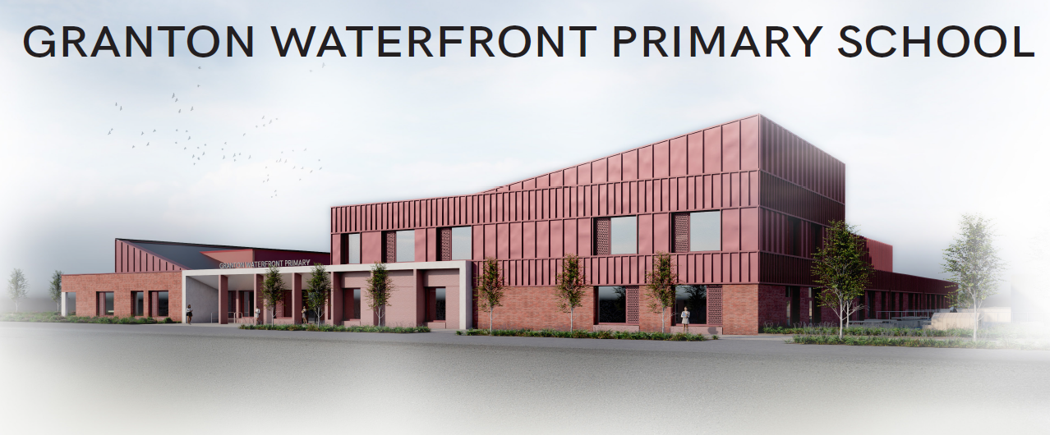
Figure 1. Proposed building visual.

Landscape and site strategy
The Granton Waterfront Primary School is a flagship project within Edinburgh’s coastal regeneration, designed to blend the area’s industrial heritage with a sustainable, “outdoor classroom” approach. The landscape proposal prioritises pupil well-being through a mix of high-energy play zones and quiet sensory spaces, ensuring the site functions as both an educational tool and a community asset. By focusing on pedestrian connectivity and ecological resilience, the design creates a seamless link between the school and the wider urban masterplan.
The landscape strategy utilises a clear zoning hierarchy to balance safety, accessibility and community use in alignment with City of Edinburgh Council guidelines. The southern portion is dedicated to Nursery and P1/P2 pupils, featuring a mix of formal play structures, loose parts play and natural sensory zones. In contrast, the northern parkland serves as a community asset with a shared MUGA and playground for out-of-hours use, alongside specialised ESB facilities, allotments and outdoor dining. Logistics and key travel routes are strategically tucked into the western and southern boundaries, ensuring the school integrates seamlessly with the wider Granton masterplan infrastructure.
The site plan is the result of an iterative, multi-disciplinary process. Developed alongside various designers and engineers, the proposal has been refined through continuous client consultation to ensure it meets the project’s strategic goals. The plan translates the client brief, technical site constraints and topographical requirements into a cohesive spatial framework. It balances functional site needs with aspirational “wants”, establishing an initial vision for a versatile community and educational hub.
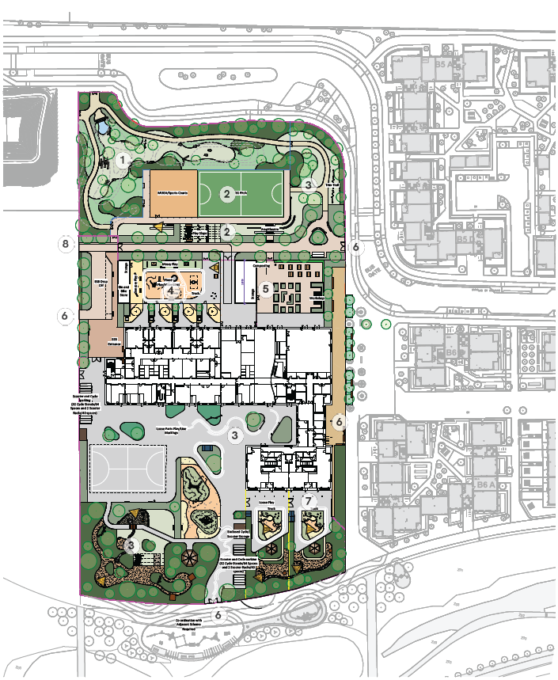
Figure 2. Landscape site plan.

Landscape zones and movement
- 1 – Floodable Park
- 2 – MUGA and Play Slope/Amphitheatre
- 3 – Playground
- 4 – ESB External Play
- 5 – Allotments/Dining Area
- 6 – Key Access Points
- 7 – Nursery External Play
- 8 – Key Movement Corridor
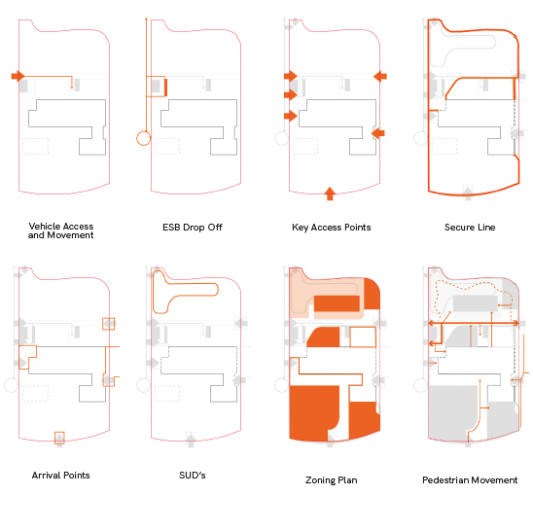
Figure 3. Landscape access, zoning and movement diagrams.
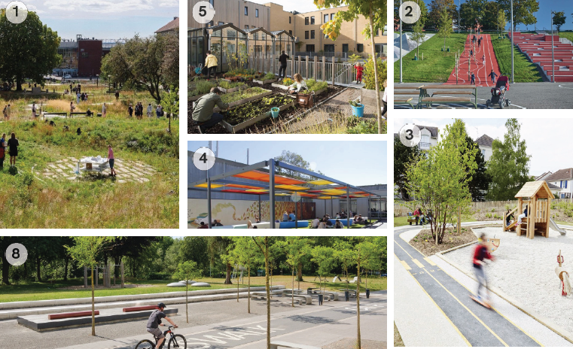
Figure 4. Landscape precedents.

Building design and spatial strategy

Massing, landscaping and environment
The building massing adopts a simple and efficient form to support Passivhaus principles, utilising compact blocks and predominantly flat roofs to minimise thermal bridging and reduce heat loss. The arrangement maximises southern orientation, allowing key elevations to benefit from passive solar gain and improved daylighting. Environmental performance is embedded within the form, with primary learning spaces positioned to receive southern light, while rooflights are introduced to provide controlled, diffuse daylight to deeper plan areas. This is particularly beneficial for ESB spaces, which require consistent, low-glare lighting conditions supported by north-facing light.
The overall massing strategy also responds to functional requirements, organising the building to create clear separation between the nursery, ESB and primary playgrounds, supporting both operational clarity and pupil wellbeing.

Spatial layout and movement
The building strategy is structured around a clear and legible spatial and movement hierarchy, with the nursery, ESB and lower primary (P1/P2) deliberately located at ground floor level to support accessibility and provide direct access to dedicated outdoor play areas and entrances. Circulation is organised around a central spine anchored within the dining hall, where an activity stair acts as a keystone for social engagement and movement.
A clear hierarchy of entrances separates public and secure zones, with a civic main entrance and a dedicated ESB entrance supporting pupil wellbeing and operational needs. Internal circulation is conceived as a series of connected learning environments, with breakout spaces strategically located between classrooms within the same age groups. These shared zones extend the learning environment beyond the classroom, supporting a range of teaching modes including small group work, informal learning and quieter retreat spaces alongside traditional classroom activities. This arrangement allows flexibility in how spaces are used while maintaining clear supervision and reinforcing the building as an integrated and adaptable learning environment.
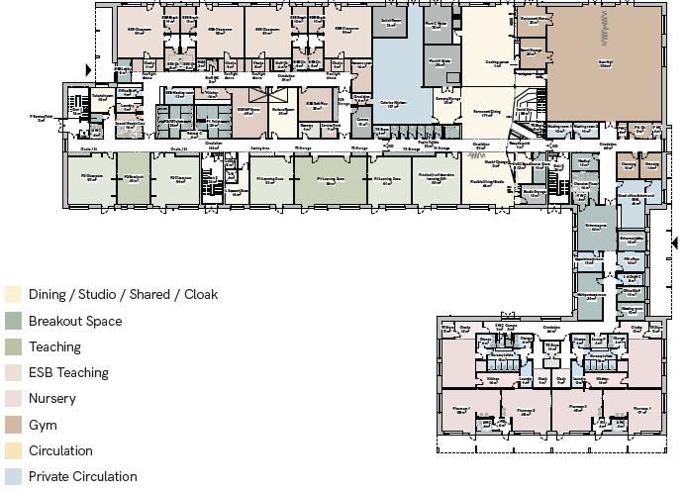
Figure 5. Ground floor plan – not to scale.

Ground floor key spaces
The ground floor includes flexible dining and studio space, permanent dining, a gym hall and sports storage, nursery playrooms and associated spaces, P1 and P2 learning zones, ESB classrooms and break spaces, sensory and nurture rooms, shared learning and breakout areas, administration and staff facilities, and dedicated entrances and circulation.
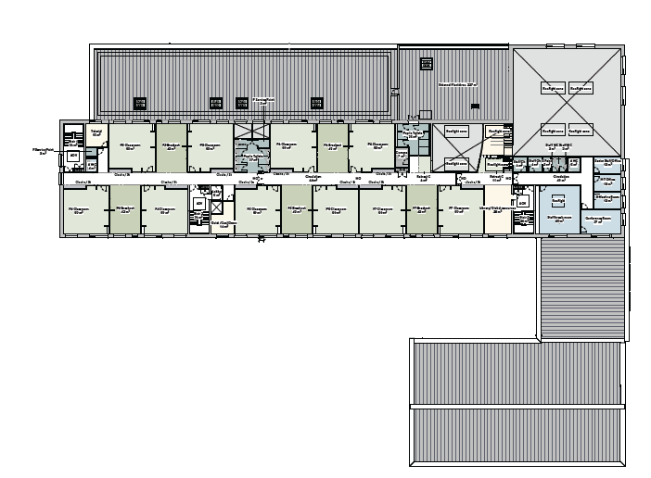
Figure 6. First floor plan – not to scale.

First floor key spaces
The first floor provides primary learning and teaching spaces for P3 to P7, with breakout spaces between classrooms. It also includes library and digital resources, meeting and conference rooms, staff facilities, tutorial space, retreat areas, quiet or cool-down space and associated circulation.
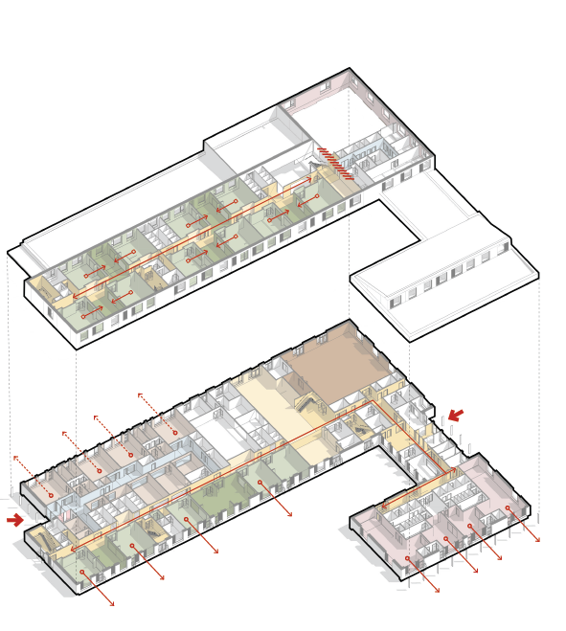
Figure 7. Building ground floor and first floor massing / axonometric view.
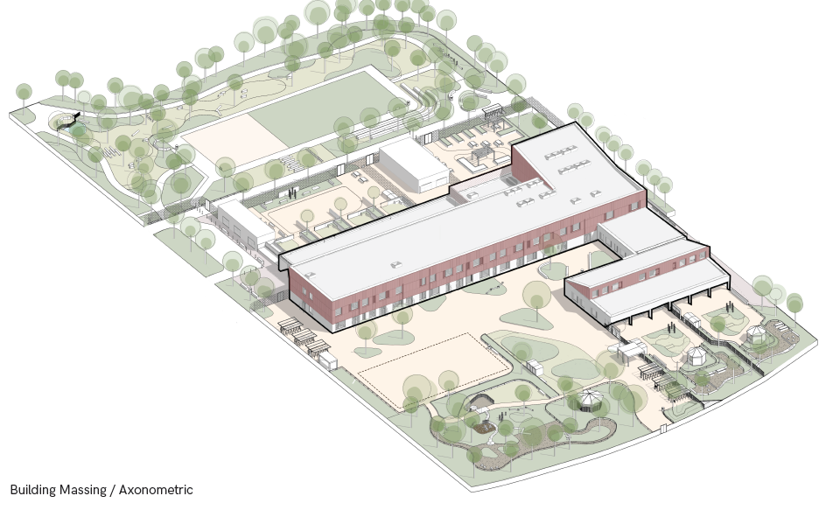

Figure 8. Building & site massing / axonometric view.

Consultation purpose
The consultation material explains the progress made to date, the key principles behind the design and landscape proposals, and the intended contribution of the new school to the emerging Granton Waterfront neighbourhood. Feedback from the local community will help inform the proposals before a formal planning application is submitted.

Accessibility and document structure
This document uses a simple reading order, structured heading styles, a minimum 12-point Arial body font and alternative text for the included images. It avoids using tables for layout.

Need a different language or format?

Please email the Interpretation and Translation Service at its@edinburgh.gov.uk quoting reference 26-0858

