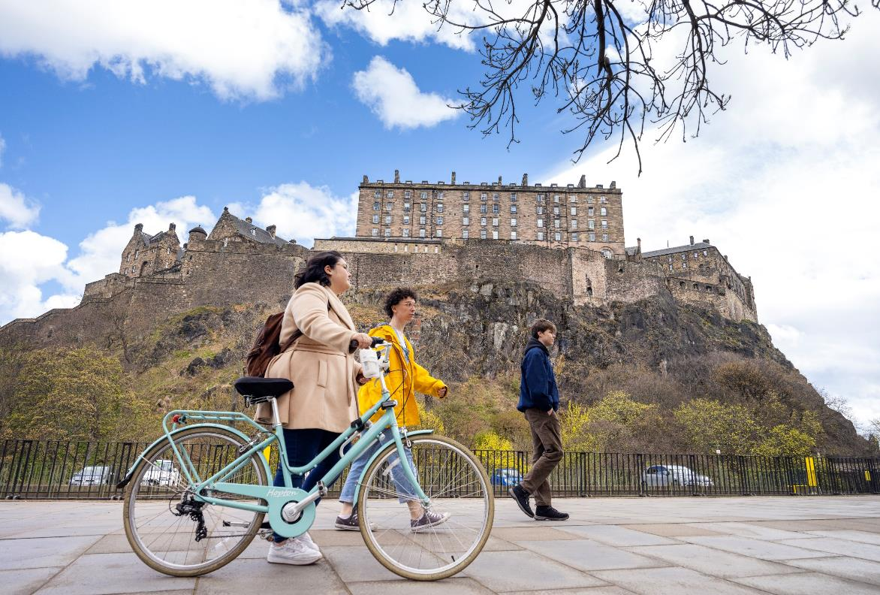
Draft Physical Activity and Sport

Strategy for Edinburgh
2024 to 2034
March 2024

Contents

Introduction 2
What is the strategy for? 3
What is the strategic context for the strategy? 4
What role does the Council play in promoting sports and physical activity in the city? 5
What is the city’s current sport and physical activity landscape and participation? 6
What are the high-level priorities for the strategy? 8
Priority one - Active systems 9
Priority two - Physical activity and sport for all 10
Priority three – Active travel 11
Priority four – Active places and spaces 12
Priority five – Active health and social care 13
Priority six – Public engagement and awareness raising 14
Priority seven – Active places of learning 15
Priority eight – Active workplace 16

Introduction

Vision
An Edinburgh where everyone enjoys the benefits of an active life.

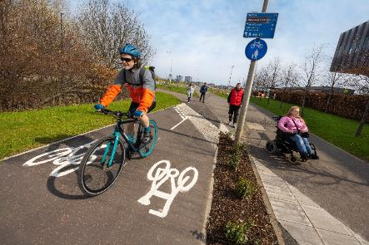

Why is physical activity and sport important?
Staying active is crucial for maintaining a healthy lifestyle. It's not just about physical health, but also mental and social wellbeing.
There is a lot of evidence that shows that activities like exercising, playing sports, dancing, and staying fit can improve our lives and our communities. Being active can not only make us feel better, but it can also improve our health, make us more productive, help us develop important skills, improve our education, and create stronger communities.
The UK Chief Medical Officers’ Physical Activity Guidelines confirm the benefits of an active life, being active:
- controls weight
- plays a key role in prevention, early intervention, and the management of long-term conditions and non-communicable disease
- improves mood
- boosts energy
- promotes better sleep
- can be fun and social
Wider benefits for our city include:
- Stronger, safer, and more connected communities
- Population level health improvement
- Environmental improvements
- Reduced inequalities
- Greater productivity

What is the strategy for?

This plan aims to address the issue of unequal participation rates in physical activity and sport. The coronavirus pandemic has worsened this situation for disadvantaged groups.
Our focus must be on confronting these inequalities more than ever before. According to the Edinburgh People’s Survey results from 2018, 72% of respondents had engaged in at least one physical activity in the last four weeks.
However, certain groups such as those who are older, have a disability, or are in a lower income bracket, are less likely to be active. Physical activity is important for people's health and wellbeing, and we want to ensure that everyone in Edinburgh has the opportunity to be active.
To achieve this goal, we need a well-organised and efficient approach that makes the most of the resources available. Many partners, clubs, and organisations already provide opportunities for physical activity in Edinburgh, but we need to work together more effectively to achieve better results. To encourage more people to participate, we will be promoting the benefits of physical activity and sport.
We’ll take a strategic approach to guide our work and make sure that everyone in Edinburgh has a chance to be active and healthy.

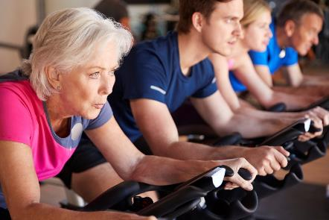

What is the strategic context for the strategy?

This strategy defines the areas of focus for our partners and outlines the key principles that will guide our support for physical activity and sport in Edinburgh for the next decade. It has been developed using evidence and ideas from a variety of sources, including:
- Active Scotland’s Outcome Framework and Delivery Plan
- sportscotland’s Sport for Life
- COSLA The Positive Contribution of PA and Sport to Scotland
- ISPAH’s (International Society for Physical Activity and Health) Eight Investments that Work for Physical Activity
- Public Health Scotland – a systems-based approach to physical activity in Scotland
- Covid-19, physical activity, inequalities evidence review
- Scottish Disability Sport Strategic Plan
This strategy considers both the national policy context and the specific city landscape of Edinburgh. It is designed to align with the city's key plans and strategies, ensuring that all efforts work together to provide the best outcomes for Edinburgh's citizens.
Key strategies include:
- Edinburgh 2050 City Vision
- Council Business Plan 2023-27
- Edinburgh Partnership Community Plan
- Edinburgh Learns for Life
- 20 Minute Neighbourhood Strategy
- City Mobility Plan2021-2030
- End Poverty in Edinburgh Plan 2020-203
- A Vision for School Grounds
- Thriving Greenspaces Strategy
- Open Space Strategy
- Proposed City Plan 2030
- Thrive Edinburgh 2019-2029
Connections and common themes between these key strategies that will influence the new Physical Activity and Sport Strategy include:
- Edinburgh is a good place to live and work
- Ending poverty in Edinburgh
- Becoming a net zero city by 2030
- Reducing inequalities
- Improving the quality of life, health, and well-being for the citizens of Edinburgh
- Access to work, learning and training opportunities

What role does the Council play in promoting sports and physical activity in the city?

We are developing a new strategy for sports and physical activity in Edinburgh, given its responsibilities for local democracy, service delivery, and infrastructure provision.
However, the success of this strategy will depend on collaboration with key partner organisations from the public, private, and voluntary sectors who share the same vision of promoting a more active Edinburgh.
By working together, partners can achieve positive outcomes through increased physical activity and sports participation. Research by Public Health Scotland suggests that integrated action is needed across multiple sectors and settings, including schools, healthcare, transport, urban planning, sports, communities, and workplaces, to effect meaningful change and improve opportunities for physical activity.
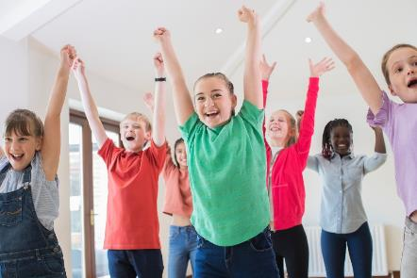

What is the city’s current sport and physical activity landscape and participation?

Several public sector organisations provide sport and physical activity programmes, including the Council (Community Sport Hubs, Active Schools, Sports Development), Edinburgh Leisure, and tertiary education institutions.
These organisations have modernised their approaches as thinking around sport and physical activity has evolved, as demonstrated by sportscotland's Changing Lives Programme. Something that has not changed is the delivery of physical activity and sport in Edinburgh by hundreds of clubs and third sector organisations who organise and develop opportunities for people to participate in many ways. Awareness and appreciation of smaller, localised community organisations that utilise sport and physical activity to support their own objectives while contributing to the delivery of broader outcomes has increased. This has led to more cohesive partnership working, particularly in areas of the city where people experience higher levels of poverty and where local groups can better connect with residents than larger, city-wide organisations.
While there is a wealth of opportunities across the city to participate in sport and physical activity, inequalities exist. Survey results from the Scottish Household Survey in 2022 show that 33% of residents living in the most deprived areas of Edinburgh took part in sport in the last four weeks, compared to 63% in the least deprived areas.
For physical activity such as walking, 60% of people living in the most deprived areas participated in recreational walking for at least 30 minutes in the last four weeks in 2019, increasing slightly to 63% in 2022. This compares to 86% of people who participated in the least deprived areas in 2019, decreasing slightly to 82% participation in 2022.
The survey also shows that men and boys are more likely to participate in sport than women and girls. Male participation in sport has steadily reduced in Edinburgh from 68% in 2013 to 62% in 2022. Female participation has remained relatively stable, with 53% participating in 2013 increasing to 54% in 2022.
There is also inequality when considering participation by those with lower levels of qualification. With 69% of those who have achieved an HNC or higher taking part in sport compared to 21% with no qualifications. This shows a widening gap between those participating in sport with higher qualifications and those with no qualifications in the last three years.
Similar patterns exist for people with disabilities and those from ethnic minority communities. In the 2022 Scottish Household Survey, 42% of people surveyed with a disability took part in sport at least once in four weeks compared to 62% of people without a disability.
For walking, the figures were 73% and 90%, respectively. When reviewing figures against ethnicity, 53% of those identifying as White Scottish and 72% of White British had participated in sport at least once in the last four weeks compared to 46% of those from ethnic minorities.
In summary, sport and physical activity participation levels across the city have remained relatively static over the years, with a significant gap in participation between the least and most deprived areas of the city.
This picture remains the same when we take educational achievement, disability, and ethnicity into account. Challenging economic times exacerbate this gap in participation, putting more financial pressure on families. There is an increasing number of residents in Edinburgh who do not have access to networks or opportunities.
Sport and physical activity can support people to integrate and live a healthy life. Therefore, we need to be creative in finding solutions to make it easier for everyone to participate in sport and physical activity in the city.

What are the guiding principles for the strategy?

This strategy is informed by the following guiding principles that will underpin the implementation of actions at every level, to be:
- inclusive
- accountable
- responsive
- collaborative
- preventative

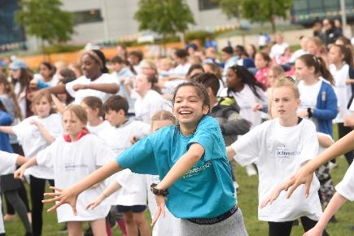

What are the high-level priorities for the strategy?
Our aim is to increase physical activity and sports participation in Edinburgh, improving people's quality of life and reducing health inequalities.
To achieve this, we have adopted Public Health Scotland's new strategic approach to physical activity in Scotland, which provides a framework for action at national and local levels.
The approach is based on ISPAH's(International Society for Physical Activity and Health) eight Investments that work for physical activity and aims to deliver outcomes that make a difference for local people while contributing positively to the national picture.
Our new Physical Activity and Sport Strategy does not replace or compete with existing strategies but provides an integrated approach that helps stakeholders understand the connections between strategies and identified priority areas. It will enable organisations to work together more effectively to support more people in becoming physically active.

Our eight strategic delivery priorities
- One: Active systems
- Two: Physical activity and sport for all
- Three: Active travel
- Four: Active places and spaces
- Five: Active health and social care
- Six: Public engagement and awareness raising
- Seven: Active places of learning
- Eight: Active workplace.
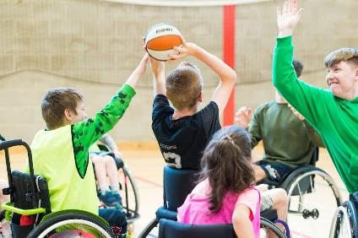

Priority one - Active systems

Why this priority matters

Edinburgh is committed to promoting physical activity for all.
To achieve this, we are adopting a joined-up or "whole systems" approach, bringing together partners from all sectors, including the Council, health organisations, national bodies, voluntary organisations, third-sector groups, and community organisations. By working together, we will create a long-term plan that will improve the quality of life of our citizens through physical activity.
This approach will enable us to optimise our resources and maximise the positive impact on our community.
By understanding our roles and responsibilities in promoting and supporting physical activity, we can achieve better outcomes for ourselves and those we work with. We invite you to join us in this effort to create a healthier, more active Edinburgh.

What success for this priority could look like
- Physical activity and its promotion will appear in more organisation’s aims, policies and strategies.
- Partners will work more closely to develop an effective and integrated strategic approach that will increase the number of people participating in physical activity and sport.
- There will be stronger leadership for physical activity and sport in Edinburgh.

To address this priority we could
- Develop new and existing partnerships to create and promote active opportunities for people of all ages.
- Improve collaboration across all sectors in areas where people stand to benefit the most from increasing their physical activity levels.
- Develop a local strategic partnership action plan to ensure that our efforts are coordinated and effective.

Priority two - Physical activity and sport for all

Why this priority matters
It's important to help those who are less active to participate in physical activities. This will benefit more people including individuals, communities, and the entire city.
By listening to what people want and having a strong and sustainable sports and recreation structure, we can make sure that everyone has the chance to join in, reduce health differences, and increase diversity and inclusivity.

What success for this priority could look like
Increased participation:
- In physical activity and sport through equitable and inclusive access to appropriate places, spaces, and services.
- By those from under-represented groups and those who live in the most deprived areas of the city or who suffer from the highest levels of poverty.

To address this priority we could
- Identify and reduce local barriers to participation through engagement with equalities groups and those who may not traditionally participate in physical activity and sport to improve access to opportunities.
- Support partners to create welcoming, positive, inclusive environments to encourage the inactive to become active.
- Support the education and development of coaches and deliverers.

Priority three – Active travel

Why this priority matters
Active travel is a practical and sustainable way to increase daily physical activity by walking, cycling, and using public transport.
Choosing to travel in more active ways improves people’s physical and mental health and wellbeing. It also reduces car usage and contributes to reducing carbon emission and Edinburgh’s net zero target.

What success for this priority could look like
Active travel behaviour positively influenced with more people choosing to walk, wheel, and cycle across Edinburgh.

To address this priority we could
- Align the Physical Activity and Sport Strategy with existing strategies and plans that support active travel such as the Council’s City Mobility Plan and the Active Travel Plan Action Plan
- Promote and support active travel opportunities as a way to increase physical activity participation.

Priority four – Active places and spaces

Why this priority matters
The provision of safe and welcoming recreational spaces and facilities is essential to improving people’s opportunities to be more active.
Edinburgh benefits from a significant number of these spaces alongside a range of available open green space as well as access to the coast and other waterways such as the canal.
Local streets and public spaces throughout a neighbourhood can also support every day and informal outdoor activity and play for all ages.
The new strategy provides a chance to maximise the physical activity opportunities that these active places and spaces provide by working across service areas, sectors and collaboratively with partners.

What success for this priority could look like
- Active places and spaces are appropriately designed, created, and maintained to enable people to be physically active in their community.
- Increased numbers of people are more physically active more often.

To address this priority we could
- Adopt a joined-up and strategic approach to Edinburgh’s sports facilities estate.
- Support local agencies, clubs, and organisations to develop accessible physical activity programmes.
- Activate and improve the quality of underutilised facilities.
- Align the Physical Activity and Sport Strategy with placemaking initiatives and other strategies and plans such as the Thriving Greenspaces Strategy, and the 20-minute Neighbourhood Strategy.

Priority five – Active health and social care

Why this priority matters
Physical inactivity has a significant financial burden on UK healthcare services and is one of the leading risk factors for non-communicable diseases. According to the British Heart Foundation Physical Inactivity and Sedentary Behaviour Report it contributes to one in ten premature deaths and one in six deaths from any cause in the UK.
Improving population levels of activity and supporting healthcare services with prevention, and early intervention approaches will reduce the pressure on welfare services and improve the health and wellbeing of the city.

What success for this priority could look like
- Increased numbers of people who have a long-term illness are more physically active more often.
- More colleagues working in health and social care are aware of the importance of promoting physical activity.

To address this priority we could
- Ensure physical activity and sport, health and social care and other key strategies are connected and complement each other.
- Continue to develop prevention and early intervention physical activity programmes and those that reduce inequalities.
- Raise awareness of the importance of promoting and facilitating physical activity for health gain to colleagues working in health and social care.

Priority six – Public engagement and awareness raising

Why this priority matters
Ensuring the public have information about the importance of being active and the benefits that brings, and developing lifelong habits of activity is essential to improving the health and wellbeing of the city.
A key part of this will be to reach those groups with most to gain from engaging in sport and physical activity and who may currently have disproportionately low levels of participation.
This work must go hand and hand with effective programme development, allowing communications and engagement to focus on local opportunities to become – and stay – active.

What success for this priority could look like
- A well-targeted programme of face-to-face engagement activities and events reinforced by clear messaging will lead to increased awareness and understanding of the benefits of regular physical activity, particularly amongst those groups with lower levels of participation.
- Clear, understandable, and targeted messaging will be essential if we are to mitigate inequalities and promote inclusion.
- This must be consistent across council services and partners, and it must be based on targeted opportunities made available in local communities. i.e. a genuine call to action.

To address this priority we could
- Work with partners to develop a targeted programme of physical activities and opportunities, tailored to target audiences to help them get active.
- Raise the profile of physical activity and sport at all levels, but in particular focusing on young people, older people, those from under-represented groups and those who live in the most deprived areas of the city or who suffer from the highest levels of poverty.
- As above, target communications and engagement activities at those groups with the most to gain from becoming active.

Priority seven – Active places of learning

Why this priority matters
Achieving the confidence, motivation, and ability to participate in physical activity and sport within learning settings (schools, colleges, community learning areas etc) can help set people up for lifelong participation.
Being active is also proven to raise attainment in education through increased confidence, behaviour, and attendance, or by enhancing skills such as self-discipline, concentration, teamwork, and time management.
Taking a rights-based approach, the right for children to play and be healthy goes hand in hand with opportunities for physical activity and is set out in the United Nations Convention on the Rights of the Child (Incorporation) (Scotland) Act.

What success for this priority could look like
- Places of learning will adopt an approach where all staff, services and partner organisations take responsibility for helping people, families and individuals become physically active.
- More children and young people will participate in physical activity and sport.

To address this priority we could
- Align the Physical Activity and Sport Strategy with existing strategies and plans that support active places of learning such as Edinburgh Learns for Life.
- Develop physical literacy programmes within learning settings that focus on building the confidence, motivation, and ability of children and young people to participate in physical activity and sport.
- Physical literacy training for staff is delivered annually, and physical literacy programme resources are made available for staff to use.

Priority eight – Active workplace

Why this priority matters
The workplace is a regular location for most of the city’s population, providing an opportunity to positively influence large numbers of people to improve their levels of physical activity. Research has also shown that there are clear benefits for organisations that have physically active employees.
The commute to/from work, navigation around buildings and patterns of behaviour through the working day can all be considered as ways of increasing activity levels.

What success for this priority could look like
- Everyday physical activity is enhanced through the workplace with a reduction in sedentary behaviour.
- Increased number of employees actively travel to and from the workplace.

To address this priority we could
- Raise the profile of the importance of physical activity and sport across the workplace.
- Share best practice across partners workplaces.

You can get this information on audio CD, in Braille or large print if you ask us. Please contact Interpretation and Translation Service by email its@edinburgh.gov.uk quoting reference number 24-9776. ITS can also give information on community language translations.

