Regulatory Committee

9.00am, Tuesday, 26 October 2021

Taxi Fares Review 2021
Executive/routine
Wards | All
Council Commitments

Recommendations
1.1 The Regulatory Committee is asked to:
    - Note the attached report from Jacobs (Appendix 2), and, in particular, the recommendations following consultation with representatives of the taxi trade;
    - Note that feedback was sought from the representatives of the taxi trade on the initial Jacobs report and, where possible, this has been incorporated in that report;
    - Approve the advertisement of a proposed fare scale with the following changes to the current fare scale, for reasons set out in this report, as required in terms of section 17 of the Civic Government (Scotland) Act 1982:
      - Increases all tariffs by 2.9%;
      - Increases the ‘additional passenger charge’ from 30p to 40p when there are more than three passengers; and
      - Amends the festive tariff so that Tariff 4 should be applied to Christmas Day and New Year's Day irrespective of day of the week and notes that Tariff 4 is retained during night times on Christmas Eve and New Year's Eve. Tariff 3 applies Monday through Friday 6am to 6pm during the defined Christmas period.
    - Instruct the Executive Director of Place to publish these proposed fare scales in a newspaper circulating in the Council area in the manner required under section 17(4A) (c) of the Act including the date on which the fare scale is planned to take effect, and to report back on any representation(s) received as a result of the consultation.
Paul Lawrence
Executive Director of Place
Contact: Andrew Mitchell, Regulatory Services Manager
E-mail: andrew.mitchell@edinburgh.gov.uk l Tel: 0131 529 4208

Report

Taxi Fares Review 2021

Executive Summary
2.1 This report informs the Committee that the statutory review of fares has been undertaken. The Council has engaged consultants to carry out the initial work on the review and their final report is attached. Consultation with the trade has also been carried out. The report makes recommendations on the remaining steps necessary to complete the review and fix taxi fares.

Background
  - The Council, as Licensing Authority under the Civic Government (Scotland) Act 1982 (‘the Act’) for taxis, is required, in terms of section 17, to review and fix the scale of fares and other charges which may be used by taxis licensed within the city. This review must take place at intervals not greater than 18 months. The Council last fixed taxi fares on 7 April 2020. The implementation of this change was delayed by the pandemic as the companies responsible for adjusting taxi meters were unable to operate during lockdown in spring/summer 2020. The subsequent fare review has been delayed due to pressures caused by the pandemic and prioritising safe reopening of businesses. The taxi fare tariff sets out the maximum charges which licensed taxis may charge any passenger for a journey within the city. Operators are free to alter any charge subject to that maximum.
  - The initial requirement of the review is that the Council, as Licensing Authority, must consult with persons or organisations appearing to them to be, or be representative of, the operators of taxis within their council area. In its work plan, the Committee agreed to commission consultants to carry out the initial consultation with the trade, review the fare structure and to make recommendations on any changes following consultation. Jacobs was commissioned to undertake the most recent review and the final report is attached at Appendix 2.
  - On 1 October 2021, a copy of the draft Jacobs report was provided to representatives of the taxi trade for final comment by 8 October 2021. No further responses were received during this period.

Main report
  - The current fee structure is set out at Appendix 1 of this report. The fee varies depending on time of day, distance travelled, and waiting time. There are particular tariffs for certain public holidays and additional fees for a range of items, including the cleaning of the taxi if it is soiled.
  - Following consultation with representatives of the trade, the Council is required to review the existing fare scales and propose new scales. The proposed fare scale is required to be advertised for a period of not less than one month, to allow for representations, after which a further report will be brought back to the committee for consideration, and if appropriate, approval.
  - There is a right of appeal in respect of any decision Committee makes regarding the new fare scales. This may be exercised by any taxi licence holder and the appeal is made to the Scottish Traffic Commissioner. Guidance issued by the Scottish Government states that the Council should consider the costs of operating a taxi as well as the income available to operators when reviewing and fixing the taxi fare scales. Committee should also avoid restricting any increase based on concern about the impact on passengers.
  - The draft Jacobs report was circulated to the taxi trade for comment, feedback was invited and the final report making recommendations as to the revisions to the fare table is now submitted for the committee’s consideration (Appendix 2).
  - Section 4 of the report outlines the responses received from the trade. Members are advised to consider this information in detail when considering the recommendations in this report. In summary, trade members seek the following:
    - 2.9% overall increase;
    - Increases the ‘additional passenger charge’ from 30p to 40p when there are more than three passengers; and
    - Amend the festive tariff so that T4 should be applied to Christmas Day and New Year's Day irrespective of day of the week and that T4 is retained during night times on Christmas Eve and New Year's Eve.
  - Section 8 of the report provides recommendations to the Council on what fare increases could be applied, and these mirror the changes sought by the trade as detailed at paragraph 4.5 above.
  - After taking the above into consideration, it is recommended that Committee fixes a taxi fare scale with the following changes to the current fare scale:
    - 2.9% overall increase;
    - Increases the ‘additional passenger charge’ from 30p to 40p when there are more than three passengers; and
    - Amend the festive tariff so that Tariff 4 should be applied to Christmas Day and New Year’s Day irrespective of the day of the week and that Tariff4 is retained during night times on Christmas Eve and New Year's Eve.
  - Adopting the proposed change to the festive tariff effectively removes Tariff 3 on Christmas and New Year’s Days. This would further widen the gap between Tariff 1 and fares paid during those periods. Figure 7.1 at paragraph 7.2 in the report (Appendix 2) sets out the effect of the proposed percentage fare increase across the tariffs.
  - Details of the final proposals and the recommendations as detailed in paragraph 4.5 above were sent to the representatives of the trade by email on 1 October 2021. No further responses were received. It is recommended that, having reviewed and proposed new fare scales, Committee directs officers to advertise the proposed fare scales in line with the statutory requirements set out above, and to report back when that process is complete.

Next Steps
  - It is recommended that the committee notes this report and agrees to receive a further report after the statutory advert is published.

Financial impact
  - There is no direct financial impact to the council. The fare structure will have a direct impact on residents or visitors to the city using a taxi.

Stakeholder/Community Impact
  - If the taxi trade has a concern about the Council’s decision on the new fare scales, taxi licence holders may appeal that decision individually or as a group, including any decision not to implement an increase in the fare scales.
  - Matters described in this report have no relationship to the public sector general equality duty, thus there is no direct equalities impact arising from this report
  - There is no environmental impact arising from the contents of this report.

Background reading/external references
  - None

Appendices
  - Appendix 1 - Current tariff (from 7 April 2020)
  - Appendix 2 - Jacobs report dated 13 October 2021
  - Appendix 3 – Proposed tariff

Appendix 1
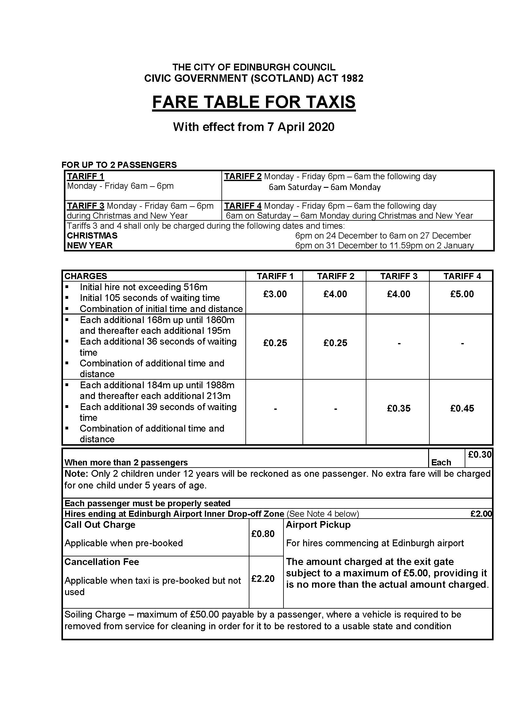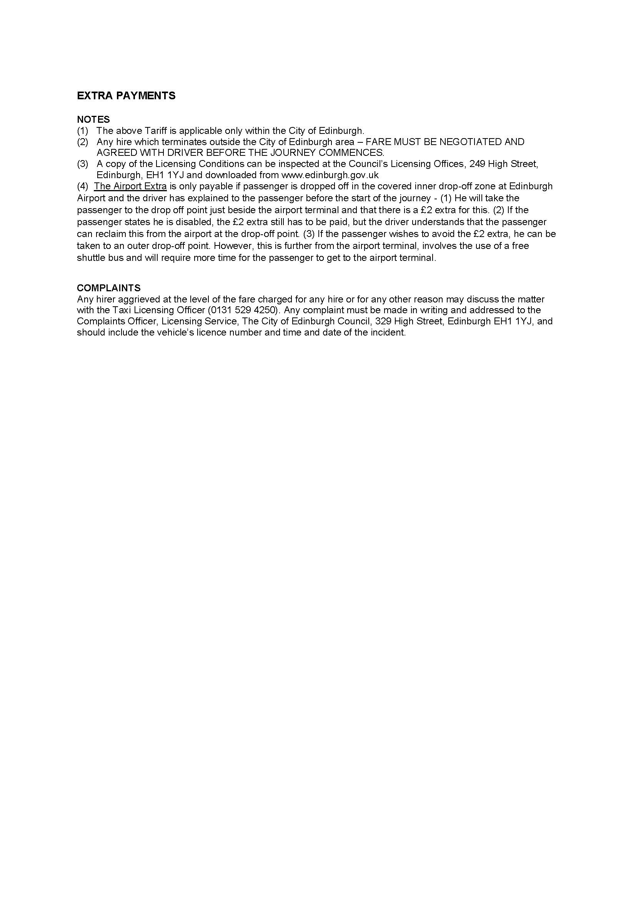

Appendix 3