Regulatory Committee

9.30am, Monday, 19 August 2019

Taxi Stance Appointment – East Market Street
Item number
Executive/routine
Wards | Citywide
Council Commitments

Recommendations
  - It is recommended that the Regulatory Committee:
    - notes the content of this report;
    - notes that officers will carry out statutory consultation on the proposed taxi stance; and
    - notes that a report will be brought back to the committee for a decision after the conclusion of statutory consultation.

Paul Lawrence
Executive Director of Place
Contact: Andrew Mitchell, Regulatory Services Manager
E-mail: andrew.mitchell@edinburgh.gov.uk l Tel: 0131 529 4208

Contact: Marcos Martinez, Higher Enforcement Officer
E-mail: marcos.martinez@edinburgh.gov.ukI Tel: 0131 529 4533

Report

Taxi Stance Appointment – East Market Street

Executive Summary
  - The Committee is asked to note the proposal by Roads Services to relocate the taxi stance currently situated at Market Street to East Market Street (Appendix 1), and that the Directorate will carry out the statutory consultation required prior to formally appointing the taxi stance, as required by the Civic Government (Scotland) Act 1982.

Background
  - The City of Edinburgh Council, as a Licensing Authority, is required to appoint taxi stances in line with the provisions of S.19 (1) of the Civic Government (Scotland) Act 1982 (‘the 1982 Act’).
  - The powers available to licensing authorities to provide taxi stances in their respective areas can be exercised provided that they obtain the necessary prior consents (including that of the roads authority); consult the appropriate trade organisations and other representatives; give notice to the Police and the public; and that they do not obstruct access to any premises.
  - To satisfy the process of obtaining relevant permission from the roads authority, taxi stances are also required to be created by way of Traffic Regulation Orders (TRO). This is separate from the requirements of the 1982 Act, falling within the remit of the Council as the roads authority (as opposed to the licensing authority). The appointment of stances is therefore subject to a dual process. Parking restrictions on and around taxi stances are facilitated by a TRO. A process map is included at Appendix 2 for the information of members.

Main report
  - There have been several concerns raised with respect to the location of the current temporary taxi rank at Market Street. These concerns largely relate to the suitability of the current site. There is significant traffic congestion and the volume of pedestrians in the area exacerbates these problems. These concerns are expected to continue to be exacerbated by planned building development in the area.
  - It has been identified that this stance is required to be moved. The mix of flow and volume of traffic and pedestrians continues to increase, in addition to several ongoing building works in the locus, and there is therefore an increase of risk to the safety of the public.
  - A solution has been identified by the City of Edinburgh Council’s Roads Services team - moving this rank to East Market Street (outside The Arches).
  - The Roads Services team has requested that the newly identified stance should be appointed as an authorised stance in line with the requirements of the Civic Government (Scotland) Act 1982. Officers from the Roads Services team have discussed these proposals with taxi trade representatives through the Taxi Stance working group as part of the initial consultation. The trade expressed a view that whilst the new location was not ideal there was a general acceptance that it was necessary to move the rank in the interest of public safety
  - The introduction of the rank will be facilitated by use of a temporary TRO (‘TTRO’) to cater for ongoing works affecting the area and the need for flexibility for works management.
  - Current plans include provision for:
    - A 10-bay stance to be located on East Market Street from the junction with Jeffrey Street heading in an easterly direction towards Waverley Court, terminating immediately adjacent to 1a The Arches;
    - Double yellow lines to remain on the north side of Market St adjacent to the Edinburgh Dungeon, with the exception of the loading bay and motorcycle bay;
    - No changes to existing parking bays on the south side of Market Street and the north side of East Market Street.

Next Steps
  - If the committee agrees to approve these proposals in principle, the Directorate will undertake its statutory obligations as detailed in 3.2 above and will also undertake the proposed additional engagement actions detailed in 3.3 above.
  - The outcome of these actions and any consultation responses received will be reported back to Committee at the next available meeting, upon conclusion of the 28-day notification period.

Financial impact
  - The costs associated with the changes to the road infrastructure etc. required to implement these proposals will be managed within the existing Roads budget.

Stakeholder/Community Impact
  - Initial consultation has been carried out with the trade as detailed in paragraph 4.4. In addition to its statutory obligations of notification and consultation, the Licensing Authority will also undertake to inform the public and the wider business and residential community, relevant partners and agencies including:
    - Ward 11 councillors;
    - Community Council representatives;
    - Affected businesses trading from The Arches.
  - The publication of the statutory advert will allow consultation to take place with the wider business and residential community, relevant partners and agencies.
  - Roads Services have undertaken the relevant actions to introduce the required TTRO which includes public notification and objection period. No objections to the TTRO have been received.
  - In the event that the proposed taxi stance is appointed, Roads Services will ensure that as part of follow up actions to implement the stance (e.g. laying of road markings, erection of appropriate signage etc.) officers will engage with Network Rail to ensure that it can take remedial steps to alter existing signage within Waverley Station.

Background reading/external references
  - None

Appendices
9.1 Appendix 1 – proposed plan of taxi stance at East Market Street
9.2 Appendix 2 – Taxi stance appointment process flowchart

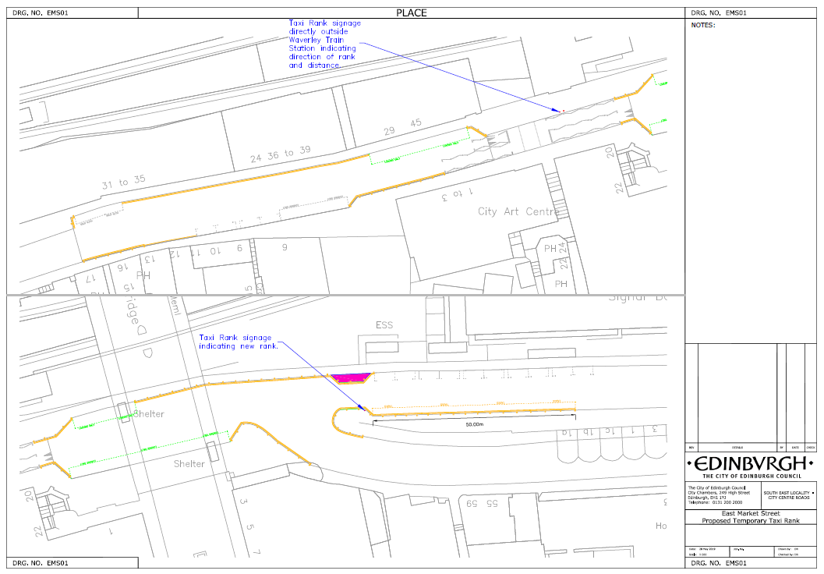
Appendix 1 - proposed plan of the taxi stance at East Market Street

Appendix 2 – Stance appointment procedure

Procedure To Appoint, Vary, Revoke or Alter a Taxi Stance

Stance requirement identified
(Council / Public / Trade / TSWG)
Consult and Obtain Consent of Area Roads Manager
Notice of CC (Police Scotland) plus public notice (Newspaper advert with 28 days for objections/representations
Consultation with trade before making any changes
(TSWG)
Licensing Regulatory committee Appoint/Vary/Alter position/Revoke

Licensing Regulatory committee or delegated authority
No Objections or representations
28 days
If revocation only, no newspaper advert required
If TRO required, revert to Statutory TRO Appointment process

